

**Cairo University Faculty of Engineering Aerospace Department**

Autopilot

|  |  |  |
| --- | --- | --- |
| name | sec | bn |
| **Mohammed Ahmed Hassan Ahmed** | **2** | **37** |
| Ibrahim Thabet Allam | 1 | 1 |
| Mohammed Hatem Mohammed Saeed | 2 | 39 |
| Mohamed Hassan Gad Ali | 2 | 41 |
| Mohammed Abd El Mawgoud Ghoneam | 2 | 43 |

Submitted To: Prof. Dr. Osama

Contents

[Task (1) 5](#_Toc104337482)

[Research questions 5](#_Toc104337483)

[a) What is an autopilot? 5](#_Toc104337484)

[b) What are the inputs & outputs of Autopilot system onboard an airplane? 5](#_Toc104337485)

[c) What would be the role of the pilot in an airplane equipped with an autopilot? 5](#_Toc104337486)

[d) What is the difference between Autopilot & SAS? 6](#_Toc104337487)

[e) What is the role of the onboard sensors like (GPS, gyroscopes, ...etc.)? give example. 6](#_Toc104337488)

[Flight Mechanics review: 7](#_Toc104337489)

[a) State the general rigid body dynamics (RBD) equations in 3D space 7](#_Toc104337490)

[b) Classify the upper equations into (Kinetics & Kinematics) equations 11](#_Toc104337491)

[c) What are the assumptions introduced while deriving those equations? 11](#_Toc104337492)

[d) State the set of equations added to the (RBD) equations to form the Fixed wing Airplanes (EOM) 11](#_Toc104337493)

[e) Classify the airplanes EOM equations mathematically. 12](#_Toc104337494)

[f) What is the difference between the (Body axes) and the (earth or inertial axes)? 12](#_Toc104337495)

[g) What is the difference between the pitch angle (θ) and the angle of attack (α), and between the sideslip angle (β) and the heading angle (ψ)? 12](#_Toc104337496)

[Numerical solutions of ODEs 13](#_Toc104337497)

[Some numerical solving algorithms for ODE 13](#_Toc104337498)

[The chosen method for solving the aircraft EOM. 13](#_Toc104337499)

[The general solution of 4th order Runge-Kutta method 14](#_Toc104337500)

[Task (2) 16](#_Toc104337501)

[RBD Equations in a vector form 16](#_Toc104337502)

[Kinetics 16](#_Toc104337503)

[Kinematics 16](#_Toc104337504)

[Givens: 16](#_Toc104337505)

[IC’s: 17](#_Toc104337506)

[Raunge-Kutta $4th order$ (our code) 17](#_Toc104337507)

[Validation with Simulink and ODE45 17](#_Toc104337508)

[Results 18](#_Toc104337509)

[velocity with respect to body Axes: 18](#_Toc104337510)

[Rotational speed W.r.t body axes 18](#_Toc104337511)

[Rotational speed w.r.t Earth Axes 19](#_Toc104337512)

[Position w.r.t Earth Axes 19](#_Toc104337513)

[Task (3) 20](#_Toc104337514)

[Introduction 20](#_Toc104337515)

[Axes systems 21](#_Toc104337516)

[Benchmark test plots B-747 airplane 23](#_Toc104337517)

[For No input 23](#_Toc104337518)

[For +ve 5-degree aileron 24](#_Toc104337519)

[For -ve 5-degree aileron 25](#_Toc104337520)

[For +ve 5-degree rudder 26](#_Toc104337521)

[For -ve 5-degree rudder 27](#_Toc104337522)

[For +ve 5-degree elevator 28](#_Toc104337523)

[For -ve 5-degree elevator 29](#_Toc104337524)

[For 1000 in thrust 30](#_Toc104337525)

[For 10000 in thrust 31](#_Toc104337526)

[Our airplane Plots (NT-33A) 32](#_Toc104337527)

[For No input 32](#_Toc104337528)

[For +ve 5-degree aileron 33](#_Toc104337529)

[For -ve 5-degree aileron 34](#_Toc104337530)

[For +ve 5-degree rudder 35](#_Toc104337531)

[For -ve 5-degree rudder 36](#_Toc104337532)

[For +ve 5-degree elevator 37](#_Toc104337533)

[For -ve 5-degree elevator 38](#_Toc104337534)

[For 1000 in thrust 39](#_Toc104337535)

[For 10000 in thrust 40](#_Toc104337536)

[Task (4) 41](#_Toc104337537)

[a) Linearization of 12 EOM for a fixed wing A/C 41](#_Toc104337538)

[EOM linearization: 41](#_Toc104337539)

[EOM 41](#_Toc104337540)

[Let:($A=Ao+∆A$) 41](#_Toc104337541)

[Longitudinal calculations: 42](#_Toc104337542)

[Lateral calculations: 43](#_Toc104337543)

[State space Model: 44](#_Toc104337544)

[b) (1) Longitudinal dynamics approximations 45](#_Toc104337545)

[Long period approximation (mode) 46](#_Toc104337546)

[short period approximation (mode) 47](#_Toc104337547)

[b) (2) Lateral dynamics approximations 48](#_Toc104337548)

[3-DOF spiral mode 48](#_Toc104337549)

[2-DOF Dutch-Roll mode 49](#_Toc104337550)

[1-Roll mode 49](#_Toc104337551)

[c) Results of the longitudinal dynamics 50](#_Toc104337552)

[d) Results of Step response (lateral Dynamics) 57](#_Toc104337553)

[Response due to Aileron ( $δa=1)$ 57](#_Toc104337554)

[Response due to Aileron ( $δa=5)$ 58](#_Toc104337555)

[Response due to Rudder ( $δa=10)$ 60](#_Toc104337556)

[Response due to Rudder ( $δa=25)$ 61](#_Toc104337557)

[Response due to Rudder ( $δr=1)$ 62](#_Toc104337558)

[Response due to Rudder ( $δr=5)$ 64](#_Toc104337559)

[Response due to Rudder ( $δr=10)$ 65](#_Toc104337560)

[Response due to Rudder ( $δr=25)$ 66](#_Toc104337561)

[f) Transfer Function graphs (Longitudinal Dynamics) 68](#_Toc104337562)

[e) Transfer Function graphs (Lateral Dynamics) 76](#_Toc104337563)

[Task (5) 87](#_Toc104337564)

[A. Design Pitch Controller with pitch rate feedback 87](#_Toc104337565)

[B. Testing Pitch Controller on the Full State Space Model 90](#_Toc104337566)

[Simulink Simulation 90](#_Toc104337567)

[Results 91](#_Toc104337568)

[C. Necessity of velocity control 92](#_Toc104337569)

[D. Design a “Velocity Controller” 94](#_Toc104337570)

[F. Design “Altitude controller” 97](#_Toc104337571)

[E. Test the (Pitch & Velocity) controllers on the full state space model and (g) Test the “Altitude & Velocity Controllers” together on the full state space model 100](#_Toc104337572)

[Simulink Simulation 100](#_Toc104337573)

[Results: 102](#_Toc104337574)

[Task (6) 105](#_Toc104337575)

[a) Design a “Yaw damper” for the Dutch Roll Mode 105](#_Toc104337576)

[Design No. One 105](#_Toc104337577)

[Design No. Two 107](#_Toc104337578)

[B. Test The “Yaw damper” controllers on the full state space model 109](#_Toc104337579)

[Design No. One 109](#_Toc104337580)

[Design No. Two 109](#_Toc104337581)

[Results: 110](#_Toc104337582)

[Design No. One 110](#_Toc104337583)

[Design No. Two 110](#_Toc104337584)

[c) Design “Roll Controller” 111](#_Toc104337585)

[d) Coordination 113](#_Toc104337586)

[e) Test the designed controllers on the full state space model 115](#_Toc104337587)

[Results: 115](#_Toc104337588)

[Task (7) 116](#_Toc104337589)

[a) Develop the testing loop Containing the “Controller + Simulator” 116](#_Toc104337590)

[b) Test the “Pitch controller” and compare the response with the same test on the State space model 117](#_Toc104337591)

[Linear block 118](#_Toc104337592)

[Results for 33.5 deg pitch angle 119](#_Toc104337593)

[c) Test the “Pitch controller + Velocity controller” and compare the 122](#_Toc104337594)

[response with the same test on the State space model 122](#_Toc104337595)

[Simulink Non-linear simulator: 122](#_Toc104337596)

[Simulink linear simulator: 124](#_Toc104337597)

[Simulation Results for 15° pitch command: 125](#_Toc104337598)

[d) Test The “Altitude Hold” Controller and Compare the response with the same test on the state space model 128](#_Toc104337599)

[e) Perform a complete autonomous mission including “climb, cruise, turn, descent” 131](#_Toc104337600)

[f) Test the “Lateral controller + Altitude Hold controller” and compare the response with the same test on the State space model 134](#_Toc104337601)

[g) Perform a complete autonomous mission including “climb, cruise, turn, descent” 138](#_Toc104337602)

[Appendix: MATLAB code 142](#_Toc104337603)

[Task (1) 142](#_Toc104337604)

[Task (2) 143](#_Toc104337605)

[main.m 143](#_Toc104337606)

[DOF6.m 146](#_Toc104337607)

[Input.m 147](#_Toc104337608)

[RBDSolver.m 148](#_Toc104337609)

[SCT.m 148](#_Toc104337610)

[Task (3) 149](#_Toc104337611)

[main.m 149](#_Toc104337612)

[airFrame.m 151](#_Toc104337613)

[DOF6.m 151](#_Toc104337614)

[Input.m 152](#_Toc104337615)

[LateralSD2BodyAxes.m 153](#_Toc104337616)

[SCT.m 154](#_Toc104337617)

[RBDSolver.m 154](#_Toc104337618)

[Task (4) 155](#_Toc104337619)

[main.m 155](#_Toc104337620)

[airFrame.m 164](#_Toc104337621)

[DOF6.m 165](#_Toc104337622)

[Input.m 166](#_Toc104337623)

[LateralSD2BodyAxes.m 167](#_Toc104337624)

[SCT.m 167](#_Toc104337625)

[RBDSolver.m 168](#_Toc104337626)

[Task (5) 169](#_Toc104337627)

[AirPlane.m 169](#_Toc104337628)

[AirPlaneDerivatives.m 172](#_Toc104337629)

[RigidBodySolver.m 174](#_Toc104337630)

[SCT.m 176](#_Toc104337631)

[Main.m 176](#_Toc104337632)

[Task (6) 178](#_Toc104337633)

[AirPlane.m 178](#_Toc104337634)

[AirPlaneDerivatives.m 181](#_Toc104337635)

[RigidBodySolver.m 183](#_Toc104337636)

[SCT.m 185](#_Toc104337637)

[Main.m 185](#_Toc104337638)

[Task (7) 188](#_Toc104337639)

[AirPlane.m 188](#_Toc104337640)

[AirPlaneDerivatives.m 191](#_Toc104337641)

[RigidBodySolver.m 194](#_Toc104337642)

[SCT.m 195](#_Toc104337643)

[Main.m 195](#_Toc104337644)

# Task (1)

Autopilot literature review

## Research questions

### a) What is an autopilot?

**An autopilot** is a system that allows an airplane, marine vehicle, or spaceship to navigate without the need for constant manual control by a human operator. Human operators are not replaced by autopilots. Instead, the autopilot supports the driver in maintaining vehicle control.

### b) What are the inputs & outputs of Autopilot system onboard an airplane?

#### Inputs:

##### Control Inputs:

1. Radio Control Receivers
2. MAVLink Data Streams, i.e., ground control stations or companion computers

##### Sensor inputs:

GPS, Compass, Airspeed, Rangefinders, IMU

##### Power Management Unit Inputs:

1. Received Signal Strength Input (RSSI)
2. Analog Airspeed Sensors

#### Outputs:

1. ESCs (electronic circuit that controls and regulates the speed of an electric motor) for motors
2. Servos for control surfaces
3. Telemetry data
4. Actuators and General Purpose I/O like LEDs, buzzers etc

### c) What would be the role of the pilot in an airplane equipped with an autopilot?

The pilot sets the flight plan and turn on the autopilot sometimes the pilot reprograms the autopilot in case if worked incorrectly. autopilot is not smart enough to fly a plane by It self

### d) What is the difference between Autopilot & SAS?

SAS (Stability augmentation system) generally used during low and slow maneuvering where the pilot may be making constant attitude changes in preparation for landing.

Autopilot do same functions as SAS in addition it provides more functions, Autopilot Is more sophisticated than SAS

### e) What is the role of the onboard sensors like (GPS, gyroscopes, ...etc.)? give example.

Sensors provide the autopilot computers with data like speed, coordinates, position so the computers can estimate the states and give the correct control actions to the actuators for example

Gyroscope an IMU supplies the autopilot with position data so if the airplane in incorrect position it gives the actuator signal so that it can adjust position

## Flight Mechanics review:

### a) State the general rigid body dynamics (RBD) equations in 3D space

#### Assume a mass element at a rigid body, the velocity of this mass w.r.t fixed axes:

$$\overset{⃑}{V}= \overset{⃑}{V_{c}}+ \frac{d\overset{⃑}{r}}{dt} (1)$$

#### By using the calculations of linear momentum:

The force at this point is given by:

$$δ\overset{⃑}{F}= δm\frac{d\overset{⃑}{V}}{dt} (2)$$

Sub. By (1) in (2) and take summation for all point masses is in the rigid body:

$$\overset{⃑}{F}= \sum{δ\overset{⃑}{F}}= \frac{d}{dt} \sum{(}\overset{⃑}{V_{c}}+ \frac{d\overset{⃑}{r}}{dt})δm$$

$$\overset{⃑}{F}=m\frac{d\overset{⃑}{V_{c}}}{dt}+ \frac{d}{dt}\sum{\frac{d\overset{⃑}{r}}{dt}} δm= m\frac{d\overset{⃑}{V_{c}}}{dt}+\frac{d^{2}}{dt^{2}}\sum{r}δm$$

Since: $rδm=0$

$$∴\overset{⃑}{F}= m\frac{d\overset{⃑}{V_{c}}}{dt}$$

From general definition:

$${\frac{d\overset{⃑}{A}}{dt}}_{I}= {\frac{d\overset{⃑}{A}}{dt}}_{B }+ ω × \overset{⃑}{A}$$

So:

$$\overset{⃑}{F}= m\frac{d\overset{⃑}{V_{c}}}{dt} +m(ω × \overset{⃑}{V_{c}})$$

Where:

$$\overset{⃑}{F}= F_{x}\overset{⃑}{i}+ F_{y}\overset{⃑}{j}+ F_{z}\overset{⃑}{k}, \overset{⃑}{ω}=P\overset{⃑}{i}+q\overset{⃑}{j}+r\overset{⃑}{k}, \overset{⃑}{V_{c }}= ui+vj+wk$$

So:

$$F_{x}=m(\dot{u}+qw-rv)$$

$$F_{y}=m(\dot{v}+ru-pw)$$

$$F_{z}=m\left(\dot{w}+pv-qu\right)$$

#### By using the calculations of angular momentum:

$$δ\overset{⃑}{M}= \frac{d}{dt}δ\overset{⃑}{H}= \frac{d}{dt}\left(\overset{⃑}{r} ×\overset{⃑}{V}\right)δm$$

By using the upper general definition:

0

$${\frac{d\overset{⃑}{r}}{dt}}_{I}= {\frac{d\overset{⃑}{r}}{dt}}_{B }+ ω × \overset{⃑}{r}$$

$$Then: \overset{⃑}{H}= \sum{δ\overset{⃑}{H}}= \sum{\left(\overset{⃑}{r} ×\overset{⃑}{V_{c}}\right)δm+ \sum{\left[r ×\left(ω ×\overset{⃑}{r}\right)\right]}}δm$$

Where: $\overset{⃑}{r}=xi+yj+zk$

Then:

$$H_{x}=p\sum{(y^{2}+ z^{2})}δm-q\sum{xy δm-r\sum{xz δm}}$$

$$H_{y}=-p\sum{xy}δm+q\sum{(x^{2}+z^{)2} δm-r\sum{yz δm}}$$

$$H_{z}=-p\sum{xz}δm+q\sum{yzδm-r\sum{(x^{2}+y^{2}) δm}}$$

By expressing the above equations in terms of moment of inertia about body axes:

$$H_{x}=pI_{x}-qI_{xy}-rI_{xz}$$

$$H_{y}=-pI_{xy}+qI_{y}-rI_{yz}$$

$$H_{z}=-pI_{xz}-qI_{yz}+rI_{z}$$

Since:

$$\overset{⃑}{M}= \frac{d}{dt}\overset{⃑}{H}= {\frac{d\overset{⃑}{H}}{dt}}_{B}+\overset{⃑}{ω} ×\overset{⃑}{H}$$

$$L= \dot{H_{x}}+{qH}_{z}-rH_{y}$$

$$M= \dot{H_{y}}+{rH}_{x}-pH_{z}$$

$$N= \dot{H_{z}}+pH_{y}-qH_{x}$$

#### we are dealing with an aircraft which means $I_{xy}=I_{yz}=0 \left(symmetry cond.\right)$

Then: The airplane translational and rotational EOM are:

$$F_{x}=m(\dot{u}+qw-rv)$$

$$F_{y}=m(\dot{v}+ru-pw)$$

$$F_{z}=m\left(\dot{w}+pv-qu\right)$$

$$L=I_{x}\dot{p}-I_{xz}\dot{r}+qr\left(I_{z}-I_{y}\right)-I_{xz}pq$$

$$M=y\dot{q}+rp\left(I_{x}-I_{z}\right)+I_{xz}\left(p^{2}-r^{2}\right)$$

$$N={-I}_{xz}\dot{p}+I_{z}\dot{r}+pq\left(I_{y}-I_{x}\right)+I_{xz}qr$$

By adding the calculations of earth axis to body axis transformation:







$$\left[\begin{aligned}X_{1} \\ Y_{1} \\ Z_{1}\end{aligned}\right]= \left[\begin{matrix}cosψ & sinψ & 0 \\ -sinψ & cosψ & 0 \\ 0 & 0 & 1\end{matrix}\right] \left[\begin{aligned}X_{E} \\ Y_{E} \\ Z_{E}\end{aligned}\right]$$

$$F_{1}=R_{3}\left(ψ\right)F_{E}$$

$$\left[\begin{aligned}X_{2} \\ Y_{2} \\ Z_{2}\end{aligned}\right]=\left[\begin{matrix}cosθ & 0 & -sinθ \\ 0 & 1 & 0 \\ sinθ & 0 & cosθ\end{matrix}\right] \left[\begin{aligned}X_{1} \\ Y_{1} \\ Z_{1}\end{aligned}\right]$$

$$F_{2}=R_{2}\left(θ\right)F_{1}= R_{2}\left(θ\right)R_{3}\left(ψ\right)F_{E}$$

$$\left[\begin{aligned}X_{B} \\ Y_{B} \\ Z_{B}\end{aligned}\right]= \left[\begin{matrix}1 & 0 & 0 \\ 0 & cosϕ & sinϕ \\ 0 & -sinϕ & cosϕ\end{matrix}\right] \left[\begin{aligned}X_{2} \\ Y_{2} \\ Z_{2}\end{aligned}\right]$$

$$F_{B}=R_{1}\left(ϕ\right)F_{2}= R_{1}\left(ϕ\right)R_{2}\left(θ\right)R_{3}\left(ψ\right)F_{E}$$

#### Linear Velocities transformation:

$${\left\{\dot{\begin{aligned}X \\ \dot{\begin{aligned}Y \\ \dot{Z}\end{aligned}}\end{aligned}}\right\}}_{E}= \left[\begin{matrix}C_{θ}C_{ψ} & S_{ϕ}S_{θ}C_{ψ}-C_{ϕ}S_{ψ} & C_{ϕ}S_{θ}C_{ψ}+S_{ϕ}S_{ψ} \\ C_{θ}S_{ψ} & S_{ϕ}S_{θ}S_{ψ}+C_{ϕ}C_{ψ} & C_{ϕ}S_{θ}S_{ψ}-S_{ϕ}C_{ψ} \\ -S_{θ} & S_{θ}C_{θ} & C_{ϕ}C_{θ}\end{matrix}\right]{\left\{\begin{aligned}u \\ v \\ w\end{aligned}\right\}}_{B}$$

#### Let’s apply the above transformation on the gravitational force of the airplane as following:

$${\overset{⃑}{F}}_{{Gravity}_{B}}= \left[\begin{matrix}1 & 0 & 0 \\ 0 & cosϕ & sinϕ \\ 0 & -sinϕ & cosϕ\end{matrix}\right]\left[\begin{matrix}cosθ & 0 & -sinθ \\ 0 & 1 & 0 \\ sinθ & 0 & cosθ\end{matrix}\right]\left[\begin{matrix}cosψ & sinψ & 0 \\ -sinψ & cosψ & 0 \\ 0 & 0 & 1\end{matrix}\right]{\left[\begin{aligned}0 \\ 0 \\ mg\end{aligned}\right]}_{E}$$

$${\overset{⃑}{F}}_{{Gravity}_{B}}= {\left[\begin{aligned}-mgsinθ \\ mgsinϕcosθ \\ mgsinθcosϕ\end{aligned}\right]}_{B}$$

Then:

$$-mgsinθ+{F_{T}}_{X}=m(\dot{u}+qw-rv)$$

$$mgsinϕcosθ+{F_{T}}_{Y} =m(\dot{v}+ru-pw)$$

$$mgsinθcosϕ + {F_{T}}_{Z}=m\left(\dot{w}+pv-qu\right)$$

#### Angular velocities transformation:

|  |  |  |
| --- | --- | --- |
| $$\overset{‾}{\dot{Ψ}}=\overset{˙}{Ψ}{\overset{‾}{K}}_{1}=\overset{˙}{Ψ}{\overset{‾}{K}}_{2}$$ | $$\overset{‾}{\dot{θ}}=\overset{˙}{θ}\overline{{\overset{˙}{j}}_{2}}=\overset{˙}{θ}\overline{{\overset{˙}{j}}_{3}}$$ | $$\overset{‾}{\dot{Φ}}=\overset{˙}{Φ}{\overline{\dot{i}}}_{3}=\overset{˙}{Φ}\overline{\dot{i}}$$ |
|  |  |  |

$$\overset{‾}{ω}=\overset{‾}{\dot{Ψ}}+\overset{‾}{\dot{θ}}+\overset{‾}{\dot{Φ}}=P\overline{\dot{i}}+Q\overline{\dot{j}}+R\overset{‾}{k}=\overset{˙}{Ψ}{\overset{‾}{K}}_{2}+\overset{˙}{θ}\overline{{\overset{˙}{j}}_{3}}+\overset{˙}{Φ}\overline{\dot{i}} \\ \left\{\begin{matrix}i_{3} \\ j_{3} \\ k_{3}\end{matrix}\right\}=\left[\begin{matrix}1 & 0 & 0 \\ 0 & \cos{Φ} & -\sin{Φ} \\ 0 & \sin{Φ} & \cos{Φ}\end{matrix}\right]\left\{\begin{matrix}i \\ j \\ k\end{matrix}\right\}$$

$$j_{3}=\cos\left(Φ\right)\overline{\dot{j}}-\sin\left(Φ\right)\overline{k}$$

$$k_{3}=\sin\left(Φ\right)\overline{\dot{j}}+\cos\left(Φ\right)\overline{k} \\ k_{2}=-\sin\left(θ\right)i+\cos\left(θ\right)\left(\sin\left(Φ\right)j+\cos\left(Φ\right)k\right)=-sin\left(θ\right)i+\cos\left(θ\right)\sin\left(Φ\right)j+\cos\left(θ\right)\cos\left(ϕ\right)k$$

$$\overset{‾}{ω}=Pi+Qj+R\overset{‾}{k}=\overset{‾}{\dot{Ψ}}+\overset{‾}{\dot{θ}}+\overset{‾}{\dot{Φ}}=\overset{˙}{Ψ}k_{2}+\overset{˙}{θ}j_{3}+\overset{˙}{Φ}i=\overset{˙}{Ψ}(-sin\left(θ\right)i+\cos\left(θ\right)\sin\left(Φ\right)j+\cos\left(θ\right)\cos\left(ϕ\right)k) +\overset{˙}{θ}\left(\cos\left(Φ\right)\overline{\dot{j}}-\sin\left(Φ\right)\overline{k}\right)+\overset{˙}{Φ}i$$

$$∴\left\{\begin{aligned}P \\ Q \\ R\end{aligned}\right\}= \left[\begin{matrix}1 & 0 & -sinθ \\ 0 & cosϕ & cosθsinϕ \\ 0 & -sinϕ & cosϕcosθ\end{matrix}\right]\left\{\dot{\begin{aligned}ϕ \\ \dot{\begin{aligned}θ \\ \dot{ψ}\end{aligned}}\end{aligned}}\right\}$$

### b) Classify the upper equations into (Kinetics & Kinematics) equations

|  |  |
| --- | --- |
| Kinetics equations | Kinematics equations |
| $$-mgsinθ+{F_{T}}_{X}=m(\dot{u}+qw-rv)$$ $$mgsinϕcosθ+{F_{T}}_{Y} =m(\dot{v}+ru-pw)$$ $$mgsinθcosϕ + {F_{T}}_{Z}=m\left(\dot{w}+pv-qu\right)$$ $$L=I_{x}\dot{p}-I_{xz}\dot{r}+qr\left(I_{z}-I_{y}\right)-I_{xz}pq$$ $$M=y\dot{q}+rp\left(I_{x}-I_{z}\right)+I_{xz}\left(p^{2}-r^{2}\right)$$ $$N={-I}_{xz}\dot{p}+I_{z}\dot{r}+pq\left(I_{y}-I_{x}\right)+I_{xz}qr$$ | $\left\{\begin{aligned}P \\ Q \\ R\end{aligned}\right\}= \left[\begin{matrix}1 & 0 & -sinθ \\ 0 & cosϕ & cosθsinϕ \\ 0 & -sinϕ & cosϕcosθ\end{matrix}\right]\left\{\dot{\begin{aligned}ϕ \\ \dot{\begin{aligned}θ \\ \dot{ψ}\end{aligned}}\end{aligned}}\right\}$ $${\left\{\dot{\begin{aligned}X \\ \dot{\begin{aligned}Y \\ \dot{Z}\end{aligned}}\end{aligned}}\right\}}_{E}= \left[\begin{matrix}C_{θ}C_{ψ} & S_{ϕ}S_{θ}C_{ψ}-C_{ϕ}S_{ψ} & C_{ϕ}S_{θ}C_{ψ}+S_{ϕ}S_{ψ} \\ C_{θ}S_{ψ} & S_{ϕ}S_{θ}S_{ψ}+C_{ϕ}C_{ψ} & C_{ϕ}S_{θ}S_{ψ}-S_{ϕ}C_{ψ} \\ -S_{θ} & S_{θ}C_{θ} & C_{ϕ}C_{θ}\end{matrix}\right]{\left\{\begin{aligned}u \\ v \\ w\end{aligned}\right\}}_{B}$$ |

### c) What are the assumptions introduced while deriving those equations?

The assumptions are:

1. The body is rigid which means the mass is constant and there is no change in geometry (Stress calculations are neglected).
2. Fix a body axis at the center of mass of the rigid body.

### d) State the set of equations added to the (RBD) equations to form the Fixed wing Airplanes (EOM)

The additional EOM of airplanes:

→ The effect of the control surfaces: $δ_{e}$, $δ_{a}$, $δ_{r}$, $δ_{T}$

1. The change in forces:

$$∆X=m \left(\frac{∂X}{∂u} ∆u+\frac{∂X}{∂w} ∆w+ \frac{∂X}{∂δ_{e}} ∆δ_{e}+ \frac{∂X}{∂δ_{T}} ∆δ_{T}\right)$$

$$∆Y=m \left(\frac{∂Y}{∂v} ∆v+\frac{∂Y}{∂β} ∆β+ \frac{∂Y}{∂δ_{a}} ∆δ_{a}+ \frac{∂Y}{∂δ_{r}} ∆δ_{r}\right)$$

$$∆Z=m \left(\frac{∂Z}{∂u} ∆u+\frac{∂Z}{∂w} ∆w+ \frac{∂Z}{∂\dot{w}} ∆\dot{w}+\frac{∂Z}{∂q} ∆q+ \frac{∂Z}{∂δ_{e}} ∆δ_{e}+ \frac{∂Z}{∂δ_{T}} ∆δ_{T}\right)$$

1. The change in moments:

$$∆L=I_{xx} \left(\frac{∂L}{∂β} ∆β+\frac{∂L}{∂p} ∆p+\frac{∂L}{∂r} ∆r+ \frac{∂L}{∂δ_{r}} ∆δ_{r}+ \frac{∂L}{∂δ_{a}} ∆δ_{a}\right)$$

$$∆M=I_{yy} \left(\frac{∂M}{∂u} ∆u+\frac{∂M}{∂w} ∆w+ \frac{∂M}{∂\dot{w}} ∆\dot{w}+\frac{∂M}{∂q} ∆q+ \frac{∂M}{∂δ_{e}} ∆δ_{e}+ \frac{∂M}{∂δ_{T}} ∆δ_{T}\right)$$

$$∆N=I_{zz} \left(\frac{∂N}{∂β} ∆β+\frac{∂N}{∂p} ∆p+\frac{∂N}{∂r} ∆r+ \frac{∂N}{∂δ_{r}} ∆δ_{r}+ \frac{∂N}{∂δ_{a}} ∆δ_{a}\right)$$

### e) Classify the airplanes EOM equations mathematically.

The EOMs are coupled, nonlinear and first order DE.

### f) What is the difference between the (Body axes) and the (earth or inertial axes)?

1. Body axes: they are a set of axes which are fixed at the body in its translational and rotations.
2. Inertial axes: they are a set of axes which are fixed at a specified position on the ground.

### g) What is the difference between the pitch angle (θ) and the angle of attack (α), and between the sideslip angle (β) and the heading angle (ψ)?

1. **Pitch angle:** it’s formed due to rotation about y-axis.
2. **AOA:** it’s formed due to a difference between the direction of flow and the plane wing.
3. **Sideslip angle:** it’s formed due to due to lateral deviation between the plane and the direction of the flow.
4. **Yaw angle (heading):** it’s formed due to due to the rotation about z-axis.

## Numerical solutions of ODEs

### Some numerical solving algorithms for ODE

one step methods, are methods that involve only $y_{i}$ and intermediate quantities to compute the next value $y_{i+1}$. In contrast, multi-step methods use more than the previous point

One-step methods, like:

Euler-Cauchy method

Improved Euler method

Raunge-Kutta method

Backward Euler method

Multistep methods, like:

Adams-Bash forth method

Adams-Moulton method

Other methods

Predictor-Corrector Methods

Exponential integrator methods

### The chosen method for solving the aircraft EOM.

We choose to use Raunge-Kutta method since its one of the most accurate one step methods used in the numerical solutions, in addition it’s the method used in the MATLAB ODE45 algorithm.

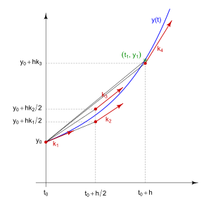The order of the Raunge-Kutta indicates the number of slopes used in the approximation; so higher orders mean higher accuracy of the solution; the wights of the slopes is determined comparing the coefficients with Taylor expansion of the function.[1] anyway, the fourth order Raunge-Kutta is commonly as it gives good accuracy and acceptable computational power.

Initial conditions:

$$u_{0}, v_{0}, w_{0},x_{0}, y_{0}, z_{0}, θ_{0}, φ_{0}, ψ_{0}, p_{0}, q_{0}, r_{0}$$

Inputs:

$$δ_{a}, δ_{e}, δ_{r}, δ_{T}$$

Outputs:

Components of air craft velocity $: u , v , w$

Position: $x , y , z$

Euler angles: $θ , φ , ψ$

Angular velocity components: $p , q , r$

[1] for more details regarding the derivation of Raunge-Kutta method use the following link

<https://www.math.hkust.edu.hk/~machas/numerical-methods-for-engineers.pdf?fbclid=IwAR1mOjc35AS3QV_ZuL0Z_nV8Ph3nCop4FlsaS_ueBMz31whmOBPh9LJ2GlM>

### The general solution of 4th order Runge-Kutta method

$$k_{1}=Δtf\left(t_{n},x_{n}\right)$$

$$k_{2}=Δtf\left(t_{n}+\frac{1}{2}Δt,x_{n}+\frac{1}{2}k_{1}\right)$$

$$k_{3}=Δtf\left(t_{n}+\frac{1}{2}Δt,x_{n}+\frac{1}{2}k_{2}\right)$$

$$k_{4}=Δtf\left(t_{n}+Δt,x_{n}+k_{3}\right)$$

$$x_{n+1}=x_{n}+\frac{1}{6}\left(k_{1}+2k_{2}+2k_{3}+k_{4}\right)$$

For the following system of ODEs

$$\begin{aligned}f=\frac{dy_{1}}{dt}=sin⁡(t)+cos⁡\left(y_{1}\right)+sin⁡\left(y_{2}\right) \\ g=\frac{dy_{2}}{dt}=cos⁡(t)+sin⁡\left(y_{2}\right)\end{aligned}$$

IC $@t=0, y_{1}=0, y_{2}=0$ $t_{f}=20 sec$ $n=100$ $h=\frac{Δt}{n}$

|  |  |
| --- | --- |
| $$K_{1}=hf\left(t_{n},y_{n}^{1},y_{n}^{2}\right)$$ | $$q_{1}=hg\left(t_{n},y_{n}^{1},y_{n}^{2}\right)$$ |
| $$K_{2}=hf\left(t_{n}+\frac{1}{2}h,y_{n}^{1}+\frac{1}{2}K_{1},y_{n}^{2}+\frac{1}{2}q_{1}\right)$$ | $$q_{2}=hg\left(t_{n}+\frac{1}{2}h,y_{n}^{1}+\frac{1}{2}K_{1},y_{n}^{2}+\frac{1}{2}q_{1}\right)$$ |
| $$K_{3}=hf\left(t_{n}+\frac{1}{2}h,y_{n}^{1}+\frac{1}{2}K_{2},y_{n}^{2}+\frac{1}{2}q_{2}\right)$$ | $$q_{3}=hg\left(t_{n}+\frac{1}{2}h,y_{n}^{1}+\frac{1}{2}K_{2},y_{n}^{2}+\frac{1}{2}q_{2}\right)$$ |
| $$K_{4}=hf\left(t_{n}+h,y_{n}^{1}+K_{3},y_{n}^{2}+q_{3}\right)$$ | $$q_{4}=hg\left(t_{n}+h,y_{n}^{1}+K_{3},y_{n}^{2}+q_{3}\right)$$ |



$$y_{n+1}^{1}=y_{n}^{1}+\frac{1}{6}\left(q_{1}+2q_{2}+2q_{3}+q_{4}\right)$$

$$y_{n+1}^{2}=y_{n}^{2}+\frac{1}{6}\left(k_{1}+2k_{2}+2k_{3}+k_{4}\right)$$

# Task (2)

RBD Equations Solver

In this task we aim to solve the 12 rigid body equations of dynamics equations that we were derived in task1, the solver is built basically to compare the results of solution from 3 sources (our code, ODE45 and Simulink).  
  
We will start by reviewing the 12 equations and the data given in this task, then we will show the figures and the code.

RBD Equations in a vector form

Kinetics

|  |  |  |
| --- | --- | --- |
| $$F_{x}=m(\dot{u}+qw-rv)$$ $$F_{y}=m(\dot{v}+ru-pw)$$ $$F_{z}=m\left(\dot{w}+pv-qu\right)$$ | | $$\left[\begin{matrix}F_{x} \\ F_{y} \\ F_{z}\end{matrix}\right]=m \left(\left[\begin{matrix}\dot{u} \\ \dot{v} \\ \dot{w}\end{matrix}\right]+\left[\begin{matrix}p \\ q \\ r\end{matrix}\right]×\left[\begin{matrix}u \\ v \\ w\end{matrix}\right]\right)=\left[\begin{matrix}X-mg S_{θ} \\ Y+mg C_{θ} S_{φ} \\ Z+mg C_{θ} C_{φ}\end{matrix}\right]$$ |
| $$L= \dot{H_{x}}+{qH}_{z}-rH_{y}$$ $$M= \dot{H_{y}}+{rH}_{x}-pH_{z}$$ $$N= \dot{H_{z}}+pH_{y}-qH_{x}$$ | $$\left[\begin{matrix}L \\ M \\ N\end{matrix}\right]= I\left[\begin{matrix}\dot{p} \\ \dot{q} \\ \dot{r}\end{matrix}\right]+\left[\begin{matrix}p \\ q \\ r\end{matrix}\right]×I\left[\begin{matrix}p \\ q \\ r\end{matrix}\right]$$ | |

Kinematics

$$\left\{\dot{\begin{aligned}ϕ \\ \dot{\begin{aligned}θ \\ \dot{ψ}\end{aligned}}\end{aligned}}\right\}= \left[\begin{matrix}1 \\ 0 \\ 0\end{matrix} \begin{matrix}Sφ Tθ \\ Cφ \\ {Sφ}/{Cθ}\end{matrix} \begin{matrix}Cφ Tθ \\ -Sφ \\ {Cφ}/{Cθ}\end{matrix}\right]\left\{\begin{aligned}P \\ Q \\ R\end{aligned}\right\}$$

$$\left\{\dot{\begin{aligned}X \\ \dot{\begin{aligned}Y \\ \dot{Z}\end{aligned}}\end{aligned}}\right\}= \left[\begin{matrix}C_{θ}C_{ψ} & S_{ϕ}S_{θ}C_{ψ}-C_{ϕ}S_{ψ} & C_{ϕ}S_{θ}C_{ψ}+S_{ϕ}S_{ψ} \\ C_{θ}S_{ψ} & S_{ϕ}S_{θ}S_{ψ}+C_{ϕ}C_{ψ} & C_{ϕ}S_{θ}S_{ψ}-S_{ϕ}C_{ψ} \\ -S_{θ} & S_{θ}C_{θ} & C_{ϕ}C_{θ}\end{matrix}\right]\left\{\begin{aligned}u \\ v \\ w\end{aligned}\right\}$$

Givens:

$$t_{final}=15 sec , Forces=\left[10 5 9\right] N , Moments=\left[10 20 5\right]N.m$$

$$Mass=15 Kg$$

$$I= \left[\begin{matrix}I_{x} & I_{xy} & I_{xz} \\ I_{yx} & I_{y} & I_{yz} \\ I_{zx} & I_{zy} & I_{z}\end{matrix}\right]= \left[\begin{matrix}1 & -2 & -1 \\ -2 & 5 & -3 \\ -1 & -3 & 0.1\end{matrix}\right]$$

IC’s:

$$\left[u v w, p q r, ϕ θ ψ, x y z\right]=[10, 2, 0;\frac{2π}{ 180},\frac{π}{180} 0; \frac{20π}{180}, \frac{15π}{180}, \frac{30π}{180}; 2, 4, 7]$$

Our solver code has main function called RBDSolver which takes the initial condition given and returns the 12 rates of change of each state, by integrating each one we get the states of the rigid body.

Raunge-Kutta $4^{th} order$ (our code)

First, we need to put our 12 equations in a form suitable for Raunge-kutta method like, $\dot{y}=function(t,x,y,z,…)$

|  |
| --- |
| $$\left[\begin{matrix}\dot{u} \\ \dot{v} \\ \dot{w}\end{matrix}\right]=\left[\begin{matrix}X-mg S_{θ} \\ Y+mg C_{θ} S_{φ} \\ Z+mg C_{θ} C_{φ}\end{matrix}\right]/m-\left(\left[\begin{matrix}p \\ q \\ r\end{matrix}\right]×\left[\begin{matrix}u \\ v \\ w\end{matrix}\right]\right)$$ |
| $$\left[\begin{matrix}\dot{p} \\ \dot{q} \\ \dot{r}\end{matrix}\right]= I^{-1}\left(\left[\begin{matrix}L \\ M \\ N\end{matrix}\right]-\left(\left[\begin{matrix}p \\ q \\ r\end{matrix}\right]×I\left[\begin{matrix}p \\ q \\ r\end{matrix}\right]\right)\right)$$ |

Validation with Simulink and ODE45

we validated our results by using Simulink (here) and ODE45 (appendix (task 2))

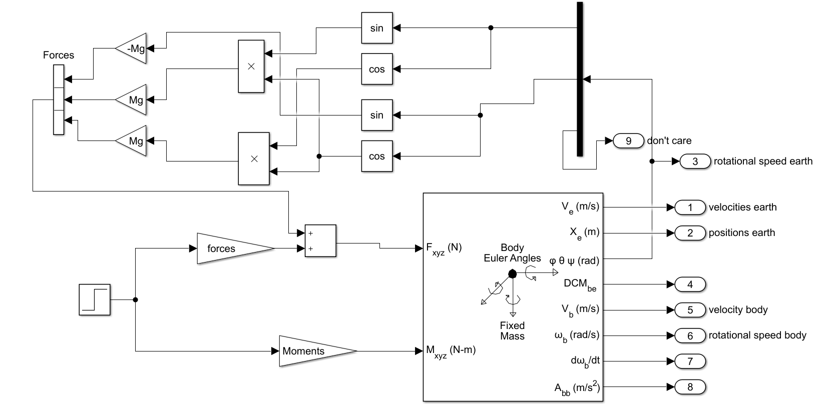

Results

velocity with respect to body Axes:

|  |
| --- |
|  |

Rotational speed W.r.t body axes

|  |
| --- |
|  |

Rotational speed w.r.t Earth Axes

|  |
| --- |
|  |

Position w.r.t Earth Axes

|  |
| --- |
|  |

# Task (3)

Introduction

In this task we are concerned about calculating the change in states due to change in control surfaces at certain aircraft data.

We will build an airframe model code that takes the control surfaces deflection values

$$δ_{aileron},δ_{thrust},δ_{rudder},δ_{elevator}$$

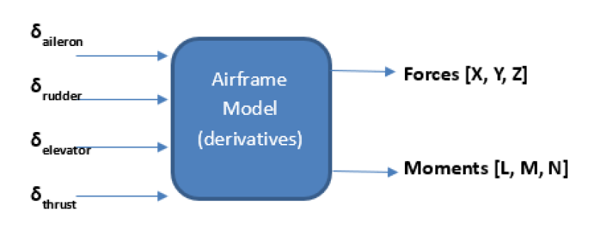

We will combine the airframe model code with the RBD solver code that we made to make a nonlinear simulator

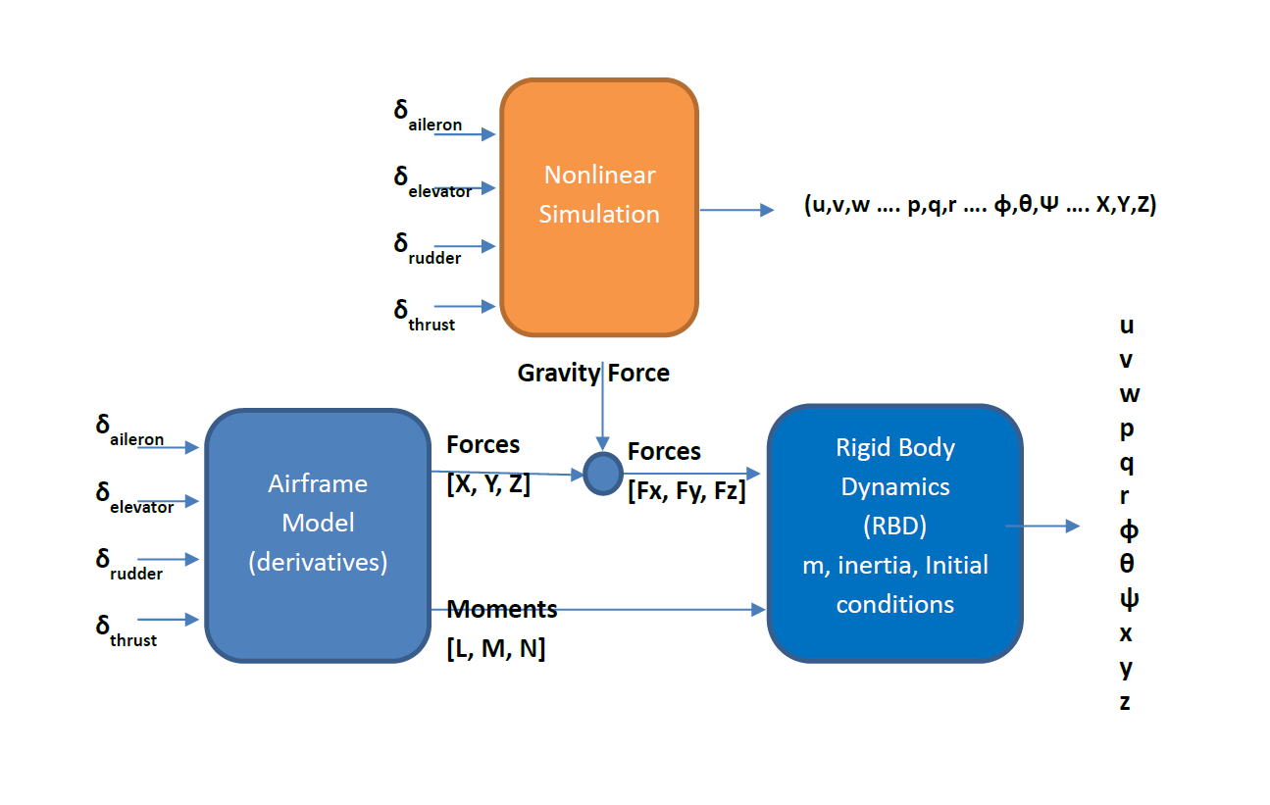

Equations representing the change in the Aerodynamic & thrust forces & moments:

$$∆X=m \left(\frac{∂X}{∂u} ∆u+\frac{∂X}{∂w} ∆w+ \frac{∂X}{∂δ_{e}} ∆δ_{e}+ \frac{∂X}{∂δ_{T}} ∆δ_{T}\right)$$

$$∆Y=m \left(\frac{∂Y}{∂v} ∆v+\frac{∂Y}{∂β} ∆β+ \frac{∂Y}{∂δ_{a}} ∆δ_{a}+ \frac{∂Y}{∂δ_{r}} ∆δ_{r}\right)$$

$$∆Z=m \left(\frac{∂Z}{∂u} ∆u+\frac{∂Z}{∂w} ∆w+ \frac{∂Z}{∂\dot{w}} ∆\dot{w}+\frac{∂Z}{∂q} ∆q+ \frac{∂Z}{∂δ_{e}} ∆δ_{e}+ \frac{∂Z}{∂δ_{T}} ∆δ_{T}\right)$$

$$∆L=I_{xx} \left(\frac{∂L}{∂β} ∆β+\frac{∂L}{∂p} ∆p+\frac{∂L}{∂r} ∆r+ \frac{∂L}{∂δ_{r}} ∆δ_{r}+ \frac{∂L}{∂δ_{a}} ∆δ_{a}\right)$$

$$∆M=I_{yy} \left(\frac{∂M}{∂u} ∆u+\frac{∂M}{∂w} ∆w+ \frac{∂M}{∂\dot{w}} ∆\dot{w}+\frac{∂M}{∂q} ∆q+ \frac{∂M}{∂δ_{e}} ∆δ_{e}+ \frac{∂M}{∂δ_{T}} ∆δ_{T}\right)$$

$$∆N=I_{zz} \left(\frac{∂N}{∂β} ∆β+\frac{∂N}{∂p} ∆p+\frac{∂N}{∂r} ∆r+ \frac{∂N}{∂δ_{r}} ∆δ_{r}+ \frac{∂N}{∂δ_{a}} ∆δ_{a}\right)$$

Axes systems

There are three types of body axes

* Principle axes ($I_{xy}=0)$
* Stability Axes ($w_{0}=0),X_{b} axis$ concides with $V_{T}$
* Body axes (fuselage reference axis)

we will transform from stability axes derivatives to body axes   


Benchmark test plots B-747 airplane

For No input





For +ve 5-degree aileron





For -ve 5-degree aileron





For +ve 5-degree rudder





For -ve 5-degree rudder





For +ve 5-degree elevator





For -ve 5-degree elevator





For 1000 in thrust





For 10000 in thrust





Our airplane Plots (NT-33A)

For No input





For +ve 5-degree aileron





For -ve 5-degree aileron





For +ve 5-degree rudder





For -ve 5-degree rudder





For +ve 5-degree elevator





For -ve 5-degree elevator





For 1000 in thrust





For 10000 in thrust





# Task (4)

a) Linearization of 12 EOM for a fixed wing A/C

EOM linearization:

EOM

|  |  |
| --- | --- |
| EOM | Airframe derivatives |
|  |  |
|  |  |
|  |  |

|  |  |
| --- | --- |
| EOM | Airframe derivatives |
| $$L=I_{x}\dot{p}-I_{xz}\dot{r}+qr\left(I_{z}-I_{y}\right)-I_{xz}pq$$ | $${∆L}/{I_{xx}}= L_{β} ∆β+L_{p} ∆p+L_{r} ∆r+ L_{δ_{r}} ∆δ_{r}+L_{δ_{a}} ∆δ_{a}$$ |
| $$M=I_{y}\dot{q}+rp\left(I_{x}-I_{z}\right)-I_{xz}\left(p^{2}-r^{2}\right)$$ | $${∆M}/{I_{yy}}=M_{u} ∆u+M_{w} ∆w+ M_{\dot{w}} ∆\dot{w}+M_{q} ∆q+ M_{δ_{e}} ∆δ_{e}+M_{δ_{th}} ∆δ_{th}$$ |
| $$N={-I}_{xz}\dot{p}+I_{z}\dot{r}+pq\left(I_{y}-I_{x}\right)+I_{xz}qr$$ | $${∆N}/{I_{zz}}=N_{β} ∆β+N_{p} ∆p+N_{r} ∆r+ N_{δ_{r}} ∆δ_{r}+N_{δ_{a}} ∆δ_{a}$$ |

$$\dot{φ}=p+q S_{φ} T_{θ}+r C_{φ} T_{θ}$$

$$\dot{θ}=q C_{φ}-r S_{φ}$$

$$\dot{ψ}=\left(q S_{φ}+r C_{φ}\right) \sec\left(θ\right)$$

$$\left[\begin{aligned}\dot{x} \\ \dot{y} \\ \dot{z}\end{aligned}\right]=\left[\begin{matrix}C_{θ}C_{ψ} & S_{φ}S_{θ}C_{ψ}-C_{φ}S_{ψ} & C_{ψ}S_{θ}C_{ψ}+S_{φ}S_{ψ} \\ C_{θ}S_{ψ} & S_{φ}S_{θ}S_{ψ}+C_{φ}C_{ψ} & C_{φ}S_{θ}S_{ψ}-S_{φ}C_{ψ} \\ {-S}_{θ} & S_{φ}C_{θ} & C_{φ}C_{θ}\end{matrix}\right]\left[\begin{matrix}u \\ v \\ w\end{matrix}\right]$$

Let:($A=A_{o}+∆A$)

|  |  |  |  |  |
| --- | --- | --- | --- | --- |
| $$u=u_{o}+∆u$$ | $$p=p_{o}+∆p$$ | $$X=X_{o}+∆X$$ | $$L=L_{o}+∆L$$ | $$φ=φ_{o}+∆φ$$ |
| $$v=v_{o}+∆v$$ | $$q=q_{o}+∆q$$ | $$Y=Y_{o}+∆Y$$ | $$M=M_{o}+∆M$$ | $$θ=θ_{o}+∆θ$$ |
| $$w=w_{o}+∆w$$ | $$r=r_{o}+∆r$$ | $$Y=Y_{o}+∆Y$$ | $$N=N_{o}+∆N$$ | $$ψ=ψ_{o}+∆ψ$$ |

And $v_{o}=p_{o}=q_{o}=r_{o}=φ_{o}=ψ_{o}=0$ but $u_{o},w_{o},θ_{o}≠0$ for Cruise condition.

Longitudinal calculations:



$X-mg Sin\left(θ\right) =m(\dot{u}+qw-rv)$

$i$. Recast each variable in terms of a steady-state value and a perturbed value.

$$X_{o}+∆X-mg Sin\left(θ_{o}+∆θ\right) =m({\dot{u}}_{o}+∆\dot{u}+\left(q_{o}+∆q\right)\left(w_{o}+∆w\right)-\left(r_{o}+∆r\right)\left(v_{o}+∆v\right))$$

$$\sin\left(a+b\right)=\sin\left(a\right)\cos\left(b\right)+\sin\left(b\right)\cos\left(a\right)$$

$$X_{o}+∆X-mg \left(\sin\left(θ_{o}\right)\cos\left(∆θ\right)+\sin\left(∆θ\right)\cos\left(θ_{o}\right)\right)=m\left(∆\dot{u}+\left(∆q\right)\left(w_{o}+∆w\right)-\left(∆r\right)\left(∆v\right)\right)$$

$ii.$ Apply the small-angle assumption to trig functions of perturbed angles

$$\sin\left(a→0\right)=a , \cos\left(a→0\right)=1$$

$$X_{o}+∆X-mg \sin\left(θ_{o}\right)-mg \cos\left(θ_{o}\right)∆θ=m\left(∆\dot{u}+∆q*w_{o}+∆q*∆w-∆r*∆v\right)$$

$iii.$ Assume products of small perturbations are negligible.

$$X_{o}+∆X-mg \sin\left(θ_{o}\right)-mg \cos\left(θ_{o}\right)∆θ=m\left(∆\dot{u}+∆q*w_{o}\right)$$

$iv.$ Remove the steady-state equation from the perturbed equation.

$$∴∆X-mg \cos\left(θ_{o}\right)∆θ=m\left(∆\dot{u}+∆q*w_{o}\right)$$

$$∴∆\dot{u}=\frac{∆X}{m}-g \cos\left(θ_{o}\right)∆θ-∆q*w_{o} , \frac{∆X}{m}= X_{u} ∆u+X_{w} ∆w+ X_{δ_{e}} ∆δ_{e}+ X_{δ_{th}} ∆δ_{th}$$

$$∴∆\dot{u}=X_{u} ∆u+X_{w} ∆w+ X_{δ_{e}} ∆δ_{e}+ X_{δ_{th}} ∆δ_{th}-g \cos\left(θ_{o}\right)∆θ-∆q*w_{o}$$

$Z+mg Cos\left(θ\right)*Cos\left(φ\right) =m\left(\dot{w}+pv-qu\right)$

Same as (a)

$$\cos\left(a+b\right)=\cos\left(a\right)\cos\left(b\right)-sin\left(a\right)\sin\left(b\right)$$

$$∴\left(1-Z_{\dot{w}}\right)∆\dot{w}=Z_{u} ∆u+Z_{w} ∆w+{(Z}_{q}+u_{o}) ∆q+ Z_{δ_{e}} ∆δ_{e}+ Z_{δ_{th}} ∆δ_{th}-g \sin\left(θ_{o}\right)∆θ$$

$$∴∆\dot{w}=\frac{Z_{u}}{\left(1-Z_{\dot{w}}\right)} ∆u+\frac{Z_{w}}{\left(1-Z_{\dot{w}}\right)} ∆w+\frac{(Z_{q}+u_{o}) }{\left(1-Z_{\dot{w}}\right)} ∆q+\frac{Z_{δ_{e}}}{\left(1-Z_{\dot{w}}\right)} ∆δ_{e}+\frac{Z_{δ_{th}}}{\left(1-Z_{\dot{w}}\right)} ∆δ_{th}-\frac{g \sin\left(θ_{o}\right)}{\left(1-Z_{\dot{w}}\right)}∆θ$$

$M=I_{y}\dot{q}+rp\left(I_{x}-I_{z}\right)-I_{xz}\left(p^{2}-r^{2}\right)$

$$∴∆\dot{q}=M_{u} ∆u+M_{w} ∆w+ M_{\dot{w}}* \left(\frac{Z_{u}}{\left(1-Z_{\dot{w}}\right)} ∆u+\frac{Z_{w}}{\left(1-Z_{\dot{w}}\right)} ∆w+\frac{\left(Z_{q}+u_{o}\right)}{\left(1-Z_{\dot{w}}\right)} ∆q+\frac{Z_{δ_{e}}}{\left(1-Z_{\dot{w}}\right)} ∆δ_{e}+\frac{Z_{δ_{th}}}{\left(1-Z_{\dot{w}}\right)} ∆δ_{th}-\frac{g \sin\left(θ_{o}\right)}{\left(1-Z_{\dot{w}}\right)}∆θ\right)+M_{q} ∆q+ M_{δ_{e}} ∆δ_{e}+M_{δ_{th}} ∆δ_{th}$$

$$∴∆\dot{q}=\left(M_{u}+ M_{\dot{w}}\frac{Z_{u}}{\left(1-Z_{\dot{w}}\right)} \right) ∆u+\left(M_{w}+ M_{\dot{w}}\frac{Z_{w}}{\left(1-Z_{\dot{w}}\right)}\right) ∆w+\left(M_{q}+ M_{\dot{w}}\frac{\left(Z_{q}+u_{o}\right)}{\left(1-Z_{\dot{w}}\right)}\right) ∆q+\left(M_{δ_{e}}+ M_{\dot{w}}\frac{Z_{δ_{e}}}{\left(1-Z_{\dot{w}}\right)}\right) ∆δ_{e}+\left(M_{δ_{th}}+ M_{\dot{w}}\frac{Z_{δ_{th}}}{\left(1-Z_{\dot{w}}\right)}\right) ∆δ_{th}- M_{\dot{w}}*\frac{g \sin\left(θ_{o}\right)}{\left(1-Z_{\dot{w}}\right)}∆θ$$

$\dot{θ}=q C_{φ}-r S_{φ}$

$$∴∆\dot{θ}=∆q$$

Lateral calculations:

$Y+mg C_{θ} S_{φ}=m\left(\dot{v}+ru-pw\right)$

$$∆\dot{v}=Y_{β} ∆β+Y_{r} ∆r+Y_{p} ∆p+ Y_{δa} ∆δ_{a}+ Y_{δ_{r}} ∆δ_{r}+g \cos\left(θ_{o}\right)∆∅-∆r*u_{o}+w_{o}*∆p$$

$$∆\dot{β}=\frac{∆\dot{v}}{V_{to}}$$

$$∴∆\dot{β}=\frac{Y_{β}}{V_{to}} ∆β+\frac{Y_{r}-u_{o}}{V_{to}} ∆r+\frac{Y_{p}+w_{o}}{V_{to}} ∆p+\frac{Y_{δa}}{V_{to}} ∆δ_{a}+\frac{Y_{δ_{r}}}{V_{to}} ∆δ_{r}+\frac{g}{V_{to}} \cos\left(θ_{o}\right)∆φ$$

$L=I_{x}\dot{p}-I_{xz}\dot{r}+qr\left(I_{z}-I_{y}\right)-I_{xz}pq$

$$eq\left(1\right): ∆\dot{p}-\frac{I_{xz}}{I_{x}}*∆\dot{r}=\frac{∆L}{I_{x}}=L_{β} ∆β+L_{p} ∆p+L_{r} ∆r+ L_{δ_{r}} ∆δ_{r}+L_{δ_{a}} ∆δ_{a}$$

$N={-I}_{xz}\dot{p}+I_{z}\dot{r}+pq\left(I_{y}-I_{x}\right)+I_{xz}qr$

$$eq\left(2\right): ∆\dot{r}-\frac{I_{xz}}{I_{z}}*∆\dot{p}=\frac{∆N}{I_{z}}=N_{β} ∆β+N_{p} ∆p+N_{r} ∆r+ N_{δ_{r}} ∆δ_{r}+N_{δ_{a}} ∆δ_{a}$$

$$Solve eq\left(1\right) and eq\left(2\right) in \left(\begin{matrix}∆\dot{r} & ∆\dot{p}\end{matrix}\right) we get:$$

$$∴∆\dot{p}=\left(\frac{∆L}{I_{x}}+\frac{I_{xz}}{I_{x}}*\frac{∆N}{I_{z}}\right)*G , where G=\frac{I_{x}I_{z}}{I_{x}I_{z}-{\left(I_{xz}\right)}^{2}}$$

$$∴∆\dot{r}=\left(\frac{I_{xz}}{I_{z}}*\frac{∆L}{I_{x}}+\frac{∆N}{I_{z}}\right)*G , where G=\frac{I_{x}I_{z}}{I_{x}I_{z}-{\left(I_{xz}\right)}^{2}}$$

$$\frac{∆L}{I_{x}}=\sum{L_{i} ∆i} , \frac{∆N}{I_{z}}=\sum{N_{i} ∆i}$$

$$∴∆\dot{p}=\sum{G*\left(L_{i}+\frac{I_{xz}}{I_{x}}*N_{i}\right)∆i=}\sum{L_{i}^{*} ∆i}=L_{β}^{*} ∆β+L_{p}^{*} ∆p+L_{r}^{*} ∆r+ L_{δ_{r}}^{*} ∆δ_{r}+L_{δ_{a}}^{*} ∆δ_{a}$$

$$∴∆\dot{r}=\sum{G*\left(N_{i}+\frac{I_{xz}}{I_{z}}*L_{i}\right)∆i=}\sum{N_{i}^{*} ∆i}=N_{β}^{*} ∆β+N_{p}^{*} ∆p+N_{r}^{*} ∆r+ N_{δ_{r}}^{*} ∆δ_{r}+N_{δ_{a}}^{*} ∆δ_{a}$$

$\dot{φ}=p+q Sin\left(φ\right) Tan\left(θ\right)+r Cos\left(φ\right) Tan\left(θ\right)$

$$\dot{φ}\cos\left(θ\right)=p\cos\left(θ\right)+q Sin\left(φ\right) sin\left(θ\right)+r Cos\left(φ\right) sin\left(θ\right)$$

$$∴∆\dot{φ}=∆p+ ∆r*\tan\left(θ_{0}\right)$$

$\dot{ψ}=\left(q S_{φ}+r C_{φ}\right) \sec\left(θ\right)$

$$∴∆\dot{ψ}=∆r*\sec\left(θ_{0}\right)$$

State space Model:

*Longitudinal*

$∆\dot{u}=X_{u} ∆u+X_{w} ∆w+ X_{δ_{e}} ∆δ_{e}+ X_{δ_{th}} ∆δ_{th}-g \cos\left(θ_{o}\right)∆θ-∆q*w_{o}$

$∴∆\dot{w}=\frac{Z_{u}}{\left(1-Z_{\dot{w}}\right)} ∆u+\frac{Z_{w}}{\left(1-Z_{\dot{w}}\right)} ∆w+\frac{\left(Z_{q}+u_{o}\right)}{\left(1-Z_{\dot{w}}\right)} ∆q+\frac{Z_{δ_{e}}}{\left(1-Z_{\dot{w}}\right)} ∆δ_{e}+\frac{Z_{δ_{th}}}{\left(1-Z_{\dot{w}}\right)} ∆δ_{th}-\frac{g \sin\left(θ_{o}\right)}{\left(1-Z_{\dot{w}}\right)}∆θ$

$∴∆\dot{q}=\left(M_{u}+ M_{\dot{w}}\frac{Z_{u}}{\left(1-Z_{\dot{w}}\right)} \right) ∆u+\left(M_{w}+ M_{\dot{w}}\frac{Z_{w}}{\left(1-Z_{\dot{w}}\right)}\right) ∆w+\left(M_{q}+ M_{\dot{w}}\frac{\left(Z_{q}+u_{o}\right)}{\left(1-Z_{\dot{w}}\right)}\right) ∆q+\left(M_{δ_{e}}+ M_{\dot{w}}\frac{Z_{δ_{e}}}{\left(1-Z_{\dot{w}}\right)}\right) ∆δ_{e}+\left(M_{δ_{th}}+ M_{\dot{w}}\frac{Z_{δ_{th}}}{\left(1-Z_{\dot{w}}\right)}\right) ∆δ_{th}- M_{\dot{w}}*\frac{g \sin\left(θ_{o}\right)}{\left(1-Z_{\dot{w}}\right)}∆θ$

$∴∆\dot{θ}=∆q$

$$\left[\begin{aligned}Δ\dot{u} \\ Δ\dot{w} \\ Δ\dot{q} \\ Δ\dot{θ}\end{aligned}\right]=\left[\begin{matrix}X_{u} & X_{w} & -w_{o} & -g \cos\left(θ_{o}\right) \\ \frac{Z_{u}}{\left(1-Z_{\dot{w}}\right)} & \frac{Z_{w}}{\left(1-Z_{\dot{w}}\right)} & \frac{\left(Z_{q}+u_{o}\right)}{\left(1-Z_{\dot{w}}\right)} & \frac{-g \sin\left(θ_{o}\right)}{\left(1-Z_{\dot{w}}\right)} \\ M_{u}+ M_{\dot{w}}\frac{Z_{u}}{\left(1-Z_{\dot{w}}\right)} & M_{w}+ M_{\dot{w}}\frac{Z_{w}}{\left(1-Z_{\dot{w}}\right)} & M_{q}+ M_{\dot{w}}\frac{\left(Z_{q}+u_{o}\right)}{\left(1-Z_{\dot{w}}\right)} & - M_{\dot{w}}*\frac{g \sin\left(θ_{o}\right)}{\left(1-Z_{\dot{w}}\right)} \\ 0 & 0 & 1 & 0\end{matrix}\right]\left[\begin{aligned}Δu \\ Δw \\ Δq \\ Δθ\end{aligned}\right]+\left[\begin{matrix}X_{δ_{e}} & X_{δ_{th}} \\ \frac{Z_{δ_{e}}}{\left(1-Z_{\dot{w}}\right)} & \frac{Z_{δ_{th}}}{\left(1-Z_{\dot{w}}\right)} \\ M_{δ_{e}}+ M_{\dot{w}}\frac{Z_{δ_{e}}}{\left(1-Z_{\dot{w}}\right)} & M_{δ_{th}}+ M_{\dot{w}}\frac{Z_{δ_{th}}}{\left(1-Z_{\dot{w}}\right)} \\ 0 & 0\end{matrix}\right]\left[\begin{aligned}∆δ_{e} \\ ∆δ_{th}\end{aligned}\right]$$

*Lateral*

$∴∆\dot{β}=\frac{Y_{β}}{V_{to}} ∆β+\frac{Y_{r}-u_{o}}{V_{to}} ∆r+\frac{Y_{p}+w_{o}}{V_{to}} ∆p+\frac{Y_{δa}}{V_{to}} ∆δ_{a}+\frac{Y_{δ_{r}}}{V_{to}} ∆δ_{r}+\frac{g}{V_{to}} \cos\left(θ_{o}\right)∆φ$

$∴∆\dot{p}=\sum{G*\left(L_{i}+\frac{I_{xz}}{I_{x}}*N_{i}\right)∆i=}\sum{L_{i}^{*} ∆i}=L_{β}^{*} ∆β+L_{p}^{*} ∆p+L_{r}^{*} ∆r+ L_{δ_{r}}^{*} ∆δ_{r}+L_{δ_{a}}^{*} ∆δ_{a}$

$∴∆\dot{r}=\sum{G*\left(N_{i}+\frac{I_{xz}}{I_{z}}*L_{i}\right)∆i=}\sum{N_{i}^{*} ∆i}=N_{β}^{*} ∆β+N_{p}^{*} ∆p+N_{r}^{*} ∆r+ N_{δ_{r}}^{*} ∆δ_{r}+N_{δ_{a}}^{*} ∆δ_{a}$

$∴∆\dot{φ}=∆p+ ∆r*\tan\left(θ_{0}\right)$

$∴∆\dot{ψ}=∆r*\sec\left(θ_{0}\right)$

$$\left[\begin{aligned}Δ\dot{β} \\ Δ\dot{p} \\ Δ\dot{r} \\ Δ\dot{φ} \\ Δ\dot{ψ}\end{aligned}\right]=\left[\begin{matrix}\frac{Y_{β}}{V_{to}} & \frac{Y_{p}+w_{o}}{V_{to}} & \frac{Y_{r}-u_{o}}{V_{to}} & \frac{g\cos\left(θ_{o}\right)}{V_{to}} & 0 \\ L_{β}^{*} & L_{p}^{*} & L_{r}^{*} & 0 & 0 \\ N_{β}^{*} & N_{p}^{*} & N_{r}^{*} & 0 & 0 \\ 0 & 1 & \tan\left(θ_{0}\right) & 0 & 0 \\ 0 & 0 & \sec\left(θ_{0}\right) & 0 & 0\end{matrix}\right]\left[\begin{aligned}Δβ \\ Δp \\ Δr \\ Δφ \\ Δψ\end{aligned}\right]+\left[\begin{matrix}\frac{Y_{δa}}{V_{to}} & \frac{Y_{δ_{r}}}{V_{to}} \\ L_{δ_{a}}^{*} & L_{δ_{r}}^{*} \\ ∆δ_{a} & N_{δ_{r}}^{*} \\ 0 & 0 \\ 0 & 0\end{matrix}\right]\left[\begin{aligned} ∆δ_{a} \\ ∆δ_{r}\end{aligned}\right]$$

b) (1) Longitudinal dynamics approximations

The longitudinal dynamics of the aircraft refer to dynamics in the x-z plane in the longitudinal axis   
there are two types of approximations for that system of equations

1. Long period approximation (mode)
2. Short period approximation (mode)



By solving the A matrix from part, a we get 2 pairs of conjugate roots the pair which has small real part has big settling time according to $T_{s}=\frac{4}{ζω_{n}}$  
on the other hand with the pair which has bigger real part

Long period approximation (mode)

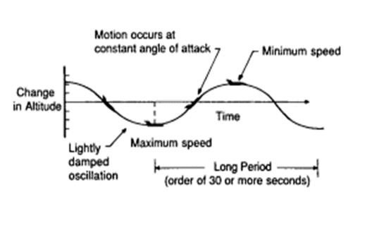

When the aircraft is exposed to some disturbances in the longitudinal direction a change in the altitude is formed due to this disturbance assuming that the angle of attack is constant the approximation to the long period mode is obtained by neglecting the pitching moment equation and assuming that the changes in angle of attack is zero.

$△α=0 Δ\dot{w}=0$ $$△α=\frac{∆w}{U_{o}} Δ\dot{q}= 0$$

$$\left[\begin{aligned}\dot{u} \\ \dot{θ}\end{aligned}\right]=\left[\begin{aligned}\begin{aligned}{ X}_{u}+\frac{w_{o}Z_{u}}{Z_{q}+u_{o}} -g\cos\left(θ_{o}\right)-\frac{w_{o}gsin(θ_{o})}{Z_{q}+u_{o}}\end{aligned} \\ \frac{-Z_{u}}{Z_{q}+u_{o}} \frac{gsin\left(θ_{o}\right)}{Z_{q}+u_{o}} \end{aligned}\right]\left[\begin{aligned}u \\ θ\end{aligned}\right]+\left[\begin{aligned}{ X}_{δ_{e}}+\frac{w_{o}Z_{δ_{e}}}{Z_{q}+u_{o}} { X}_{δ_{th}}+\frac{w_{o}Z_{δ_{th}}}{Z_{q}+u_{o}} \\ \frac{-Z_{δ_{e}}}{Z_{q}+u_{o}} \frac{-Z_{δ_{th}}}{Z_{q}+u_{o}} \end{aligned}\right]\left[\begin{aligned} ∆δ_{e} \\ ∆δ_{th}\end{aligned}\right]$$

short period approximation (mode)

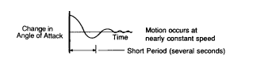

The same definition which we applied in the previous mode we will use here but with taking in consideration that the disturbance will damp quickly and but there will be a change in angle of attack and neglecting the change in velocity.

$$Δu=0 \\ Δ\dot{θ}=0$$

$$M_{α}=\frac{1}{I_{y}}*\frac{∂M}{∂α}=\frac{1}{I_{y}}*\frac{∂M}{∂\left(\frac{∆w}{u_{o}}\right)}=\frac{u_{o}}{I_{y}}*\frac{∂M}{∂w}=u_{o}M_{w}$$

$$Z_{∝}=u_{o}Z_{w}$$

$$M_{\dot{α}}=u_{o}M_{\dot{w}}$$

$$\left[\begin{aligned}\dot{α} \\ \dot{q}\end{aligned}\right]=\left[\begin{aligned}\frac{Z_{α}}{u_{o}} 1 \\ M_{α}+\frac{{M_{\dot{α}} Z}_{α}}{u_{o}} M_{q}+M_{\dot{α}}\end{aligned}\right]\left[\begin{aligned}α \\ q\end{aligned}\right]+\left[\begin{aligned}Z_{δ_{e}} Z_{δ_{th}} \\ M_{δ_{e}}+\frac{{M_{α} Z}_{δ_{e}}}{u_{o}} M_{\dot{α}}+\frac{{M_{α} Z}_{δ_{th}}}{u_{o}}\end{aligned}\right]\left[\begin{aligned} ∆δ_{e} \\ ∆δ_{th}\end{aligned}\right]$$

and by solving the characteristic equation of the system and getting its Eigen values we finally reach that;

$$w_{n}=\sqrt{(M_{q}\frac{Z_{α}}{u_{o}}}-M_{α})$$

$$ζ=\frac{\frac{Z_{α}}{u_{o}}+M_{q}+M_{\dot{α}}}{-2w_{n}}$$

b) (2) Lateral dynamics approximations

3-DOF spiral mode

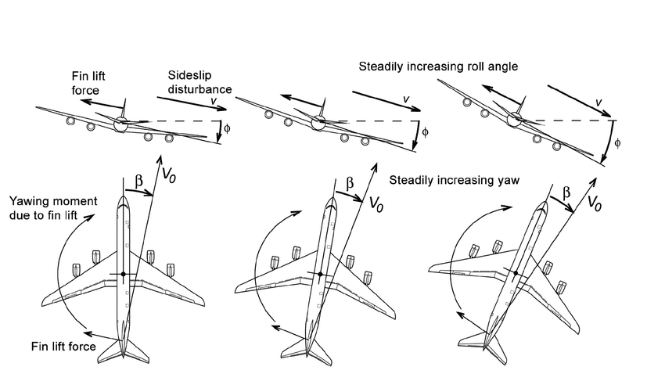

As it is clear in the attached figure how does the airplane behave when it is in the spiral mode.

The side force equation of motion will be neglected and will put $∆β=0$.

Therefore, the 3 DOF spiral approximation will be as shown in the following:

$$\left[\begin{aligned}Δ\dot{p} \\ Δ\dot{r} \\ Δ\dot{φ}\end{aligned}\right]=\left[\begin{matrix}\grave{L_{p}} & \grave{L_{r}} & 0 \\ \grave{N_{p}} & \grave{N_{r}} & 0 \\ 1 & \tan\left(θ_{o}\right) & 0\end{matrix}\right]\left[\begin{aligned}Δp \\ Δr \\ Δφ\end{aligned}\right]+\left[\begin{aligned}\acute{{ L}_{δ_{r}}} \\ \acute{{ N}_{δ_{r}}} \\ 0 \end{aligned}\right]\left[\begin{aligned} ∆δ_{r}\end{aligned}\right]$$

2-DOF Dutch-Roll mode

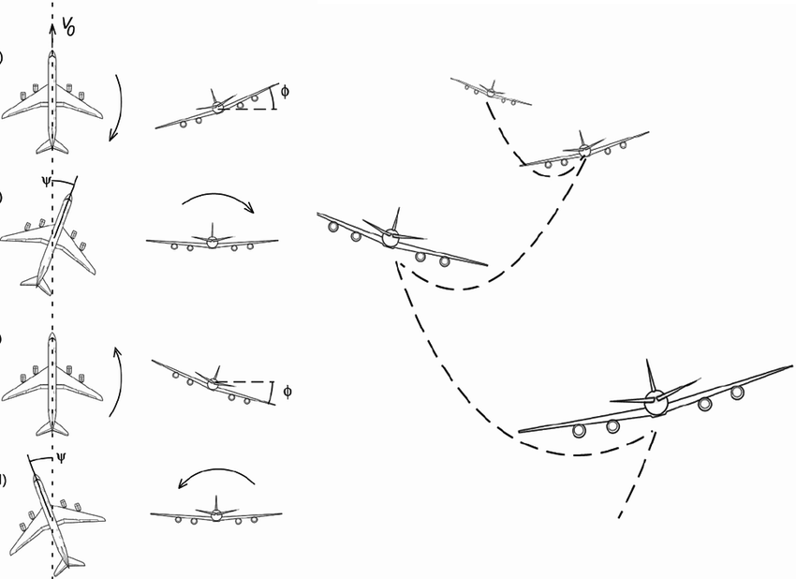

The combination of the roll and yaw approximations is called the Dutch roll Motion.

In this equation the rolling moment equation is neglected and we put $∆φ=0$.

Therefore, the 2 DOF spiral approximation will be as shown in the following:

$$\left[\begin{aligned}Δ\dot{β} \\ Δ\dot{r}\end{aligned}\right]=\left[\begin{aligned}Y_{v} \frac{Y_{r}-1}{V_{to}} \\ \grave{N_{β}} \grave{N_{r}} \end{aligned}\right]\left[\begin{aligned}Δβ \\ Δr\end{aligned}\right]+\left[\begin{aligned}{{ Y}_{δ_{a}}}^{*} {{ Y}_{δ_{r}}}^{*} \\ \acute{{ N}_{δ_{a}}} \acute{{ N}_{δ_{r}}}\end{aligned}\right]\left[\begin{aligned} ∆δ_{a} \\ ∆δ_{r}\end{aligned}\right]$$

1-Roll mode

It has been seen that the rolling mode almost corresponds to the pure rolling. Thus it is reasonable to neglect all equations except the rolling moment equation and all perturbations except p. So we will reach the following relation;

$$\dot{P}-L_{p}'p=L_{δa}'δ_{a}$$

c) Results of the longitudinal dynamics

For states

|  |  |
| --- | --- |
|  |  |
|  |  |

|  |  |
| --- | --- |
|  |  |
|  |  |

|  |  |
| --- | --- |
|  |  |
|  |  |

|  |  |
| --- | --- |
|  |  |
|  |  |

|  |  |
| --- | --- |
|  |  |
|  |  |

|  |  |
| --- | --- |
|  |  |
|  |  |

|  |  |
| --- | --- |
|  |  |
|  |  |

d) Results of Step response (lateral Dynamics)

Response due to Aileron ($δ_{a}=1)$

|  |  |
| --- | --- |
|  |  |
|  |  |
|  |  |
|  |  |



Response due to Aileron ($δ_{a}=5)$

|  |  |
| --- | --- |
|  |  |
|  |  |
|  |  |

‘

|  |  |
| --- | --- |
|  |  |
|  |  |

Response due to Rudder ($δ_{a}=10)$

|  |  |
| --- | --- |
|  |  |
|  |  |
|  |  |
|  |  |



Response due to Rudder ($δ_{a}=25)$

|  |  |
| --- | --- |
|  |  |
|  |  |
|  |  |
|  |  |
|  |  |



Response due to Rudder ($δ_{r}=1)$

|  |  |
| --- | --- |
|  |  |
|  |  |
|  |  |
|  |  |



Response due to Rudder ($δ_{r}=5)$

|  |  |
| --- | --- |
|  |  |
|  |  |
|  |  |
|  |  |



Response due to Rudder ($δ_{r}=10)$

|  |  |
| --- | --- |
|  |  |
|  |  |
|  |  |
|  |  |



Response due to Rudder ($δ_{r}=25)$

|  |  |
| --- | --- |
|  |  |
|  |  |
|  |  |
|  |  |



f) Transfer Function graphs (Longitudinal Dynamics)































e) Transfer Function graphs (Lateral Dynamics)



# Task (5)

A. Design Pitch Controller with pitch rate feedback

Long period:



$$ξ=0.3714>0.04$$

Short period



$$0.3<ξ=0.4831<2.0$$

Then the open loop transfer function is

OL\_theta\_thetacom =

527 s^2 + 1848 s + 74.13

---------------------------------------------------------

s^5 + 16.43 s^4 + 108.3 s^3 + 441.9 s^2 + 18.57 s + 1.377

Continuous-time transfer function.

Design control loop with PD and PID:

PD\_tf =

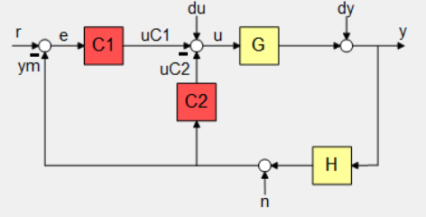 0.085498 s

Name: C2

Continuous-time zero/pole/gain model.

PI\_tf =

0.75333 (s+0.6555)

------------------

s

Name: C1

Continuous-time zero/pole/gain model.

Closed Loop transfer function:

CL\_theta\_thetacom\_tf =

From input "r" to output "y":

397 s^3 + 1653 s^2 + 968.6 s + 36.61

------------------------------------------------------------------

s^6 + 16.43 s^5 + 153.4 s^4 + 996.9 s^3 + 1678 s^2 + 970 s + 36.61

Continuous-time transfer function.

|  |  |
| --- | --- |
| *Figure 1. Response* | *Figure 2. Control Action* |

Control action transfer function:

C\_action\_tf =

From input "r" to output "u":

0.7533 s^6 + 12.87 s^5 + 89.72 s^4 + 386.4 s^3 + 232.2 s^2 + 10.21 s + 0.6802

-----------------------------------------------------------------------------

s^6 + 16.43 s^5 + 153.4 s^4 + 996.9 s^3 + 1678 s^2 + 970 s + 36.61

Continuous-time transfer function.

B. Testing Pitch Controller on the Full State Space Model

Simulink Simulation

|  |
| --- |
| *Figure 3. Simulink - Pitch Controller check* |
| *Figure 4. Simulink - Gamma & Altitude* |

Results

*Command of 15-degree pitch angle*

|  |
| --- |
| *Figure 5. Theta response with Theta Command* |
| *Figure 6. Control Action* |

C. Necessity of velocity control

when we input positive pitch angle, the action depends on the thrust if the thrust is big enough to climb upward the airplane will climb upward if the thrust is not enough the airplane would dive downward but logically, when the pilot input a positive pitch the airplane should climb upward.

$$∵γ=θ-α$$

$$tan \left(α\right) =\frac{w}{u}$$

|  |
| --- |
| *Figure 7. Gamma* |

We did use this relation to calculate the altitude rate of change and by integration we could obtain the current altitude value.

$$∵\dot{h}=V_{to}*Sin\left(γ\right)$$

|  |
| --- |
| *Figure 8. Altitude* |

Our plane climbs upward because it has enough thrust to accomplish this. But this not meaning that we control altitude because the airplane will climb to specific height that its thrust enough to reach, then the airplane would dive downward. And this specific height may be before or after that height we need to reach, so we need to control the velocity to reach to required altitude by change thrust ($δ_{th}$)

D. Design a “Velocity Controller”

Then the open loop transfer function is

Ol\_u\_ucom =

0.00235 s^3 + 0.015 s^2 + 0.1027 s - 5.831e-05

------------------------------------------------------------------

s^6 + 16.53 s^5 + 110 s^4 + 452.7 s^3 + 62.76 s^2 + 3.234 s + 0.1377

Continuous-time transfer function.

Design control loop with PD and PID:

PD\_tf\_vel =

15.095 (s+0.1)

--------------

(s+0.109)

Name: C2

Continuous-time zero/pole/gain model.

PI\_tf\_vel =

32.915 (s+0.03648)

------------------

S

Name: C1

Continuous-time zero/pole/gain model.

Closed Loop transfer function:

CL\_u\_ucom\_tf =

From input "r" to output "y":

0.07735 s^5 + 0.5051 s^4 + 3.454 s^3 + 0.4919 s^2 + 0.01316 s- 7.629e-06

-------------------------------------------------------------------------

s^8 + 16.64 s^7 + 111.8 s^6 + 464.7 s^5 + 111.8 s^4 + 8.193 s^3 + 0.1525 s^2 + 0.001761 s + 7.629e-06

Continuous-time transfer function.



*Figure 9 Response*

Control action transfer function:

Con\_action\_tf\_vel =

From input "r" to output "u":

32.92 s^8 + 548.9 s^7 + 3699 s^6 + 1.543e04 s^5 + 4247 s^4 + 466.1 s^3 + 28.23 s^2 + 1.083 s + 0.01802

-------------------------------------------------------------------------

s^8 + 16.64 s^7 + 111.8 s^6 + 464.7 s^5 + 111.8 s^4 + 8.193 s^3 + 0.1525 s^2 + 0.001761 s + 7.629e-06

Continuous-time transfer function.



*Figure 10 Control Action*

F. Design “Altitude controller”

Then the open loop transfer function is

Ol\_h\_hcom =

From input "r" to output:

-1145 s^4 - 4001 s^3 + 1.073e06 s^2 + 7.461e05 s + 2.728e04

----------------------------------------------------------------------

s^7 + 16.43 s^6 + 153.4 s^5 + 996.9 s^4 + 1678 s^3 + 970 s^2 + 36.61 s

Continuous-time transfer function.

Design control loop with PD and PID:

PD\_tf\_alt =

0.0014691 (s+1.799)

Name: C2

Continuous-time zero/pole/gain model.

PI\_tf\_alt =

0.00067403 (s+1.784)

--------------------

S

Name: C1

Continuous-time zero/pole/gain model.

Closed Loop transfer function:

CL\_h\_hcom\_tf =

From input "r" to output "y":

-0.7718 s^5 - 4.074 s^4 + 718.1 s^3 + 1793 s^2 + 915.7 s + 32.81

-------------------------------------------------------------------------

s^8 + 16.43 s^7 + 151.7 s^6 + 987.2 s^5 + 3239 s^4 + 5620 s^3 + 3842 s^2 + 987.8 s + 32.81

Continuous-time transfer function.



*Figure 11 Response*

Control action transfer function:

Con\_action\_tf\_alt =

From input "r" to output "u":

0.000674 s^8 + 0.01228 s^7 + 0.1231 s^6 + 0.8564 s^5 + 2.33 s^4 + 2.671 s^3 + 1.191 s^2 + 0.04403 s + 5.584e-17

-------------------------------------------------------------------------

s^8 + 16.43 s^7 + 151.7 s^6 + 987.2 s^5 + 3239 s^4 + 5620 s^3 + 3842 s^2 + 987.8 s + 32.81

Continuous-time transfer function.



*Figure 12 Control Action*

E. Test the (Pitch & Velocity) controllers on the full state space model and (g) Test the “Altitude & Velocity Controllers” together on the full state space model

Simulink Simulation

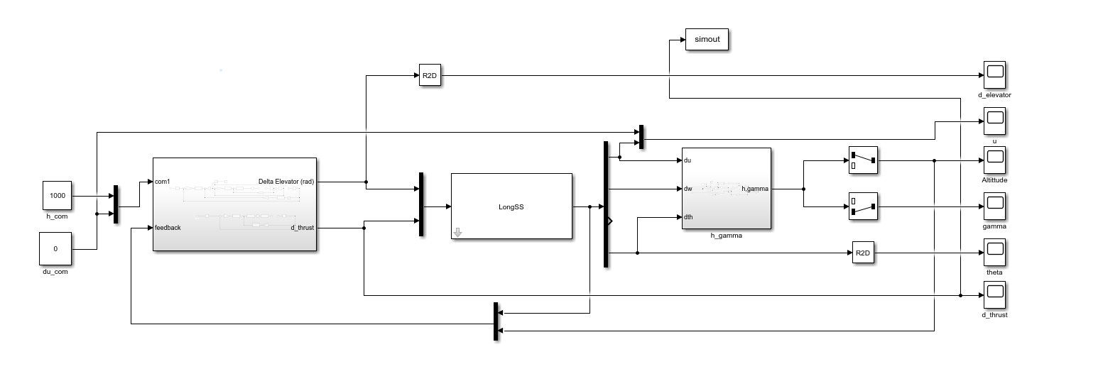

*Subsystems:*

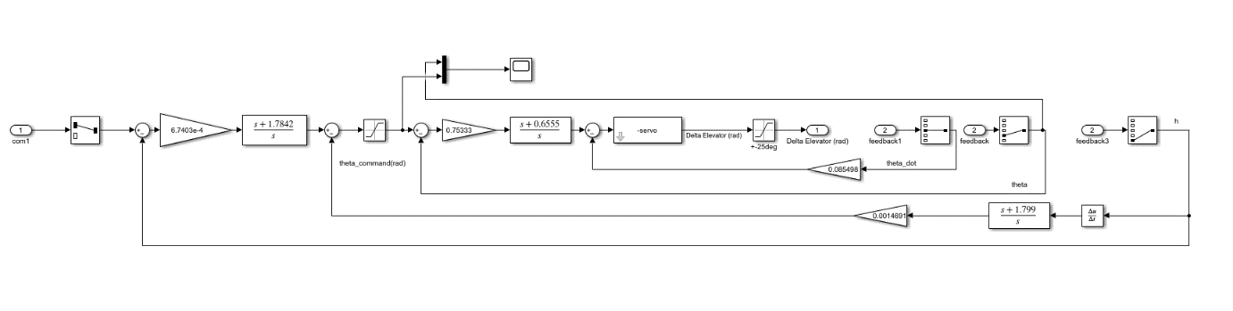

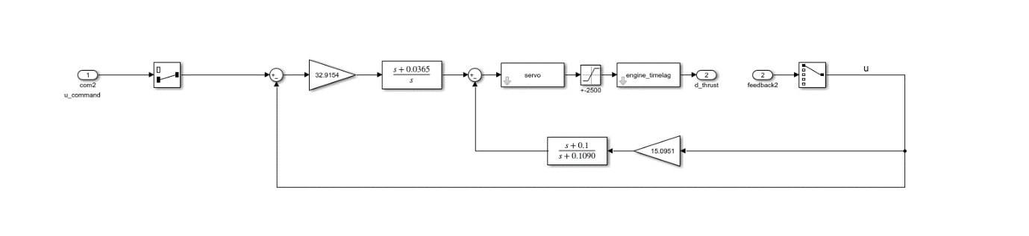

Results:



# Task (6)

a) Design a “Yaw damper” for the Dutch Roll Mode

Design No. One

Then the open loop transfer function is

OL\_r\_rcom =

-126 s^3 - 599.3 s^2 - 168.9 s - 67.62

--------------------------------------------------------

s^5 + 15.41 s^4 + 69.2 s^3 + 200.4 s^2 + 492.9 s + 2.303

Continuous-time transfer function.

Design control loop:

|  |  |  |
| --- | --- | --- |
| yaw\_C1\_tf | yaw\_C2\_tf | Architecture |
| 0.065926 | 0.21623 s  ---------  (s+3.281) |  |

Closed Loop transfer function:

CL\_r\_rcom\_tf =

From input "r" to output "y":

-8.307 s^4 - 66.76 s^3 - 140.7 s^2 - 40.98 s - 14.62

-------------------------------------------------------------------

s^6 + 18.69 s^5 + 155.3 s^4 + 623.8 s^3 + 1328 s^2 + 1675 s + 22.18

Control action transfer function:

yaw\_C\_action\_tf =

From input "r" to output "u":

0.06593 s^6 + 1.232 s^5 + 7.895 s^4 + 28.18 s^3 + 75.84 s^2 + 106.7 s + 0.4981

----------------------------------------------------------------------

s^6 + 18.69 s^5 + 155.3 s^4 + 623.8 s^3 + 1328 s^2 + 1675 s + 22.18

|  |
| --- |
| *Figure 13. Design 1 - Response* |
| *Figure 14. Design 1 - Control Action* |

Design No. Two

Then the open loop transfer function is

OL\_r\_rcom =

-126 s^3 - 599.3 s^2 - 168.9 s - 67.62

--------------------------------------------------------

s^5 + 15.41 s^4 + 69.2 s^3 + 200.4 s^2 + 492.9 s + 2.303

Continuous-time transfer function.

Design control loop:

|  |  |
| --- | --- |
| yaw\_C\_tf | Architecture |
| 0.12324 s  ---------  (s+1.464) |  |

Closed Loop transfer function:

CL\_r\_rcom\_tf =

From input "r" to output "y":

-126 s^4 - 783.7 s^3 - 1046 s^2 - 314.8 s - 98.98

---------------------------------------------------------------------

s^6 + 16.87 s^5 + 107.3 s^4 + 375.6 s^3 + 807.1 s^2 + 732.1 s + 3.371

Control action transfer function:

yaw\_C\_action\_tf =

From input "r" to output "u":

s^6 + 16.87 s^5 + 91.76 s^4 + 301.7 s^3 + 786.3 s^2 + 723.7 s + 3.371

---------------------------------------------------------------------

s^6 + 16.87 s^5 + 107.3 s^4 + 375.6 s^3 + 807.1 s^2 + 732.1 s + 3.371

|  |
| --- |
| *Figure 15. Design 2 - Response* |
| *Figure 16. Design 2 - Control Action* |

B. Test The “Yaw damper” controllers on the full state space model

Design No. One

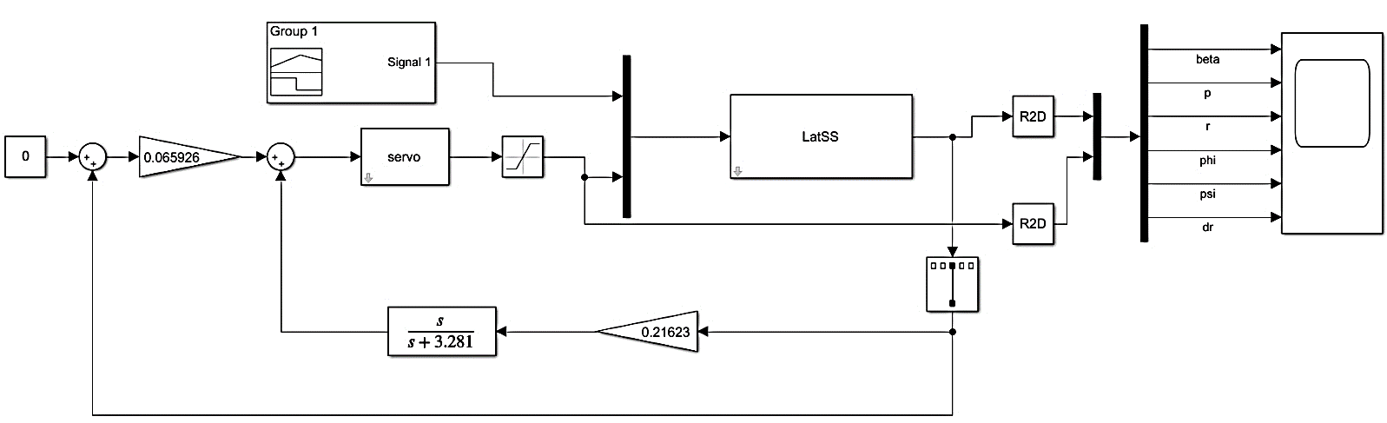

Design No. Two

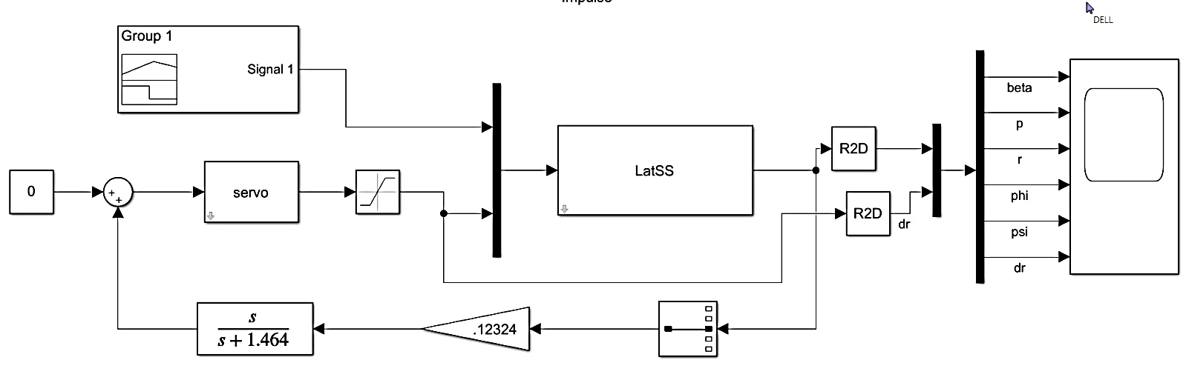

Results:

Design No. One



Design No. Two



c) Design “Roll Controller”

Then the open loop transfer function is

OL\_phi\_phicom =

4700 s^4 + 5.811e04 s^3 + 2.417e05 s^2 + 6.669e05 s + 7.489e05

-------------------------------------------------------------------------

s^8 + 36.87 s^7 + 544.7 s^6 + 4209 s^5 + 1.905e04 s^4 + 5.443e04 s^3 + 9.535e04 s^2 + 7.327e04 s + 337.1

Continuous-time transfer function.

Design control loop:

|  |  |
| --- | --- |
| roll\_C\_tf | Architecture |
| 0.0078128 (s+0.02203)  ---------------------  s |  |

Closed Loop transfer function:

**CL\_roll\_tf =**

**From input "r" to output "y":**

**36.72 s^5 + 454.8 s^4 + 1898 s^3 + 5252 s^2 + 5966 s + 128.9**

**------------------------------------------------------------------------**

**s^9 + 36.87 s^8 + 544.7 s^7 + 4209 s^6 + 1.908e04 s^5 + 5.489e04 s^4 + 9.725e04 s^3 + 7.853e04 s^2 + 6303 s + 128.9**

Control action transfer function:

roll\_C\_action\_tf =

From input "r" to output "u":

0.007813 s^9 + 0.2882 s^8 + 4.262 s^7 + 32.97 s^6 + 149.5 s^5 + 428.5 s^4 + 754.3 s^3 + 588.9 s^2 + 15.24 s + 0.05802

---------------------------------------------------------------------------

s^9 + 36.87 s^8 + 544.7 s^7 + 4209 s^6 + 1.908e04 s^5 + 5.489e04 s^4 + 9.725e04 s^3 + 7.853e04 s^2 + 6303 s + 128.9

|  |
| --- |
| *Figure 17. Response* |
| *Figure 18. Control Action* |

d) Coordination

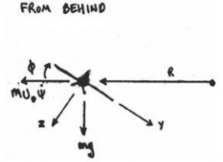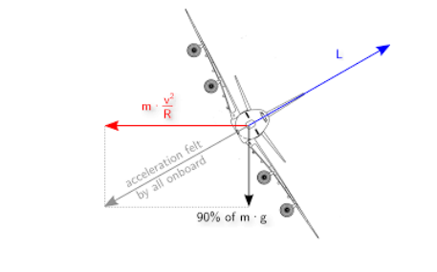d)

As we can see from previous results that the sideslip angle (β) didn’t settle at zero, therefore coordination is not achieved by default.

This can be achieved at a certain bank angle (**φ**) for a given Speed ($U_{o}$) and turning rate $\dot{ψ}$**.**This value of **φ** can be found from the free body diagram of the airplane during a turn.

Noting that the tangential Velocity is $U_{o}$**,** **R** is the radius of the turn.

$$∴U_{o}=R\dot{ψ}$$

From the free body diagram for a coordinated turn, we get the following:

$$L\cos\left(ϕ\right)=mg$$

$$L\sin\left(ϕ\right)=m U_{o}\dot{ψ}$$

By dividing the 2nd equation by the 1st one we get:

$$\tan\left(ϕ\right)=\frac{U_{o}\dot{ψ}}{g}$$

$$∴ϕ≃\frac{U_{o}\dot{ψ}}{g}$$

Therefore, in order to fly coordinated flight; for each velocity there is only one corresponding value of bank angle that satisfies the condition.

With:

$ψ/{ψ_{d}}=\frac{1/τ}{s+1/τ}$, $15≤τ≤20$

$$∴ϕ=\frac{U_{o}}{τ g} (ψ_{desired}-ψ)$$

We choose $τ=15 \&{ ψ}_{d}=360 degree (Complete turn)$

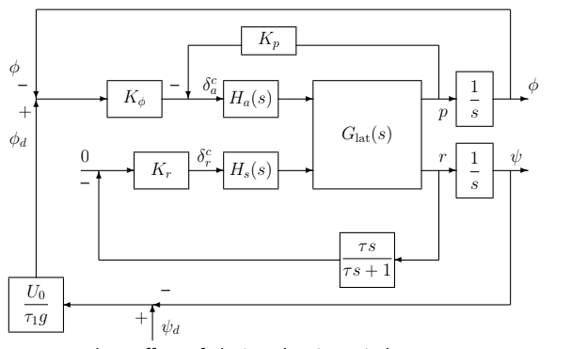**Final Controller after putting pieces together**

e) Test the designed controllers on the full state space model

Simulink

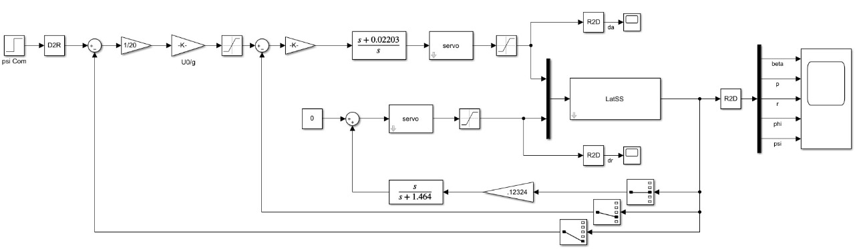

Results:



# Task (7)

a) Develop the testing loop Containing the “Controller + Simulator”

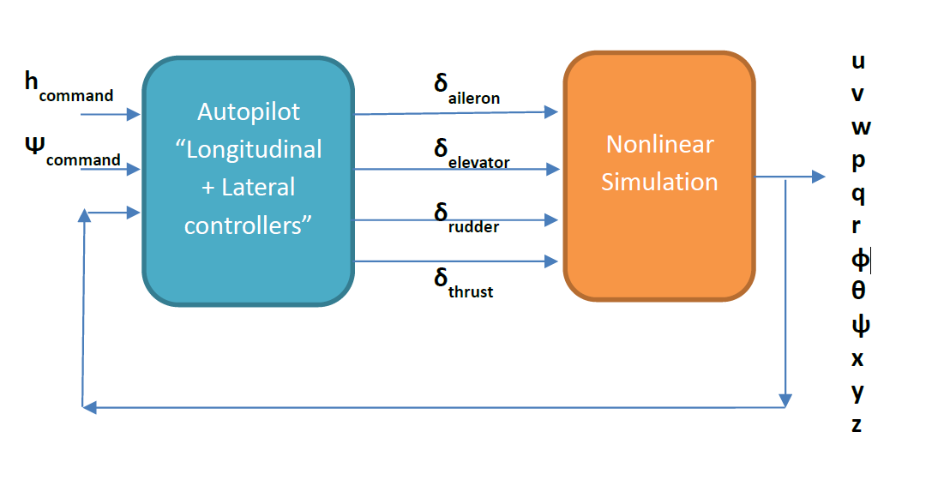

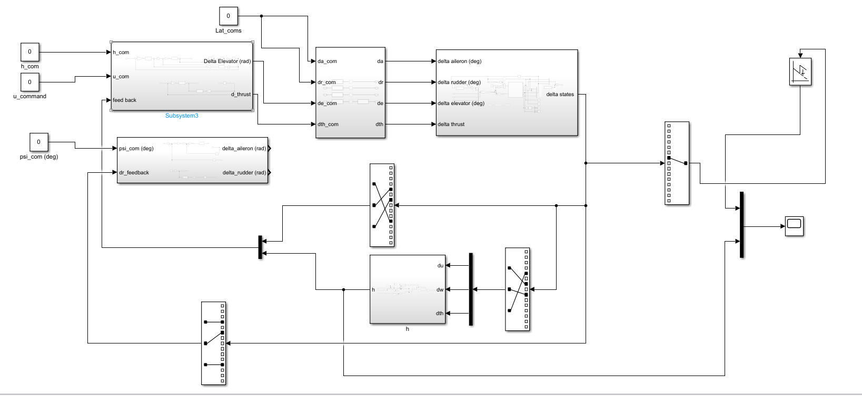

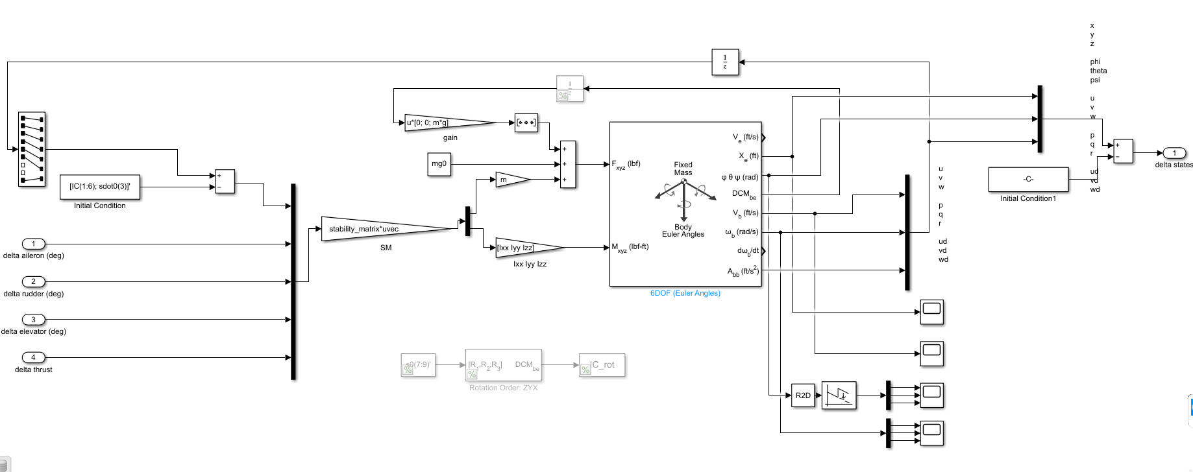

b) Test the “Pitch controller” and compare the response with the same test on the State space model

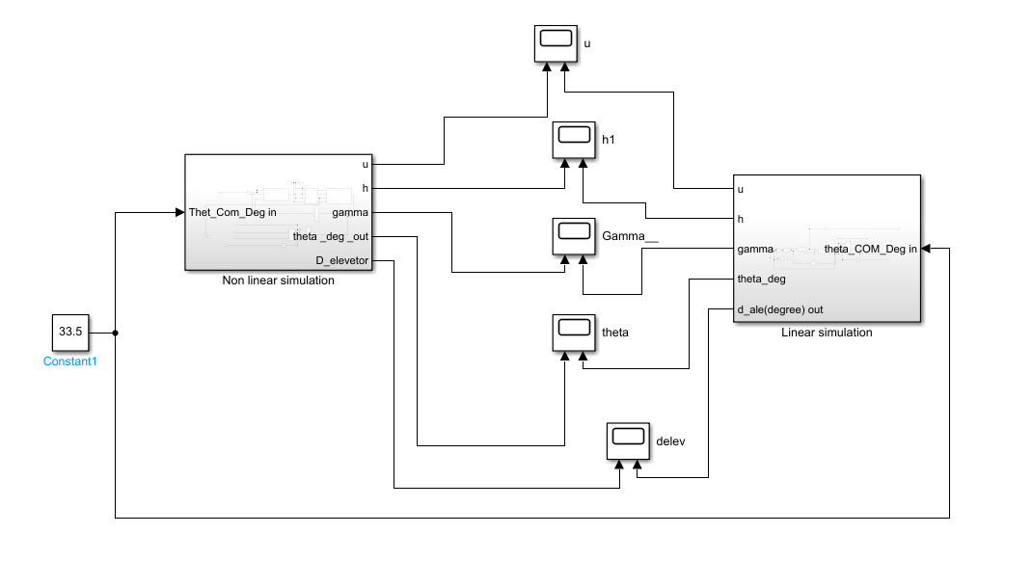

Linear block

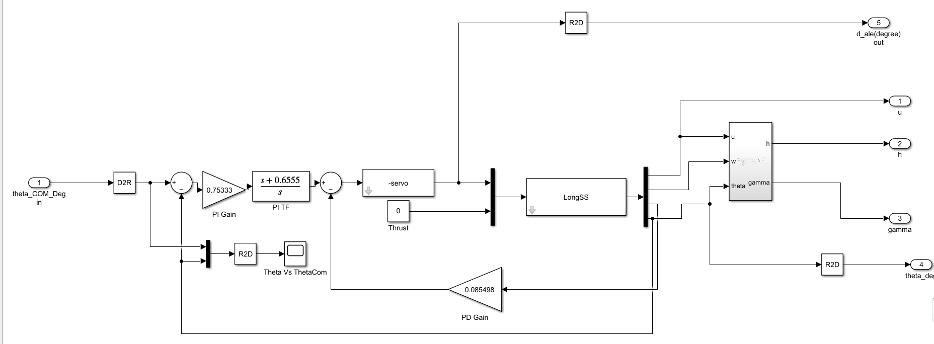

Nonlinear block

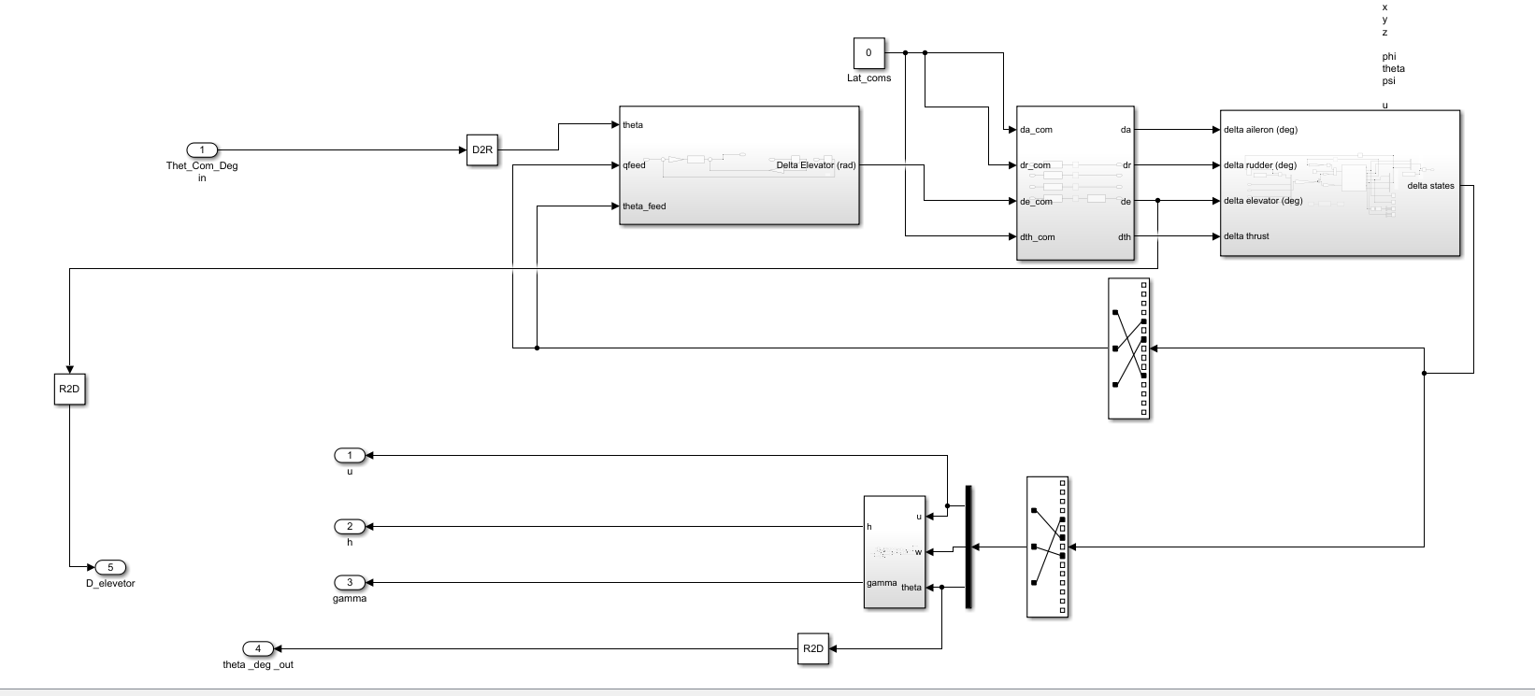

Results for 33.5 deg pitch angle

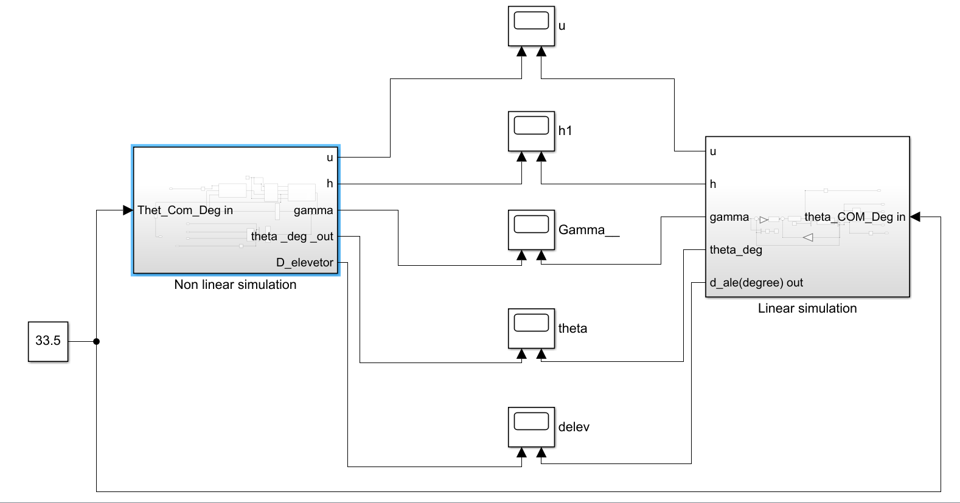

*1-u*



*2- $γ$*



*3- $θ$*



*4- $δ_{elevator}$*



*5-h*



c) Test the “Pitch controller + Velocity controller” and compare the

response with the same test on the State space model

* Give a commanded input signal of pitch angle and observe the response and control action $(θ,u, γ, h, δ_{e}. δ_{th})$.
* Perform the same test on the Linear Longitudinal state space model and observe the response and control action $(θ, u, γ, h, δ_{e}. δ_{th})$
* Plot the results against each other.
* Note: in this test all the control actions are set to zero except the $(δ_{e} , δ_{th})$ which are.
* calculated by the Autopilot, this test shows the effect of the velocity controller and validate.
* the operation of both the pitch and velocity controllers.

Simulink Non-linear simulator:

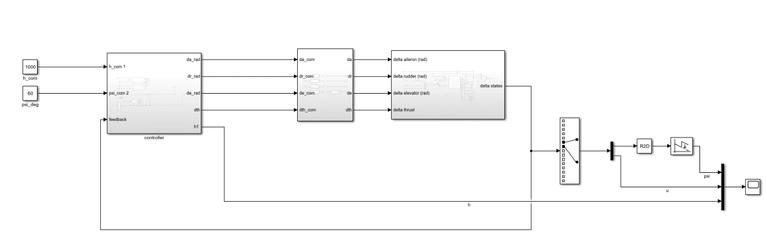

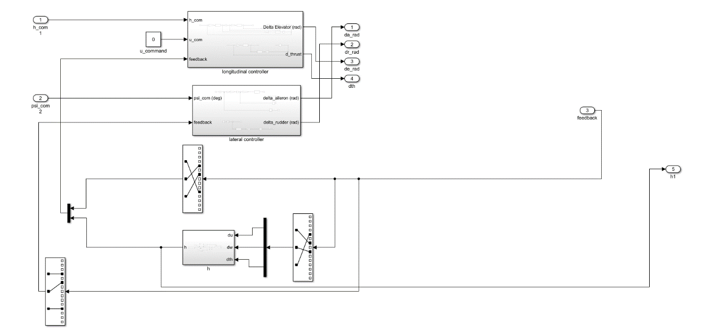 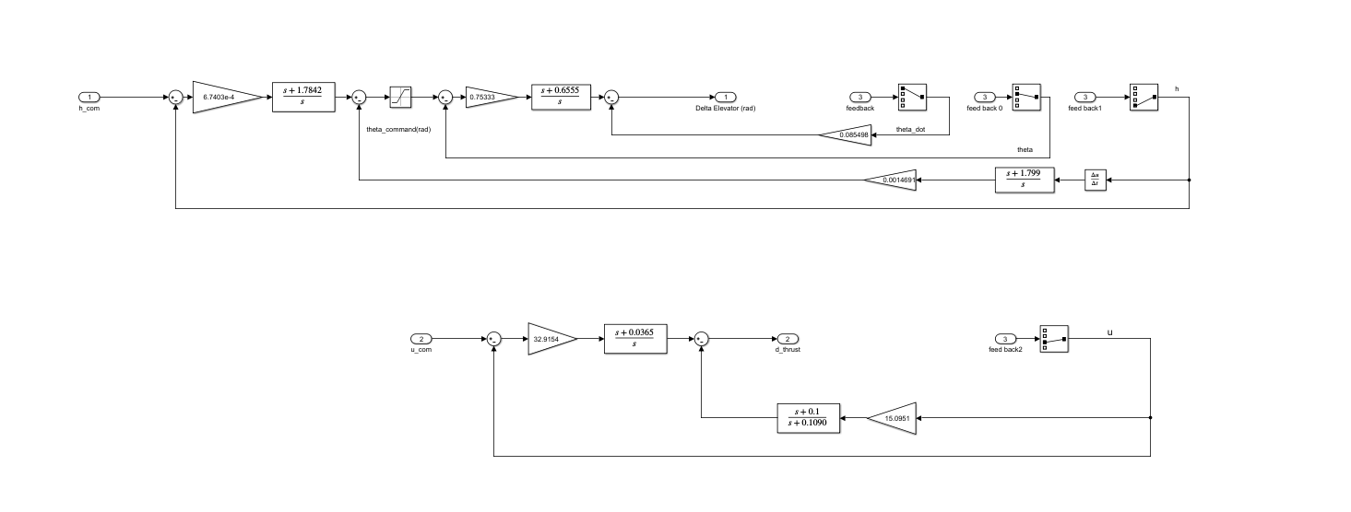

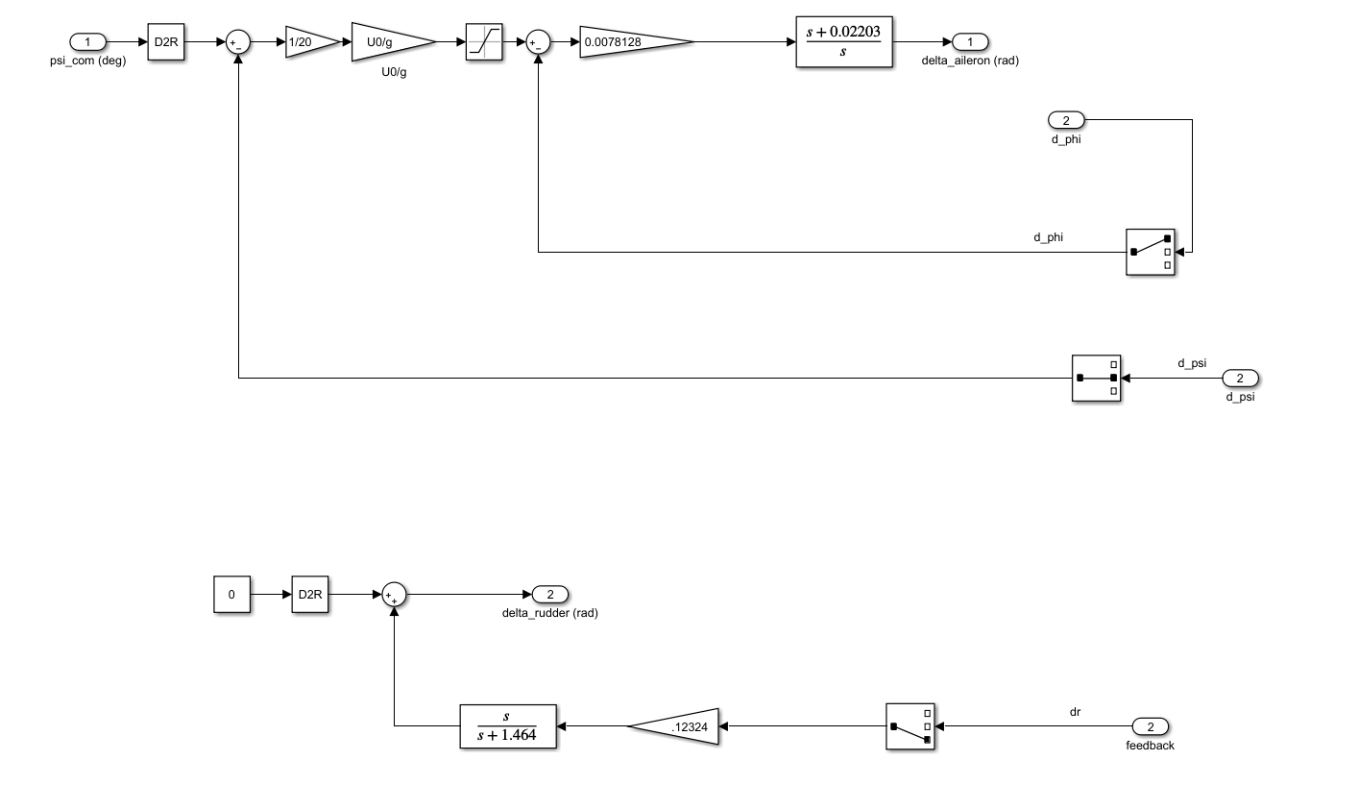

Simulink linear simulator:

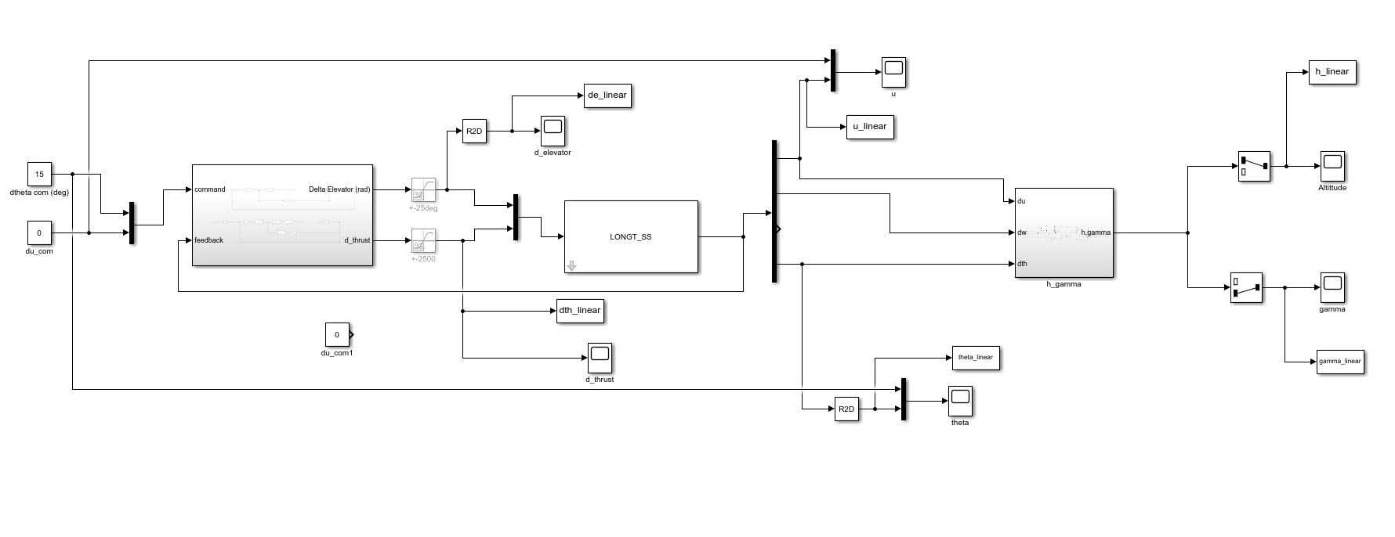

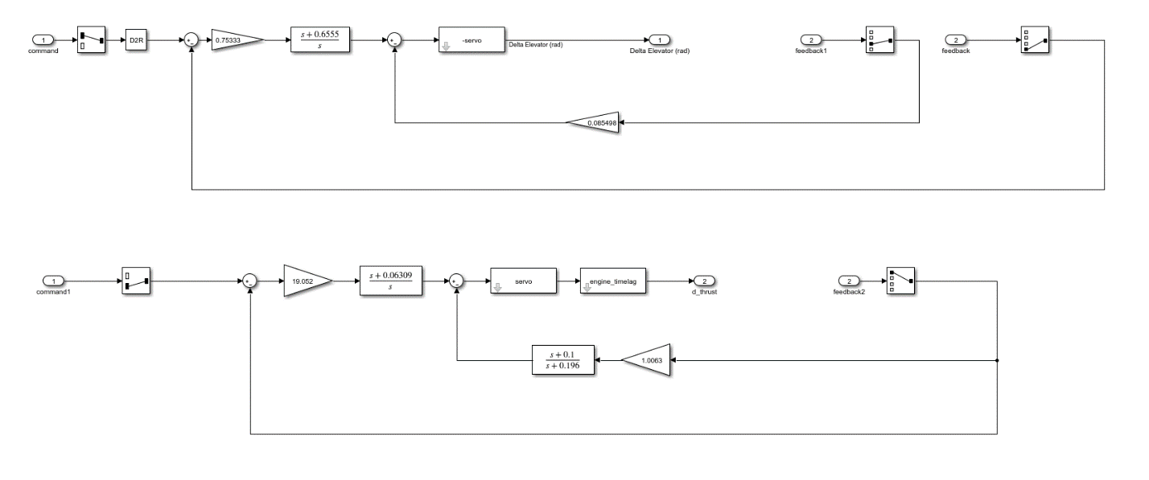

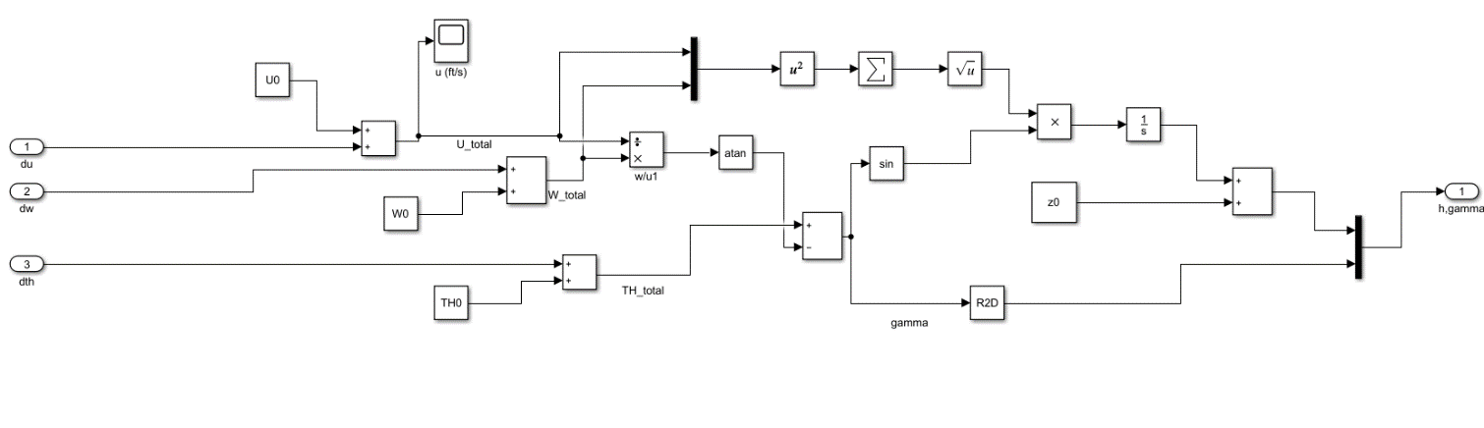

Simulation Results for 15° pitch command:











## d) Test The “Altitude Hold” Controller and Compare the response with the same test on the state space model

Results for input command of 1000ft.

|  |
| --- |
| C:\Users\OWNER\AppData\Local\Microsoft\Windows\INetCache\Content.Word\delta_theta.emf |
| C:\Users\OWNER\AppData\Local\Microsoft\Windows\INetCache\Content.Word\delta_u.emf |
| Y:\Aerospace\AeroSpace 4\Term 2\AutoPilot (Dr. Osama Saaid)\Tasks\Task 7\code\Results\AltitudeHold\delta_gamma.emf |
| Y:\Aerospace\AeroSpace 4\Term 2\AutoPilot (Dr. Osama Saaid)\Tasks\Task 7\code\Results\AltitudeHold\altitude.emf |
| Y:\Aerospace\AeroSpace 4\Term 2\AutoPilot (Dr. Osama Saaid)\Tasks\Task 7\code\Results\AltitudeHold\delta_elevetor.emf |
| Y:\Aerospace\AeroSpace 4\Term 2\AutoPilot (Dr. Osama Saaid)\Tasks\Task 7\code\Results\AltitudeHold\delta_thrust.emf |

## e) Perform a complete autonomous mission including “climb, cruise, turn, descent”

|  |
| --- |
|  |
|  |
|  |
|  |
|  |

## f) Test the “Lateral controller + Altitude Hold controller” and compare the response with the same test on the State space model

|  |
| --- |
|  |
|  |
|  |
|  |
|  |
|  |
|  |
|  |

## g) Perform a complete autonomous mission including “climb, cruise, turn, descent”

|  |
| --- |
|  |
|  |
|  |
|  |
|  |

# Appendix: MATLAB code

## Task (1)

|  |
| --- |
| clc  clear All  close All    t1=0;  t2=20;  n=100;  h=(t2-t1)/n;  t=(linspace(t1,t2,n+1))';  y1=zeros(length(t),1);  y2=zeros(length(t),1);  y2(1)=1;  y1(1)=-1;      for n=1:length(t)-1  k1=h\*(cos(t(n))+sin(y2(n)));  q1=h\*(sin(t(n))+cos(y1(n))+sin(y2(n)));    k2=h\*(cos(t(n)+0.5\*h)+sin(y2(n)+0.5\*k1));  q2=h\*(sin(t(n)+0.5\*h)+cos(y1(n)+0.5\*q1)+sin(y2(n)+0.5\*k1));    k3=h\*(cos(t(n)+0.5\*h)+sin(y2(n)+0.5\*k2));  q3=h\*(sin(t(n)+0.5\*h)+cos(y1(n)+0.5\*q2)+sin(y2(n)+0.5\*k2));    k4=h\*(cos(t(n)+h)+sin(y2(n)+k3));  q4=h\*(sin(t(n)+h)+cos(y1(n)+q3)+sin(y2(n)+k3));    y2(n+1)=y2(n)+(1/6)\*(k1+2\*k2+2\*k3+k4);  y1(n+1)=y1(n)+(1/6)\*(q1+2\*q2+2\*q3+q4);  end      figure  hold on  plot(t,y1,'r')  plot(t,y2,'b')  legend({'y(1)','y(2)'},...  'Location','southeast','FontSize',8,'Interpreter','latex')  xlabel('$t$','Interpreter','latex','FontSize',13)  %% Check using ode45  [tv,Yv]=ode45(@sys\_fun,[0 20],[-1 1]);  plot(tv,Yv(:,1),'r--','LineWidth',1.5)  plot(tv,Yv(:,2),'k--','LineWidth',1.5)  legend({'y(1)','y(2)','y(1)ode45','y(2)ode45'},...  'Location','southeast','FontSize',8,'Interpreter','latex')  xlabel('$t$','Interpreter','latex','FontSize',13)  function f=sys\_fun(t,Y)  f(1,1)=sin(t)+cos(Y(1))+sin(Y(2));  f(2,1)=cos(t)+sin(Y(2));  end |

## Task (2)

### main.m

|  |
| --- |
| clc; clear; close all;    %% Inputs  % Forces, Moments and Inertia  [forces,Moments,Mass,I,timeSpan,dt,ICs] = Input();  g = 9.81;  Mg = Mass\*g;  t\_vec = timeSpan(1):dt:timeSpan(2);  n = length(t\_vec);    %% Solving  Result = NaN(12,n);  Result(:,1) = ICs;  time = linspace(timeSpan(1), timeSpan(2), n);  for i =2:n  Result(:, i) = RBDSolver(Result(:, i-1), dt);  end    % Rearranging Results  u\_vec=Result(1,:);  v\_vec=Result(2,:);  w\_vec=Result(3,:);  p\_vec=Result(4,:);  q\_vec=Result(5,:);  r\_vec=Result(6,:);  phi\_vec=Result(7,:);  theta\_vec=Result(8,:);  epsi\_vec=Result(9,:);  xe\_vec=Result(10,:);  ye\_vec=Result(11,:);  ze\_vec=Result(12,:);    %% Solving using ODE45    [t, states] = ode45(@DOF6,timeSpan,ICs);  t\_ODE=t';  u\_ODE=states(:,1)';  v\_ODE=states(:,2)';  w\_ODE=states(:,3)';  p\_ODE=states(:,4)';  q\_ODE=states(:,5)';  r\_ODE=states(:,6)';  phi\_ODE=states(:,7)';  theta\_ODE=states(:,8)';  epsi\_ODE=states(:,9)';  xe\_ODE=states(:,10)';  ye\_ODE=states(:,11)';  ze\_ODE=states(:,12);    %% solving using simulink  %Run Smulink file  Sim\_run=sim('simulink\_test.slx');    %Extraxt Data from Simulink  %velocity body  Velocity\_body=Sim\_run.yout.getElement('velocity body');  %rotational speed body  Rotat\_Velocity\_body=Sim\_run.yout.getElement('rotational speed body');  %rotational speed earth  Rotat\_Velocity\_earth=Sim\_run.yout.getElement('rotational speed earth');  %positions earth  positions\_earth=Sim\_run.yout.getElement('positions earth');    t\_sim=Velocity\_body.Values.time;  u\_sim=Velocity\_body.Values.Data(:,1)';  v\_sim=Velocity\_body.Values.Data(:,2)';  w\_sim=Velocity\_body.Values.Data(:,3)';  p\_sim=Rotat\_Velocity\_body.Values.Data(:,1)';  q\_sim=Rotat\_Velocity\_body.Values.Data(:,2)';  r\_sim=Rotat\_Velocity\_body.Values.Data(:,3)';  phi\_sim=Rotat\_Velocity\_earth.Values.Data(:,1)';  theta\_sim=Rotat\_Velocity\_earth.Values.Data(:,2)';  epsi\_sim=Rotat\_Velocity\_earth.Values.Data(:,3)';  xe\_sim=positions\_earth.Values.Data(:,1)';  ye\_sim=positions\_earth.Values.Data(:,2)';  ze\_sim=positions\_earth.Values.Data(:,3)';    %% plots  %velocity body  figure  subplot(3, 1,1)  plot(t\_vec,u\_vec,'b',t\_ODE,u\_ODE,'g',t\_sim,u\_sim,'r')  legend({'$u(code)$','$u(ODE45)$','$u(sim)$'},'Location','southeast','FontSize',8,...  'Interpreter','latex')  xlabel('$t$','Interpreter','latex','FontSize',13)  ylabel('$u$','Interpreter','latex','FontSize',13)  title('u(from the code ,ODE45 and Simulink)')  grid on  subplot(3,1, 2)  plot(t\_vec,v\_vec,'b',t\_ODE,v\_ODE,'g',t\_sim,v\_sim,'r')  legend({'$v(code)$','$v(ODE45)$','$v(sim)$'},'Location','southeast','FontSize',8,...  'Interpreter','latex')  xlabel('$t$','Interpreter','latex','FontSize',13)  ylabel('$v$','Interpreter','latex','FontSize',13)  title('v(from the code ,ODE45 and Simulink)')  grid on  subplot(3,1, 3)  plot(t\_vec,w\_vec,'b',t\_ODE,w\_ODE,'g',t\_sim,w\_sim,'r')  legend({'$w(code)$','$w(ODE45)$','$w(sim)$'},'Location','southeast','FontSize',8,...  'Interpreter','latex')  xlabel('$t$','Interpreter','latex','FontSize',13)  ylabel('$w$','Interpreter','latex','FontSize',13)  title('w(from the code ,ODE45 and Simulink)')  grid on      %rotational speed body  figure  subplot(3, 1,1)  plot(t\_vec,p\_vec,'b',t\_ODE,p\_ODE,'g',t\_sim,p\_sim,'r')  legend({'$p(code)$','$p(ODE45)$','$p(sim)$'},'Location','southeast','FontSize',8,...  'Interpreter','latex')  xlabel('$t$','Interpreter','latex','FontSize',13)  ylabel('$p$','Interpreter','latex','FontSize',13)  title('p(from the code ,ODE45 and Simulink)')  grid on  subplot(3,1, 2)  plot(t\_vec,q\_vec,'b',t\_ODE,q\_ODE,'g',t\_sim,q\_sim,'r')  legend({'$q(code)$','$q(ODE45)$','$q(sim)$'},'Location','southeast','FontSize',8,...  'Interpreter','latex')  xlabel('$t$','Interpreter','latex','FontSize',13)  ylabel('$q$','Interpreter','latex','FontSize',13)  title('q(from the code ,ODE45 and Simulink)')  grid on  subplot(3,1, 3)  plot(t\_vec,r\_vec,'b',t\_ODE,r\_ODE,'g',t\_sim,r\_sim,'r')  legend({'$r(code)$','$r(ODE45)$','$r(sim)$'},'Location','southeast','FontSize',8,...  'Interpreter','latex')  xlabel('$t$','Interpreter','latex','FontSize',13)  ylabel('$r$','Interpreter','latex','FontSize',13)  title('r(from the code ,ODE45 and Simulink)')  grid on      %rotational speed earth  figure  subplot(3, 1,1)  plot(t\_vec,phi\_vec,'b',t\_ODE,phi\_ODE,'g',t\_sim,phi\_sim,'r')  legend({'$\phi(code)$','$\phi(ODE45)$','$\phi(sim)$'},'Location','southeast','FontSize',8,...  'Interpreter','latex')  xlabel('$t$','Interpreter','latex','FontSize',13)  ylabel('$\phi$','Interpreter','latex','FontSize',13)  title('\phi(from the code ,ODE45 and Simulink)')  grid on  subplot(3,1, 2)  plot(t\_vec,theta\_vec,'b',t\_ODE,theta\_ODE,'g',t\_sim,theta\_sim,'r')  legend({'$\theta(code)$','$\theta(ODE45)$','$\theta(sim)$'},'Location','southeast','FontSize',8,...  'Interpreter','latex')  xlabel('$t$','Interpreter','latex','FontSize',13)  ylabel('$\theta$','Interpreter','latex','FontSize',13)  title('\theta(from the code ,ODE45 and Simulink)')  grid on  subplot(3,1, 3)  plot(t\_vec,epsi\_vec,'b',t\_ODE,epsi\_ODE,'g',t\_sim,epsi\_sim,'r')  legend({'$\psi(code)$','$\psi(ODE45)$','$\psi(sim)$'},'Location','southeast','FontSize',8,...  'Interpreter','latex')  xlabel('$t$','Interpreter','latex','FontSize',13)  ylabel('$\psi$','Interpreter','latex','FontSize',13)  title('\psi(from the code ,ODE45 and Simulink)')  grid on      %positions earth  figure  subplot(3, 1,1)  plot(t\_vec,xe\_vec,'b',t\_ODE,xe\_ODE,'g',t\_sim,xe\_sim,'r')  legend({'$xe(code)$','$xe(ODE45)$','$xe(sim)$'},'Location','southeast','FontSize',8,...  'Interpreter','latex')  xlabel('$t$','Interpreter','latex','FontSize',13)  ylabel('$xe$','Interpreter','latex','FontSize',13)  title('xe(from the code ,ODE45 and Simulink)')  grid on  subplot(3,1, 2)  plot(t\_vec,ye\_vec,'b',t\_ODE,ye\_ODE,'g',t\_sim,ye\_sim,'r')  legend({'$ye(code)$','$ye(ODE45)$','$ye(sim)$'},'Location','southeast','FontSize',8,...  'Interpreter','latex')  xlabel('$t$','Interpreter','latex','FontSize',13)  ylabel('$ye$','Interpreter','latex','FontSize',13)  title('ye(from the code ,ODE45 and Simulink)')  grid on  subplot(3,1, 3)  plot(t\_vec,ze\_vec,'b',t\_ODE,ze\_ODE,'g',t\_sim,ze\_sim,'r')  legend({'$ze(code)$','$ze(ODE45)$','$ze(sim)$'},'Location','southeast','FontSize',8,...  'Interpreter','latex')  xlabel('$t$','Interpreter','latex','FontSize',13)  ylabel('$ze$','Interpreter','latex','FontSize',13)  title('ze(from the code ,ODE45 and Simulink)')  grid on |

### DOF6.m

|  |
| --- |
| % Function return the set of 12 state of the six degree of freedom  % system after sub., with given ICs  function F = DOF6(~, ICs)  [forces,Moments,Mass,Inertia,~,~,~] = Input();  % (Sin, Cos, Tan) of (phi, theta, epsi)  [S, C, T] = SCT(ICs(7:9));    Forces = forces + Mass\*9.81\*[  -S.theta;  S.phi\*C.theta;  C.phi\*C.theta;  ];    % (u, v, w) dot  F(1:3, 1) = Forces/Mass - cross(...  ICs(4:6, 1), ICs(1:3, 1)...  );    % (p, q, r) dot  F(4:6, 1) = Inertia\(Moments - cross(...  ICs(4:6, 1), Inertia \* ICs(4:6, 1)...  ));    % (phi, theta, epsi) dot  F(7:9, 1) = [  1, S.phi\*T.theta, C.phi\*T.theta;  0, C.phi, -S.phi;  0, S.phi/C.theta, C.phi/C.theta;  ] \* ICs(4:6, 1);    % (x, y, z) dot  F(10:12, 1) = [  C.theta\*C.epsi, (S.phi\*S.theta\*C.epsi - C.phi\*S.epsi), (C.phi\*S.theta\*C.epsi + S.phi\*S.epsi);  C.theta\*S.epsi, (S.phi\*S.theta\*S.epsi + C.phi\*C.epsi), (C.phi\*S.theta\*S.epsi - S.phi\*C.epsi);  -S.theta, S.phi\*C.theta, C.phi\*C.theta  ] \* ICs(1:3, 1);    end |

### Input.m

|  |
| --- |
| function [Forces,Moments,Mass,I,timeSpan,dt,ICs] = Input()  % Inputs  % Forces, Moments and Inertia  Forces = [10 5 9]'; % Vector  Moments = [10 20 5]'; % Vector  Mass = 15;  I = [1 -2 -1;  -2 5 -3;  -1 -3 0.1];  % Integration time span & Step  timeSpan = [0 15];  dt = 0.001;  % Initial Conditions  % [u; v; w; p; q; r; phi; theta; epsi; xe0; ye0; ze0]  ICs = [10; 2; 0; 2\*pi/180; pi/180; 0; 20\*pi/180; 15\*pi/180; 30\*pi/180; 2; 4; 7];    end |

### RBDSolver.m

|  |
| --- |
| % RBD Solver is function that implements Runge-Kutta-4  % Algorithm in order to integrate 6 DOF set of equations  % with a give Inital Conditions ICs, for single dt time step.  function state = RBDSolver(ICs, dt)  K = zeros(12, 4);    K(:, 1) = dt\*DOF6(0, ICs );  K(:, 2) = dt\*DOF6(0, ICs+0.5\*K(:, 1) );  K(:, 3) = dt\*DOF6(0, ICs+0.5\*K(:, 2) );  K(:, 4) = dt\*DOF6(0, ICs+K(:, 3) );    state = ICs + (...  K(:, 1)+...  2\*K(:, 2)+...  2\*K(:, 3)+...  K(:, 4))/6;  end |

### SCT.m

|  |
| --- |
| % Calculate Sin, Cos ,Tan for any set of three angles  % and return results in struct form for easy access in code.  function [S, C, T] = SCT(ICs)  S = struct(...  'phi', sin(ICs(1)),...  'theta', sin(ICs(2)),...  'epsi', sin(ICs(3))...  );  C = struct(...  'phi', cos(ICs(1)),...  'theta', cos(ICs(2)),...  'epsi', cos(ICs(3))...  );  T = struct(...  'phi', tan(ICs(1)),...  'theta', tan(ICs(2)),...  'epsi', tan(ICs(3))...  );  end |

## Task (3)

### main.m

|  |
| --- |
| clc; clear; close all;    %% Inputs  % Forces, Moments and Inertia    [Mass, g, I, invI, timeSpan, dt, ICs, ICs\_dot0, Vt0, ...  dControl, SD\_Long, SD\_Lat, initialGravity] = Input("excelsheet\_data\_modified.xlsx");    %% Solving  steps = (timeSpan(2) - timeSpan(1))/dt;  Result = NaN(12, steps);  Result(:,1) = ICs;  time\_V = linspace(0, timeSpan(2), steps+1);  dForces = [0 ; 0; 0];  dMoments = [0 ; 0; 0];    for i =1:steps  i  Result(:, i+1) = RBDSolver(Result(:, i), dt, (initialGravity + dForces), dMoments, Mass, I, invI, g);    [dF, dM] = airFrame(SD\_Long, SD\_Lat, dControl, ICs, ICs\_dot0, Result(:, i+1) ,Vt0, ...  (initialGravity + dForces), dMoments, Mass, I, invI, g);      dForces = vpa(dF');  dMoments = vpa(dM');    end    %% Plotting  % Rearranging Results  u = Result(1,:);  v = Result(2,:);  w = Result(3,:);  p = Result(4,:);  q = Result(5,:);  r = Result(6,:);  phi = Result(7,:);  theta = Result(8,:);  psi = Result(9,:);  x = Result(10,:);  y = Result(11,:);  z = Result(12,:);    beta\_deg=asin(v/Vt0)\*180/pi;  alpha\_deg=atan(w./u)\*180/pi;  p\_deg=p\*180/pi;  q\_deg=q\*180/pi;  r\_deg=r\*180/pi;  phi\_deg=phi\*180/pi;  theta\_deg=theta\*180/pi;  psi\_deg=psi\*180/pi;    figure  plot3(x,y,z);  title('Trajectory')  figure  subplot(4,3,1)  plot(time\_V,u)  title('u (ft/sec)')  xlabel('time (sec)')  subplot(4,3,2)  plot(time\_V,beta\_deg)  title('\beta (deg)')  xlabel('time (sec)')  subplot(4,3,3)  plot(time\_V,alpha\_deg)  title('\alpha (deg)')  xlabel('time (sec)')  subplot(4,3,4)  plot(time\_V,p\_deg)  title('p (deg/sec)')  xlabel('time (sec)')  subplot(4,3,5)  plot(time\_V,q\_deg)  title('q (deg/sec)')  xlabel('time (sec)')  subplot(4,3,6)  plot(time\_V,r\_deg)  title('r (deg/sec)')  xlabel('time (sec)')  subplot(4,3,7)  plot(time\_V,phi\_deg)  title('\phi (deg)')  xlabel('time (sec)')  subplot(4,3,8)  plot(time\_V,theta\_deg)  title('\theta (deg)')  xlabel('time (sec)')  subplot(4,3,9)  plot(time\_V,psi\_deg)  title('\psi (deg)')  xlabel('time (sec)')  subplot(4,3,10)  plot(time\_V,x)  title('x (ft)')  xlabel('time (sec)')  subplot(4,3,11)  plot(time\_V,y)  title('y (ft)')  xlabel('time (sec)')  subplot(4,3,12)  plot(time\_V,z)  title('z (ft)')  xlabel('time (sec)') |

### airFrame.m

|  |
| --- |
| function [dForce, dMoment] = airFrame(SD\_Long, SD\_Lat, dControl, state0, state0\_dot, state, Vt0 ,forces, moments, Mass, I, invI, g)    [YV, YB, LB, NB, LP, NP, LR, NR, YDA, YDR, LDA, NDA, LDR, NDR] = feval(@(x) x{:}, num2cell(SD\_Lat));  [XU, ZU, MU, XW, ZW, MW, ZWD, ZQ, MWD, MQ, XDE, ZDE, MDE, XD\_TH, ZD\_TH, MD\_TH] = feval(@(x) x{:}, num2cell(SD\_Long));  [Da, Dr, De, Dth] = feval(@(x) x{:}, num2cell(dControl));    Ixx = I(1,1);  Iyy = I(2,2);  Izz = I(3,3);    state\_dot = DOF6(state, forces, moments, Mass, I, invI, g);    ds = state - state0;  ds\_dot = state\_dot - state0\_dot;    beta0 = asin(state0(2)/Vt0);  beta = asin(state(2)/Vt0);  dbeta = beta-beta0;    dX = Mass\*(XU\*ds(1)+XW\*ds(3)+XDE\*De+XD\_TH\*Dth);  dY = Mass\*(YV\*ds(2)+YB\*dbeta+YDA\*Da+YDR\*Dr);  dZ = Mass\*(ZU\*ds(1)+ZW\*ds(3)+ZWD\*ds\_dot(3)+ZQ\*ds(5)+ZDE\*De+ZD\_TH\*Dth);    dL = Ixx\*(LB\*dbeta+LP\*ds(4)+LR\*ds(6)+LDR\*Dr+LDA\*Da);  dM = Iyy\*(MU\*ds(1)+MW\*ds(3)+MWD\*ds\_dot(3)+MQ\*ds(5)+MDE\*De+MD\_TH\*Dth);  dN = Izz\*(NB\*dbeta+NP\*ds(4)+NR\*ds(6)+NDR\*Dr+NDA\*Da);    dForce = [dX dY dZ];  dMoment = [dL dM dN];    end |

### DOF6.m

|  |
| --- |
| % Function return the set of 12 state of the six degree of freedom  % system after sub., with given ICs  function F = DOF6(ICs, forces, Moments, Mass, Inertia, invI, g)    % (Sin, Cos, Tan) of (phi, theta, epsi)  [S, C, T] = SCT(ICs(7:9));    Forces = forces + Mass\*g\*[  -S.theta;  S.phi\*C.theta;  C.phi\*C.theta;  ];    % (u, v, w) dot  F(1:3, 1) = Forces/Mass - cross(...  ICs(4:6, 1), ICs(1:3, 1)...  );    % (p, q, r) dot  F(4:6, 1) = invI\*(Moments - cross(...  ICs(4:6, 1), Inertia \* ICs(4:6, 1)...  ));    % (phi, theta, epsi) dot  F(7:9, 1) = [  1, S.phi\*T.theta, C.phi\*T.theta;  0, C.phi, -S.phi;  0, S.phi/C.theta, C.phi/C.theta;  ] \* ICs(4:6, 1);    % (x, y, z) dot  F(10:12, 1) = [  C.theta\*C.epsi, (S.phi\*S.theta\*C.epsi - C.phi\*S.epsi), (C.phi\*S.theta\*C.epsi + S.phi\*S.epsi);  C.theta\*S.epsi, (S.phi\*S.theta\*S.epsi + C.phi\*C.epsi), (C.phi\*S.theta\*S.epsi - S.phi\*C.epsi);  -S.theta, S.phi\*C.theta, C.phi\*C.theta  ] \* ICs(1:3, 1);    end |

### Input.m

|  |
| --- |
| function [Mass, g, I, invI, timeSpan, dt, ICs, ICs\_dot0, Vt0, ...  dc, SD\_Long, SD\_Lat, initialGravity] = Input(inputs\_filename)  % Inputs  % here B2:B61 means read the excel sheet from cell B2 to cell B61  aircraft\_data=xlsread(inputs\_filename,'B2:B61');    % Integration time span & Step  dt = aircraft\_data(1);  tfinal = aircraft\_data(2);  timeSpan = [0 tfinal];    % Initial Conditions  % [u; v; w; p; q; r; phi; theta; epsi; xe0; ye0; ze0]  % ICs = [10; 2; 0; 2\*pi/180; pi/180; 0; 20\*pi/180; 15\*pi/180; 30\*pi/180; 2; 4; 7];  ICs = aircraft\_data(4:15);  ICs\_dot0 = zeros(12,1);  Vt0 = sqrt(ICs(1)^2 + ICs(2)^2 + ICs(3)^2); % Vto    % control actions values  % D\_a, D\_r, D\_e, D\_th  dc = [ aircraft\_data(57:59) \* pi/180 ; aircraft\_data(60)];    % gravity, mass % inertia  Mass = aircraft\_data(51);  g = aircraft\_data(52);  Ixx = aircraft\_data(53);  Iyy = aircraft\_data(54);  Izz = aircraft\_data(55);  Ixz = aircraft\_data(56);  Ixy=0; Iyz=0;  I = [Ixx , -Ixy , -Ixz ;...  -Ixy , Iyy , -Iyz ;...  -Ixz , -Iyz , Izz];  invI = inv(I);      % Stability Derivatives Longitudinal motion  SD\_Long = aircraft\_data(21:36);    % Stability Derivatives Lateral motion  SD\_Lat\_dash = aircraft\_data(37:50);  SD\_Lat\_dash(9) = SD\_Lat\_dash(9)\*Vt0; % From dimension-less to dimensional  SD\_Lat\_dash(10) = SD\_Lat\_dash(10)\*Vt0; % Form dimension-less to dimensional    SD\_Lat = LateralSD2BodyAxes(SD\_Lat\_dash, I);    % initial gravity force  [S, C, ~] = SCT(ICs(7:9));  initialGravity = Mass\*g\*[  S.theta;  -S.phi\*C.theta;  -C.phi\*C.theta;  ];    end |

### LateralSD2BodyAxes.m

|  |
| --- |
| function SD\_Lat = LateralSD2BodyAxes(SD\_Lat\_dash, I)    [YV, YB,LBd,NBd,LPd,NPd,LRd,NRd,YDA,YDR,LDAd,NDAd,LDRd,NDRd] = feval(@(x) x{:}, num2cell(SD\_Lat\_dash));    Ixx = I(1);  Izz = I(9);  Ixz = -I(3);    G = 1/(1 - Ixz^2 / Ixx / Izz);    syms LB LP LR LDR LDA NB NP NR NDR NDA  eq1 = (LB+Ixz\*NB/Ixx)\*G == LBd;  eq2 = (NB+Ixz\*LB/Izz)\*G == NBd;  eq3 = (LP+Ixz\*NP/Ixx)\*G == LPd;  eq4 = (NP+Ixz\*LP/Izz)\*G == NPd;  eq5 = (LR+Ixz\*NR/Ixx)\*G == LRd;  eq6 = (NR+Ixz\*LR/Izz)\*G == NRd;  eq7 = (LDR+Ixz\*NDR/Ixx)\*G == LDRd;  eq8 = (NDR+Ixz\*LDR/Izz)\*G == NDRd;  eq9 = (LDA+Ixz\*NDA/Ixx)\*G == LDAd;  eq10 = (NDA+Ixz\*LDA/Izz)\*G == NDAd;    [A,B] = equationsToMatrix(...  [eq1, eq2, eq3, eq4, eq5, eq6, eq7, eq8, eq9, eq10],...  [LB LP LR LDR LDA NB NP NR NDR NDA]);    X = A\B;    SD\_Lat = [  YV YB ...  X(1) X(6) X(2) X(7) ...  X(3) X(8) ...  YDA YDR ...  X(5) X(10) X(4) X(9) ...  ]';    SD\_Lat = vpa(SD\_Lat);    end |

### SCT.m

|  |
| --- |
| % Calculate Sin, Cos ,Tan for any set of three angles  % and return results in struct form for easy access in code.  function [S, C, T] = SCT(ICs)  S = struct(...  'phi', sin(ICs(1)),...  'theta', sin(ICs(2)),...  'epsi', sin(ICs(3))...  );  C = struct(...  'phi', cos(ICs(1)),...  'theta', cos(ICs(2)),...  'epsi', cos(ICs(3))...  );  T = struct(...  'phi', tan(ICs(1)),...  'theta', tan(ICs(2)),...  'epsi', tan(ICs(3))...  );  end |

### RBDSolver.m

|  |
| --- |
| % RBD Solver is function that implements Runge-Kutta-4  % Algorithm in order to integrate 6 DOF set of equations  % with a give Inital Conditions ICs, for single dt time step.  function state = RBDSolver(ICs, dt, Force, Moments, Mass, I, invI, g)    K = zeros(12, 4);    K(:, 1) = dt\*DOF6(ICs ,Force, Moments, Mass, I, invI, g);  K(:, 2) = dt\*DOF6(ICs+0.5\*K(:, 1) ,Force, Moments, Mass, I, invI, g);  K(:, 3) = dt\*DOF6(ICs+0.5\*K(:, 2) ,Force, Moments, Mass, I, invI, g);  K(:, 4) = dt\*DOF6(ICs+K(:, 3) ,Force, Moments, Mass, I, invI, g);    state = ICs + (...  K(:, 1)+...  2\*K(:, 2)+...  2\*K(:, 3)+...  K(:, 4))/6;    end |

## Task (4)

### main.m

|  |
| --- |
| clc; clear; close all;    %% Inputs  % Forces, Moments and Inertia    [Mass, g, I, invI, timeSpan, dt, ICs, ICs\_dot0, Vt0, ...  dControl, SD\_Long, SD\_Lat,SD\_Lat\_dash, initialGravity] = Input("NT-33A\_4.xlsx");  steps = (timeSpan(2) - timeSpan(1))/dt;  Result = NaN(12, steps);  Result(:,1) = ICs;  time\_V = linspace(0, timeSpan(2), steps+1);    %% Solving  %profile on;  dForces = [0 ; 0; 0];  dMoments = [0 ; 0; 0];    for i =1:steps    Result(:, i+1) = RBDSolver(Result(:, i), dt, (initialGravity + dForces), dMoments, Mass, I, invI, g);    [dF, dM] = airFrame(SD\_Long, SD\_Lat, dControl, ICs, ICs\_dot0, Result(:, i+1) ,Vt0, ...  (initialGravity + dForces), dMoments, Mass, I, invI, g);      dForces = vpa(dF');  dMoments = vpa(dM');    end  %profile viewer    %% Rearranging Results  u = Result(1,:);  v = Result(2,:);  w = Result(3,:);  p = Result(4,:);  q = Result(5,:);  r = Result(6,:);  phi = Result(7,:);  theta = Result(8,:);  psi = Result(9,:);  x = Result(10,:);  y = Result(11,:);  z = Result(12,:);    beta\_deg=asin(v/Vt0)\*180/pi;  alpha\_deg=atan(w./u)\*180/pi;  p\_deg=p\*180/pi;  q\_deg=q\*180/pi;  r\_deg=r\*180/pi;  phi\_deg=phi\*180/pi;  theta\_deg=theta\*180/pi;  psi\_deg=psi\*180/pi;    %% Longitudenal Full Linear Model  XU=SD\_Long(1);  ZU=SD\_Long(2);  MU=SD\_Long(3);  XW=SD\_Long(4);  ZW=SD\_Long(5);  MW=SD\_Long(6);  ZWD=SD\_Long(7);  ZQ=SD\_Long(8);  MWD=SD\_Long(9);  MQ=SD\_Long(10);  XDE=SD\_Long(11);  ZDE=SD\_Long(12);  MDE=SD\_Long(13);  XDTH=SD\_Long(14);  ZDTH=SD\_Long(15);  MDTH=SD\_Long(16);  u0 = ICs(1);  v0 = ICs(2);  w0 = ICs(3);  q0 = ICs(5);  theta0 = ICs(8);  A\_long=[XU XW -w0 -g\*cos(theta0)  ZU/(1-ZWD) ZW/(1-ZWD) (ZQ+u0)/(1-ZWD) -g\*sin(theta0)/(1-ZWD)  MU+MWD\*ZU/(1-ZWD) MW+MWD\*ZW/(1-ZWD) MQ+MWD\*(ZQ+u0)/(1-ZWD) -MWD\*g\*sin(theta0)/(1-ZWD)  0 0 1 0];  B\_long=[XDE XDTH  ZDE/(1-ZWD) ZDTH/(1-ZWD)  MDE+MWD\*ZDE/(1-ZWD) MDTH+MWD\*ZDTH/(1-ZWD)  0 0];  C\_long=eye(4);  D\_long=zeros(4,2);    % Two Inputs - Four Output Each  LongSS = ss(A\_long, B\_long, C\_long, D\_long);    %% APPROXIMATE  %% PHUGOID MODE (LONG PERIOD MODE)    A\_phug=[XU -g  -ZU/(u0+ZQ) 0];  B\_phug=[XDE XDTH  -ZDE/(ZQ+u0) -ZDTH/(ZQ+u0)];  C\_phug=eye(2);D\_phug=zeros(2,2);    PHUG\_SS=ss(A\_phug,B\_phug,C\_phug,D\_phug);    %% SHORT PERIOD MODE  A\_short=[ZW/(1-ZWD) (ZQ+u0)/(1-ZWD)  (MW+ZW\*MWD/(1-ZWD)) (MQ+MWD\*(ZQ+u0)/(1-ZWD))];  B\_short=[ZDE/(1-ZWD) ZDTH/(1-ZWD)  MDE+MWD\*ZDE/(1-ZWD) MDTH+MWD\*ZDTH/(1-ZWD)];  C\_short=eye(2);D\_short=zeros(2,2);    SHORT\_SS=ss(A\_short,B\_short,C\_short,D\_short);    %% Longitudinal Full Linear Model Step Response  %%% Due to delta\_elevetor or delta\_thrust  dControl\_long = dControl(3:4); % dE, dTh  opt = stepDataOptions;  opt.StepAmplitude = dControl\_long;  [res, ~, ~] = step(LongSS, time\_V, opt);  res\_dE =res(:,:,1);  res\_dTh =res(:,:,2);  %% Longitudinal Approximate Models Step Response  %%% Due to delta\_elevetor or delta\_thrust  dControl\_long = dControl(3:4); % dE, dTh  opt = stepDataOptions;  opt.StepAmplitude = dControl\_long;  [APPres\_PH, ~,~] = step(PHUG\_SS, time\_V, opt);  [APPres\_SH, ~,~] = step(SHORT\_SS, time\_V, opt);    APPres\_dE=zeros (length(time\_V),4);  APPres\_dE(:,[1,4])=APPres\_PH(:,:,1);  APPres\_dE(:,[2,3])=APPres\_SH(:,:,1);    APPres\_dTH=zeros (length(time\_V),4);  APPres\_dTH(:,[1,4])=APPres\_PH(:,:,2);  APPres\_dTH(:,[2,3])=APPres\_SH(:,:,2);  %% u response Full Linear - Approximate - Non Linear  figure(1)  if(dControl\_long(1) ~= 0)  plot(time\_V, res\_dE(:, 1) + u0, '--', 'DisplayName', 'u (Full Linear)'); % Full Linear Model  hold on  plot(time\_V, APPres\_dE(:, 1) + u0, '--', 'DisplayName', 'u (Long Period Approximation)'); % Approximate (long period Mode)  elseif(dControl\_long(2) ~= 0)  plot(time\_V, res\_dTh(:, 1) + u0, '--', 'DisplayName', 'u (Full Linear)'); % Full Linear Model  hold on  plot(time\_V, APPres\_dTH(:, 1) + u0, '--', 'DisplayName', 'u (Long Period Approximation)'); % Approximate (long period Mode)  end    hold on  plot(time\_V, u, '-', 'DisplayName', 'u (Non-Linear)'); % Non-Linear Model  title('u (ft/sec)'); xlabel('t (sec)');  legend('show');  grid on  %% w response Full Linear - Approximate - Non Linear  figure(2)  if(dControl\_long(1) ~= 0)  plot(time\_V, res\_dE(:, 2) + w0, '--', 'DisplayName', 'w (Full Linear)'); % Full Linear Model  hold on  plot(time\_V, APPres\_dE(:, 2) + w0, '--', 'DisplayName', 'w (short Period Approximation)'); % Approximate (short period Mode)  elseif(dControl\_long(2) ~= 0)  plot(time\_V, res\_dTh(:, 2) + w0, '--', 'DisplayName', 'w (Full Linear)'); % Full Linear Model  hold on  plot(time\_V, APPres\_dTH(:, 2) + w0, '--', 'DisplayName', 'w (short Period Approximation)'); % Approximate (short period Mode)  end    hold on  plot(time\_V, w, '-', 'DisplayName', 'w (Non-Linear)'); % Non-Linear Model  title('w (ft/sec)'); xlabel('t (sec)');  legend('show');  grid on  %% q response Full Linear - Approximate - Non Linear  figure(3)  if(dControl\_long(1) ~= 0)  q\_ = res\_dE(:, 3) + q0;  plot(time\_V, q\_\*180/pi, '--', 'DisplayName', 'q (Full Linear)'); % Full Linear Model  hold on  q\_APP = APPres\_dE(:, 3) + q0;  plot(time\_V, q\_APP\*180/pi, '--', 'DisplayName', 'q (short Period Approximation)'); % Approximate (short period Mode)    elseif(dControl\_long(2) ~= 0)  q\_ = res\_dTh(:, 3) + q0;  plot(time\_V, q\_\*180/pi, '--', 'DisplayName', 'q (Full Linear)'); % Full Linear Model  hold on  q\_APP = APPres\_dTH(:, 3) + q0;  plot(time\_V, q\_APP\*180/pi, '--', 'DisplayName', 'q (short Period Approximation)'); % Approximate (short period Mode)  end    hold on  plot(time\_V, q\_deg , '-', 'DisplayName', 'q (Non-Linear)'); % Non-Linear Model  title('q (1/sec^2)'); xlabel('t (sec)');  legend('show');  grid on  %% theta response Full Linear - Approximate - Non Linear  figure(4)  if(dControl\_long(1) ~= 0)  theta\_ = (res\_dE(:, 4) + theta0)\*180/pi;  plot(time\_V, theta\_, '--', 'DisplayName', '\Theta (Full Linear)'); % Full Linear Model  hold on  theta\_APP = (APPres\_dE(:, 4) + theta0)\*180/pi;  plot(time\_V, theta\_APP, '--', 'DisplayName', '\Theta (Long Period Approximation)'); % Full Linear Model  elseif(dControl\_long(2) ~= 0)  theta\_ = (res\_dTh(:, 4) + theta0)\*180/pi;  plot(time\_V, theta\_, '--', 'DisplayName', '\Theta (Full Linear)'); % Full Linear Model  hold on  theta\_APP = (APPres\_dTH(:, 4) + theta0)\*180/pi;  plot(time\_V, theta\_APP, '--', 'DisplayName', '\Theta (Long Period Approximation)'); % Full Linear Model  end    hold on  plot(time\_V, theta\_deg, '-', 'DisplayName', '\Theta (Non-Linear)'); % Non-Linear Model  title('theta (deg/sec)'); xlabel('t (sec)');  legend('show');  grid on  %% Lateral Full Linear Model    U0=u0; W0=w0; TH0=theta0; psi0=ICs(9); phi0=ICs(7);  Vto = sqrt(ICs(1)^2 + ICs(2)^2 + ICs(3)^2); % Vto    % stability derivatives Lateral motion    Yp=0;  Yr=0;  YDa\_star=SD\_Lat\_dash(9);  YDr\_star=SD\_Lat\_dash(10);  Yb=SD\_Lat\_dash(2);  YDa=SD\_Lat\_dash(9)\*Vto;  YDr=SD\_Lat\_dash(10)\*Vto;    Lbd=SD\_Lat\_dash(3);  Lpd=SD\_Lat\_dash(5);  Lrd=SD\_Lat\_dash(7);  LDrd=SD\_Lat\_dash(13);  LDad=SD\_Lat\_dash(11);    Nbd=SD\_Lat\_dash(4);  Npd=SD\_Lat\_dash(6);  Nrd=SD\_Lat\_dash(8);  NDrd=SD\_Lat\_dash(14);  NDad=SD\_Lat\_dash(12);      A\_Lat=[Yb/Vto (Yp+W0)/Vto (Yr-U0)/Vto g\*cos(TH0)/Vto 0;...  Lbd Lpd Lrd 0 0;...  Nbd Npd Nrd 0 0;...  0 1 tan(TH0) 0 0;...  0 0 1/cos(TH0) 0 0];  B\_Lat=[YDa YDr;...  LDad LDrd;...  NDad NDrd;...  0 0;0 0];  C\_Lat=eye(5); D\_Lat=zeros(5,2);      Lateral\_SS = ss(A\_Lat,B\_Lat,C\_Lat,D\_Lat);  Lateral\_TF = tf(Lateral\_SS);    B\_DA\_L = Lateral\_TF(1,1);  B\_DR\_L = Lateral\_TF(1,2);    P\_DA\_L = Lateral\_TF(2,1);  P\_DR\_L = Lateral\_TF(2,2);    R\_DA\_L = Lateral\_TF(3,1);  R\_DR\_L = Lateral\_TF(3,2);    PHI\_DA\_L = Lateral\_TF(4,1);  PHI\_DR\_L = Lateral\_TF(4,2);    PSI\_DA\_L = Lateral\_TF(5,1);  PSI\_DR\_L = Lateral\_TF(5,2);      %% 3DOF Spiral Mode Approximation  A\_Spiral = [Lpd Lrd 0;...  Npd Nrd 0;...  1 tan(TH0) 0];  B\_Spiral = [LDad LDrd;NDad NDrd;0 0];  C\_Spiral = eye(3); D\_Spiral = zeros(3,2);    Spiral\_SS = ss(A\_Spiral,B\_Spiral,C\_Spiral,D\_Spiral);  Spiral\_TF = tf(Spiral\_SS);    P\_DA\_S= Spiral\_TF(1, 1);  P\_DR\_S = Spiral\_TF(1, 2);    R\_DA\_S = Spiral\_TF(2, 1);  R\_DR\_S = Spiral\_TF(2, 2);    PHI\_DA\_S = Spiral\_TF(3, 1);  PHI\_DR\_S = Spiral\_TF(3, 2);      %% 2DOF Dutch Mode Approximation  A\_Dutch = [Yb/Vto (Yr-U0)/Vto-tan(TH0)\*(Yp+W0)/Vto;Nbd Nrd-tan(TH0)\*Npd];  B\_Dutch = [YDa\_star YDr\_star;NDad NDrd];  C\_Dutch = eye(2); D\_Dutch = zeros(2,2);    Dutch\_SS = ss(A\_Dutch, B\_Dutch, C\_Dutch, D\_Dutch);  Dutch\_TF = tf(Dutch\_SS);    B\_DA\_D = Dutch\_TF(1, 1);  B\_DR\_D = Dutch\_TF(1, 2);    R\_DA\_D = Dutch\_TF(2, 1);  R\_DR\_D = Dutch\_TF(2, 2);      %% 1DOF Roll Approximation  A\_Roll = Lpd;  B\_Roll = LDad;  C\_Roll = eye(1); D\_Roll = zeros(1, 1);    Roll\_SS = ss(A\_Roll, B\_Roll, C\_Roll, D\_Roll);  Roll\_TF = tf(Roll\_SS);    P\_DA\_R = Roll\_TF(1 ,1);    %% Lateral Full Linear Model Step Response  %% Due to delta\_elevetor or delta\_thrust  dControl\_latr = dControl(1:2); % dA, dR  opt = stepDataOptions;  opt.StepAmplitude = dControl\_latr;  [Lat\_res, ~, ~] = step(Lateral\_SS, time\_V, opt);  Lat\_res\_dA =Lat\_res(:,:,1);  Lat\_res\_dR =Lat\_res(:,:,2);  %% Lateral Approximate Models Step Response    dControl\_latr = dControl(1:2); % dA, dR  opt = stepDataOptions;  opt.StepAmplitude = dControl\_latr;    [Spir\_res, ~,~] = step(Spiral\_SS, time\_V, opt);  [Dutch\_res, ~,~] = step(Dutch\_SS, time\_V, opt);    dC1= dControl(1); % dA, dR  opt = stepDataOptions;  opt.StepAmplitude = dC1;  [Roll\_res, ~,~] = step(Roll\_SS, time\_V, opt);    %%% Spiral  Spir\_res\_dA=zeros (length(time\_V),5);  Spir\_res\_dA(:,[2,3,4])=Spir\_res(:,:,1);    Spir\_res\_dR=zeros (length(time\_V),5);  Spir\_res\_dR(:,[2,3,4])=Spir\_res(:,:,2);  %%% Dutch  Dutch\_res\_dA=zeros (length(time\_V),5);  Dutch\_res\_dA(:,[1,3])=Dutch\_res(:,:,1);    Dutch\_res\_dR=zeros (length(time\_V),5);  Dutch\_res\_dR(:,[1,3])=Dutch\_res(:,:,2);  %%% Roll  Roll\_res\_dA=zeros (length(time\_V),5);  Roll\_res\_dA(:,2)=Roll\_res;  %%  figure(5)  beta0=v0/Vt0;  if(dControl\_latr(1) ~= 0)  beta\_ = (Lat\_res\_dA(:, 1) + beta0)\*180/pi;  plot(time\_V, beta\_, '--', 'DisplayName', '\beta (Full Linear lateral)'); % Full Lateral Linear Model  hold on  beta\_d = (Dutch\_res\_dA(:, 1) + beta0)\*180/pi;  plot(time\_V, beta\_d, '--', 'DisplayName', '\beta (dutch)'); % spiral Linear Model  elseif(dControl\_latr(2) ~= 0)  beta\_ = (Lat\_res\_dR(:, 1) + beta0)\*180/pi;  plot(time\_V, beta\_, '--', 'DisplayName', '\beta (Full Linear lateral)'); % Full Lateral Linear Model  hold on  beta\_d = (Dutch\_res\_dR(:, 1) + beta0)\*180/pi;  plot(time\_V, beta\_d, '--', 'DisplayName', '\beta (dutch)'); % spiral Linear Model  end    hold on  plot(time\_V, beta\_deg, '-', 'DisplayName', '\beta (Non-Linear)'); % Non-Linear Model  title('\beta (deg/sec)'); xlabel('t (sec)');  legend('show');  grid on  %%  figure(6)  beta0=v0/Vt0;  if(dControl\_latr(1) ~= 0)  P\_ = Lat\_res\_dA(:, 2) ;  plot(time\_V, P\_, '--', 'DisplayName', 'P (Full Linear lateral)'); % Full Lateral Linear Model  hold on  P\_r = Roll\_res\_dA(:, 2);  plot(time\_V, P\_r, '--', 'DisplayName', 'P (Roll)'); % spiral Linear Model  hold on  P\_s = Spir\_res\_dA(:, 2);  plot(time\_V, P\_s, '--', 'DisplayName', 'P (Spiral)'); % spiral Linear Model  elseif(dControl\_latr(2) ~= 0)  P\_ = Lat\_res\_dR(:, 2) ;  plot(time\_V, P\_, '--', 'DisplayName', 'P (Full Linear lateral)'); % Full Lateral Linear Model  hold on  P\_s = Spir\_res\_dR(:, 2);  plot(time\_V, P\_s, '--', 'DisplayName', 'P (Spiral)'); % spiral Linear Model  end    hold on  plot(time\_V, p, '-', 'DisplayName', 'p (Non-Linear)'); % Non-Linear Model  title('p (1/sec^2)'); xlabel('t (sec)');  legend('show');  grid on  %%  figure(7)  if(dControl\_latr(1) ~= 0)  R\_ = Lat\_res\_dA(:, 3) ;  plot(time\_V, R\_, '--', 'DisplayName', 'R (Full Linear lateral)'); % Full Lateral Linear Model  hold on  R\_d = Dutch\_res\_dA(:, 3);  plot(time\_V, R\_d, '--', 'DisplayName', 'R (dutch)'); % spiral Linear Model  hold on  R\_s = Spir\_res\_dA(:, 3);  plot(time\_V, R\_s, '--', 'DisplayName', 'R (Spiral)'); % spiral Linear Model  elseif(dControl\_latr(2) ~= 0)  R\_ = Lat\_res\_dR(:, 3) ;  plot(time\_V, R\_, '--', 'DisplayName', 'R (Full Linear lateral)'); % Full Lateral Linear Model  hold on  R\_d = Dutch\_res\_dR(:, 3);  plot(time\_V, R\_d, '--', 'DisplayName', 'R (dutch)'); % spiral Linear Model  hold on  R\_s = Spir\_res\_dR(:, 3);  plot(time\_V, R\_s, '--', 'DisplayName', 'R (Spiral)'); % spiral Linear Model  end    hold on  plot(time\_V, r, '-', 'DisplayName', 'r (Non-Linear)'); % Non-Linear Model  title('r (1/sec^2)'); xlabel('t (sec)');  legend('show');  grid on  %%  figure(8)  if(dControl\_latr(1) ~= 0)  phi\_ = (Lat\_res\_dA(:, 4) + phi0)\*180/pi;  plot(time\_V, phi\_, '--', 'DisplayName', '\phi (Full Linear lateral)'); % Full Lateral Linear Model  hold on  phi\_s = (Spir\_res\_dA(:, 4) + phi0)\*180/pi;  plot(time\_V, phi\_s, '--', 'DisplayName', '\phi (spiral)'); % spiral Linear Model  elseif(dControl\_latr(2) ~= 0)  phi\_ = (Lat\_res\_dR(:, 4) + phi0)\*180/pi;  plot(time\_V, phi\_, '--', 'DisplayName', '\phi (Full Linear lateral)'); % Full Linear Model  hold on  phi\_s = (Spir\_res\_dR(:, 4) + phi0)\*180/pi;  plot(time\_V, phi\_s, '--', 'DisplayName', '\phi (spiral)'); % Full Linear Model  end    hold on  plot(time\_V, phi\_deg, '-', 'DisplayName', '\phi (Non-Linear)'); % Non-Linear Model  title('\phi (deg/sec)'); xlabel('t (sec)');  legend('show');  grid on  %%  figure(9)  if(dControl\_latr(1) ~= 0)  psi\_ = (Lat\_res\_dA(:, 5) + psi0)\*180/pi;  plot(time\_V, psi\_, '--', 'DisplayName', '\psi (Full Linear lateral)'); % Full Linear Model    elseif(dControl\_latr(2) ~= 0)  psi\_ = (Lat\_res\_dR(:, 5) + psi0)\*180/pi;  plot(time\_V, psi\_, '--', 'DisplayName', '\psi (Full Linear lateral)'); % Full Linear Model    end    hold on  plot(time\_V, phi\_deg, '-', 'DisplayName', '\psi (Non-Linear)'); % Non-Linear Model  title('\psi (deg/sec)'); xlabel('t (sec)');  legend('show');  grid on    % export\_figure(max(double(get(groot,'Children')))+[-8:0], '', {'t1', 't2','t3','t4','t5','t6','t7','t8','t9'}, 600, {'emf', 'emf','emf','emf','emf','emf','emf','emf','emf'}) |

airFrame.m

|  |
| --- |
| function [dForce, dMoment] = airFrame(SD\_Long, SD\_Lat, dControl, state0, state0\_dot, state, Vt0 ,forces, moments, Mass, I, invI, g)    [YV, YB, LB, NB, LP, NP, LR, NR, YDA, YDR, LDA, NDA, LDR, NDR] = feval(@(x) x{:}, num2cell(SD\_Lat));  [XU, ZU, MU, XW, ZW, MW, ZWD, ZQ, MWD, MQ, XDE, ZDE, MDE, XD\_TH, ZD\_TH, MD\_TH] = feval(@(x) x{:}, num2cell(SD\_Long));  [Da, Dr, De, Dth] = feval(@(x) x{:}, num2cell(dControl));    Ixx = I(1,1);  Iyy = I(2,2);  Izz = I(3,3);    state\_dot = DOF6(state, forces, moments, Mass, I, invI, g);    ds = state - state0;  ds\_dot = state\_dot - state0\_dot;    beta0 = asin(state0(2)/Vt0);  beta = asin(state(2)/Vt0);  dbeta = beta-beta0;    dX = Mass\*(XU\*ds(1)+XW\*ds(3)+XDE\*De+XD\_TH\*Dth);  dY = Mass\*(YV\*ds(2)+YB\*dbeta+YDA\*Da+YDR\*Dr);  dZ = Mass\*(ZU\*ds(1)+ZW\*ds(3)+ZWD\*ds\_dot(3)+ZQ\*ds(5)+ZDE\*De+ZD\_TH\*Dth);    dL = Ixx\*(LB\*dbeta+LP\*ds(4)+LR\*ds(6)+LDR\*Dr+LDA\*Da);  dM = Iyy\*(MU\*ds(1)+MW\*ds(3)+MWD\*ds\_dot(3)+MQ\*ds(5)+MDE\*De+MD\_TH\*Dth);  dN = Izz\*(NB\*dbeta+NP\*ds(4)+NR\*ds(6)+NDR\*Dr+NDA\*Da);    dForce = [dX dY dZ];  dMoment = [dL dM dN];    end |

DOF6.m

|  |
| --- |
| % Function return the set of 12 state of the six degree of freedom  % system after sub., with given ICs  function F = DOF6(ICs, forces, Moments, Mass, Inertia, invI, g)    % (Sin, Cos, Tan) of (phi, theta, epsi)  [S, C, T] = SCT(ICs(7:9));    Forces = forces + Mass\*g\*[  -S.theta;  S.phi\*C.theta;  C.phi\*C.theta;  ];    % (u, v, w) dot  F(1:3, 1) = Forces/Mass - cross(...  ICs(4:6, 1), ICs(1:3, 1)...  );    % (p, q, r) dot  F(4:6, 1) = invI\*(Moments - cross(...  ICs(4:6, 1), Inertia \* ICs(4:6, 1)...  ));    % (phi, theta, epsi) dot  F(7:9, 1) = [  1, S.phi\*T.theta, C.phi\*T.theta;  0, C.phi, -S.phi;  0, S.phi/C.theta, C.phi/C.theta;  ] \* ICs(4:6, 1);    % (x, y, z) dot  F(10:12, 1) = [  C.theta\*C.epsi, (S.phi\*S.theta\*C.epsi - C.phi\*S.epsi), (C.phi\*S.theta\*C.epsi + S.phi\*S.epsi);  C.theta\*S.epsi, (S.phi\*S.theta\*S.epsi + C.phi\*C.epsi), (C.phi\*S.theta\*S.epsi - S.phi\*C.epsi);  -S.theta, S.phi\*C.theta, C.phi\*C.theta  ] \* ICs(1:3, 1);    end |

Input.m

|  |
| --- |
| function [Mass, g, I, invI, timeSpan, dt, ICs, ICs\_dot0, Vt0, ...  dc, SD\_Long, SD\_Lat, initialGravity] = Input(inputs\_filename)  % Inputs  % here B2:B61 means read the excel sheet from cell B2 to cell B61  aircraft\_data=xlsread(inputs\_filename,'B2:B61');    % Integration time span & Step  dt = aircraft\_data(1);  tfinal = aircraft\_data(2);  timeSpan = [0 tfinal];    % Initial Conditions  % [u; v; w; p; q; r; phi; theta; epsi; xe0; ye0; ze0]  % ICs = [10; 2; 0; 2\*pi/180; pi/180; 0; 20\*pi/180; 15\*pi/180; 30\*pi/180; 2; 4; 7];  ICs = aircraft\_data(4:15);  ICs\_dot0 = zeros(12,1);  Vt0 = sqrt(ICs(1)^2 + ICs(2)^2 + ICs(3)^2); % Vto    % control actions values  % D\_a, D\_r, D\_e, D\_th  dc = [ aircraft\_data(57:59) \* pi/180 ; aircraft\_data(60)];    % gravity, mass % inertia  Mass = aircraft\_data(51);  g = aircraft\_data(52);  Ixx = aircraft\_data(53);  Iyy = aircraft\_data(54);  Izz = aircraft\_data(55);  Ixz = aircraft\_data(56);  Ixy=0; Iyz=0;  I = [Ixx , -Ixy , -Ixz ;...  -Ixy , Iyy , -Iyz ;...  -Ixz , -Iyz , Izz];  invI = inv(I);      % Stability Derivatives Longitudinal motion  SD\_Long = aircraft\_data(21:36);    % Stability Derivatives Lateral motion  SD\_Lat\_dash = aircraft\_data(37:50);  SD\_Lat\_dash(9) = SD\_Lat\_dash(9)\*Vt0; % From dimension-less to dimensional  SD\_Lat\_dash(10) = SD\_Lat\_dash(10)\*Vt0; % Form dimension-less to dimensional    SD\_Lat = LateralSD2BodyAxes(SD\_Lat\_dash, I);    % initial gravity force  [S, C, ~] = SCT(ICs(7:9));  initialGravity = Mass\*g\*[  S.theta;  -S.phi\*C.theta;  -C.phi\*C.theta;  ];    end |

LateralSD2BodyAxes.m

|  |
| --- |
| function SD\_Lat = LateralSD2BodyAxes(SD\_Lat\_dash, I)    [YV, YB,LBd,NBd,LPd,NPd,LRd,NRd,YDA,YDR,LDAd,NDAd,LDRd,NDRd] = feval(@(x) x{:}, num2cell(SD\_Lat\_dash));    Ixx = I(1);  Izz = I(9);  Ixz = -I(3);    G = 1/(1 - Ixz^2 / Ixx / Izz);    syms LB LP LR LDR LDA NB NP NR NDR NDA  eq1 = (LB+Ixz\*NB/Ixx)\*G == LBd;  eq2 = (NB+Ixz\*LB/Izz)\*G == NBd;  eq3 = (LP+Ixz\*NP/Ixx)\*G == LPd;  eq4 = (NP+Ixz\*LP/Izz)\*G == NPd;  eq5 = (LR+Ixz\*NR/Ixx)\*G == LRd;  eq6 = (NR+Ixz\*LR/Izz)\*G == NRd;  eq7 = (LDR+Ixz\*NDR/Ixx)\*G == LDRd;  eq8 = (NDR+Ixz\*LDR/Izz)\*G == NDRd;  eq9 = (LDA+Ixz\*NDA/Ixx)\*G == LDAd;  eq10 = (NDA+Ixz\*LDA/Izz)\*G == NDAd;    [A,B] = equationsToMatrix(...  [eq1, eq2, eq3, eq4, eq5, eq6, eq7, eq8, eq9, eq10],...  [LB LP LR LDR LDA NB NP NR NDR NDA]);    X = A\B;    SD\_Lat = [  YV YB ...  X(1) X(6) X(2) X(7) ...  X(3) X(8) ...  YDA YDR ...  X(5) X(10) X(4) X(9) ...  ]';    SD\_Lat = vpa(SD\_Lat);    end |

SCT.m

|  |
| --- |
| % Calculate Sin, Cos ,Tan for any set of three angles  % and return results in struct form for easy access in code.  function [S, C, T] = SCT(ICs)  S = struct(...  'phi', sin(ICs(1)),...  'theta', sin(ICs(2)),...  'epsi', sin(ICs(3))...  );  C = struct(...  'phi', cos(ICs(1)),...  'theta', cos(ICs(2)),...  'epsi', cos(ICs(3))...  );  T = struct(...  'phi', tan(ICs(1)),...  'theta', tan(ICs(2)),...  'epsi', tan(ICs(3))...  );  end |

RBDSolver.m

|  |
| --- |
| % RBD Solver is function that implements Runge-Kutta-4  % Algorithm in order to integrate 6 DOF set of equations  % with a give Inital Conditions ICs, for single dt time step.  function state = RBDSolver(ICs, dt, Force, Moments, Mass, I, invI, g)    K = zeros(12, 4);    K(:, 1) = dt\*DOF6(ICs ,Force, Moments, Mass, I, invI, g);  K(:, 2) = dt\*DOF6(ICs+0.5\*K(:, 1) ,Force, Moments, Mass, I, invI, g);  K(:, 3) = dt\*DOF6(ICs+0.5\*K(:, 2) ,Force, Moments, Mass, I, invI, g);  K(:, 4) = dt\*DOF6(ICs+K(:, 3) ,Force, Moments, Mass, I, invI, g);    state = ICs + (...  K(:, 1)+...  2\*K(:, 2)+...  2\*K(:, 3)+...  K(:, 4))/6;    end |

## Task (5)

### AirPlane.m

|  |
| --- |
| classdef AirPlane < handle  %UNTITLED Summary of this class goes here  % Detailed explanation goes here    properties  Mass  g  I % Inirtia  invI % Inverse of Inirtia  timeSpan  dt  ICs  ICs\_dot0  Vt0  dControl  SD\_Long  SD\_Lat  SD\_Lat\_dash  initialGravity  airPlaneDerivatives % Class  rigidBodySolver % Class    u0, v0, w0, theta0, z0    end    methods  function airPlane = AirPlane(inputsFilePath)  % Inputs  % here B2:B61 means read the excel sheet from cell B2 to cell B61  aircraft\_data = xlsread(inputsFilePath,'B2:B61');  % Integration time span & Step  airPlane.dt = aircraft\_data(1);  tfinal = aircraft\_data(2);  airPlane.timeSpan = [0 tfinal];    % Initial Conditions  % [u; v; w; p; q; r; phi; theta; epsi; xe0; ye0; ze0]  % ICs = [10; 2; 0; 2\*pi/180; pi/180; 0; 20\*pi/180; 15\*pi/180; 30\*pi/180; 2; 4; 7];  airPlane.ICs = aircraft\_data(4:15);  airPlane.ICs\_dot0 = zeros(12,1);  airPlane.Vt0 = sqrt(airPlane.ICs(1)^2 + airPlane.ICs(2)^2 + airPlane.ICs(3)^2); % Vto      % D\_a, D\_r, D\_e, D\_th  airPlane.dControl = [ aircraft\_data(57:59) \* pi/180 ; aircraft\_data(60)];    % gravity, mass % inertia  airPlane.Mass = aircraft\_data(51);  airPlane.g = aircraft\_data(52);  Ixx = aircraft\_data(53);  Iyy = aircraft\_data(54);  Izz = aircraft\_data(55);  Ixz = aircraft\_data(56);  Ixy=0; Iyz=0;  airPlane.I = [Ixx , -Ixy , -Ixz ;...  -Ixy , Iyy , -Iyz ;...  -Ixz , -Iyz , Izz];  airPlane.invI = inv(airPlane.I);    % Stability Derivatives Longitudinal motion  airPlane.SD\_Long = aircraft\_data(21:36);    % Stability Derivatives Lateral motion  airPlane.SD\_Lat\_dash = aircraft\_data(37:50);  airPlane.SD\_Lat\_dash(9) = airPlane.SD\_Lat\_dash(9)\*airPlane.Vt0; % From dimension-less to dimensional  airPlane.SD\_Lat\_dash(10) = airPlane.SD\_Lat\_dash(10)\*airPlane.Vt0; % Form dimension-less to dimensional        airPlane.airPlaneDerivatives = AirPlaneDerivatives(...  airPlane.SD\_Lat\_dash , airPlane.SD\_Long, airPlane.I);    airPlane.rigidBodySolver = RigidBodySolver(airPlane.Mass, airPlane.I, airPlane.invI, airPlane.dt, airPlane.g);    [S, C, ~] = SCT(airPlane.ICs(7:9));  airPlane.initialGravity = airPlane.Mass\*airPlane.g\*[  S.theta;  -S.phi\*C.theta;  -C.phi\*C.theta;  ];    airPlane.u0 = airPlane.ICs(1);  airPlane.v0 = airPlane.ICs(2);  airPlane.w0 = airPlane.ICs(3);  airPlane.theta0 = airPlane.ICs(8);  airPlane.z0 = airPlane.ICs(12);    end  function [dForce, dMoment] = airFrame1(obj, state, forces, moments, dControl)  [Da, Dr, De, Dth] = feval(@(x) x{:}, num2cell(dControl));  Ixx = obj.I(1,1);  Iyy = obj.I(2,2);  Izz = obj.I(3,3);  state\_dot = obj.rigidBodySolver.DOF6(state, forces, moments);  ds = state - obj.ICs;  ds\_dot = state\_dot - obj.ICs\_dot0;  beta0 = asin(obj.ICs(2)/obj.Vt0);  beta = asin(state(2)/obj.Vt0);  dbeta = beta-beta0;  dX = obj.Mass\*(obj.airPlaneDerivatives.XU\*ds(1)+ ...  obj.airPlaneDerivatives.XW\*ds(3)+ ...  obj.airPlaneDerivatives.XDE\*De+ ...  obj.airPlaneDerivatives.XD\_TH\*Dth);    dY = obj.Mass\*(obj.airPlaneDerivatives.YV\*ds(2)+ ...  obj.airPlaneDerivatives.YB\*dbeta + ...  obj.airPlaneDerivatives.YDA\*Da + ...  obj.airPlaneDerivatives.YDR\*Dr);    dZ = obj.Mass\*(obj.airPlaneDerivatives.ZU\*ds(1) + ...  obj.airPlaneDerivatives.ZW\*ds(3) + ...  obj.airPlaneDerivatives.ZWD\*ds\_dot(3) + ...  obj.airPlaneDerivatives.ZQ\*ds(5) + ...  obj.airPlaneDerivatives.ZDE\*De + ...  obj.airPlaneDerivatives.ZD\_TH\*Dth);  dL = Ixx\*(obj.airPlaneDerivatives.LB\*dbeta + ...  obj.airPlaneDerivatives.LP\*ds(4) + ...  obj.airPlaneDerivatives.LR\*ds(6) + ...  obj.airPlaneDerivatives.LDR\*Dr + ...  obj.airPlaneDerivatives.LDA\*Da);    dM = Iyy\*(obj.airPlaneDerivatives.MU\*ds(1) + ...  obj.airPlaneDerivatives.MW\*ds(3) + ...  obj.airPlaneDerivatives.MWD\*ds\_dot(3) + ...  obj.airPlaneDerivatives.MQ\*ds(5) + ...  obj.airPlaneDerivatives.MDE\*De+ ...  obj.airPlaneDerivatives.MD\_TH\*Dth);    dN = Izz\*(obj.airPlaneDerivatives.NB\*dbeta + ...  obj.airPlaneDerivatives.NP\*ds(4) + ...  obj.airPlaneDerivatives.NR\*ds(6) + ...  obj.airPlaneDerivatives.NDR\*Dr + ...  obj.airPlaneDerivatives.NDA\*Da);  dForce = [dX dY dZ];  dMoment = [dL dM dN];  end    function [A\_long, B\_long, C\_long, D\_long] = fullLinearModel(obj)  [A\_long, B\_long, C\_long, D\_long] = obj.airPlaneDerivatives.fullLinearModel(obj.ICs, obj.g);  end    function [A\_phug, B\_phug, C\_phug, D\_phug] = longPeriodModel(obj)  [A\_phug, B\_phug, C\_phug, D\_phug] = obj.airPlaneDerivatives.longPeriodModel(obj.ICs, obj.g);  end  end  end |

### AirPlaneDerivatives.m

|  |
| --- |
| classdef AirPlaneDerivatives < handle  %UNTITLED2 Summary of this class goes here  % Detailed explanation goes here    properties  % Longtudinal  XU, ZU, MU, XW, ZW, MW, ZWD, ZQ, MWD, MQ, XDE, ZDE, MDE, XD\_TH, ZD\_TH, MD\_TH  % Lateral  YV  YB  LBd, NBd, LPd, NPd, LRd, NRd, LDAd, LDRd,NDAd, NDRd  LB, NB, LP, NP, LR, NR, YDA, YDR, LDA, NDA, LDR, NDR  end    methods  function obj = AirPlaneDerivatives(SD\_Lat\_dash , SD\_Long, Inertia, ICs, g)    [obj.YV, obj.YB, obj.LBd, obj.NBd, obj.LPd, obj.NPd, ...  obj.LRd, obj.NRd, obj.YDA, obj.YDR, obj.LDAd, ...  obj.NDAd, obj.LDRd, obj.NDRd] = feval(@(x) x{:}, num2cell(SD\_Lat\_dash));    [obj.XU, obj.ZU, obj.MU, obj.XW, obj.ZW, obj.MW, obj.ZWD,...  obj.ZQ, obj.MWD, obj.MQ, obj.XDE, obj.ZDE, obj.MDE, obj.XD\_TH,...  obj.ZD\_TH, obj.MD\_TH] = feval(@(x) x{:}, num2cell(SD\_Long));    LateralSD2BodyAxes(obj, Inertia);  end    function [obj] = LateralSD2BodyAxes(obj, Inertia)  Ixx = Inertia(1);  Izz = Inertia(9);  Ixz = -Inertia(3);  G = 1/(1 - Ixz^2 / Ixx / Izz);  syms LB\_ LP\_ LR\_ LDR\_ LDA\_ NB\_ NP\_ NR\_ NDR\_ NDA\_  eq1 = (LB\_+Ixz\*NB\_/Ixx)\*G == obj.LBd;  eq2 = (NB\_+Ixz\*LB\_/Izz)\*G == obj.NBd;  eq3 = (LP\_+Ixz\*NP\_/Ixx)\*G == obj.LPd;  eq4 = (NP\_+Ixz\*LP\_/Izz)\*G == obj.NPd;  eq5 = (LR\_+Ixz\*NR\_/Ixx)\*G == obj.LRd;  eq6 = (NR\_+Ixz\*LR\_/Izz)\*G == obj.NRd;  eq7 = (LDR\_+Ixz\*NDR\_/Ixx)\*G == obj.LDRd;  eq8 = (NDR\_+Ixz\*LDR\_/Izz)\*G == obj.NDRd;  eq9 = (LDA\_+Ixz\*NDA\_/Ixx)\*G == obj.LDAd;  eq10 = (NDA\_+Ixz\*LDA\_/Izz)\*G == obj.NDAd;    [A,B] = equationsToMatrix(...  [eq1, eq2, eq3, eq4, eq5, eq6, eq7, eq8, eq9, eq10],...  [LB\_ LP\_ LR\_ LDR\_ LDA\_ NB\_ NP\_ NR\_ NDR\_ NDA\_]);    X = A\B;  X = vpa(X);    obj.LB = X(1);  obj.LP = X(2) ;  obj.LR = X(3) ;  obj.LDR = X(4);  obj.LDA = X(5);  obj.NB = X(6);  obj.NP = X(7);  obj.NR = X(8);  obj.NDR = X(9);  obj.NDA = X(10);  end    function [A, B, C, D] = fullLinearModel(obj, ICs, g)    u0 = ICs(1);  w0 = ICs(3);  theta0 = ICs(8);    A =[obj.XU obj.XW -w0 -g\*cos(theta0)  obj.ZU/(1-obj.ZWD) obj.ZW/(1-obj.ZWD) (obj.ZQ+u0)/(1-obj.ZWD) -g\*sin(theta0)/(1-obj.ZWD)  obj.MU+obj.MWD\*obj.ZU/(1-obj.ZWD) obj.MW+obj.MWD\*obj.ZW/(1-obj.ZWD) obj.MQ+obj.MWD\*(obj.ZQ+u0)/(1-obj.ZWD) -obj.MWD\*g\*sin(theta0)/(1-obj.ZWD)  0 0 1 0];  B = [obj.XDE obj.XD\_TH;  obj.ZDE/(1-obj.ZWD) obj.ZD\_TH/(1-obj.ZWD);  obj.MDE+obj.MWD\*obj.ZDE/(1-obj.ZWD) obj.MD\_TH+obj.MWD\*obj.ZD\_TH/(1-obj.ZWD);  0 0];  C = eye(4);  D = zeros(4,2);    end    function [A, B, C, D] = longPeriodModel(obj,ICs, g)  u0 = ICs(1);    A =[obj.XU -g  -obj.ZU/(u0+obj.ZQ) 0];  B =[obj.XDE obj.XD\_TH  -obj.ZDE/(obj.ZQ+u0) -obj.ZD\_TH/(obj.ZQ+u0)];  C = eye(2);  D = zeros(2,2);    end    end  end |

### RigidBodySolver.m

|  |
| --- |
| classdef RigidBodySolver < handle  %UNTITLED3 Summary of this class goes here  % Detailed explanation goes here    properties  Mass, Inertia, invInertia, dt, g  end    methods  function obj = RigidBodySolver(Mass, Inertia, invInertia, dt,g)  obj.Mass = Mass;  obj.Inertia = Inertia;  obj.invInertia = invInertia;  obj.dt = dt;  obj.g = g;  end    function state = nextStep(RBS, currentState, Force, Moments)  K = zeros(12, 4);    K(:, 1) = RBS.dt\*DOF6(RBS, currentState ,Force, Moments);  K(:, 2) = RBS.dt\*DOF6(RBS, currentState+0.5\*K(:, 1) ,Force, Moments);  K(:, 3) = RBS.dt\*DOF6(RBS, currentState+0.5\*K(:, 2) ,Force, Moments);  K(:, 4) = RBS.dt\*DOF6(RBS, currentState+K(:, 3) ,Force, Moments);    state = currentState + (...  K(:, 1)+...  2\*K(:, 2)+...  2\*K(:, 3)+...  K(:, 4))/6;  end    function F = DOF6(RBS, currentState, forces, Moments)    % (Sin, Cos, Tan) of (phi, theta, epsi)  [S, C, T] = SCT(currentState(7:9));  s\_theta = S.theta;  c\_theta = C.theta;  t\_theta = T.theta;  s\_epsi = S.epsi;  c\_epsi = C.epsi;  s\_phi = S.phi;  c\_phi = C.phi;    Forces = forces + RBS.Mass\*RBS.g\*[  -s\_theta;  s\_phi\*c\_theta;  c\_phi\*c\_theta;  ];    % (u, v, w) dot  u\_v\_w\_dot = (1/RBS.Mass)\*Forces - cross(...  currentState(4:6, 1), currentState(1:3, 1)...  );    % (p, q, r) dot  p\_q\_r\_dot = RBS.invInertia \*(Moments - cross(...  currentState(4:6, 1), RBS.Inertia \* currentState(4:6, 1)...  ));    % (phi, theta, epsi) dot  phi\_theta\_epsi\_dot = [  1, s\_phi\*t\_theta, c\_phi\*t\_theta;  0, c\_phi, -s\_phi;  0, s\_phi/c\_theta, c\_phi/c\_theta;  ] \* currentState(4:6, 1);    % (x, y, z) dot  x\_y\_z\_dot = [  c\_theta\*c\_epsi, (s\_phi\*s\_theta\*c\_epsi - c\_phi\*s\_epsi), (c\_phi\*s\_theta\*c\_epsi + s\_phi\*s\_epsi);  c\_theta\*s\_epsi, (s\_phi\*s\_theta\*s\_epsi + c\_phi\*c\_epsi), (c\_phi\*s\_theta\*s\_epsi - s\_phi\*c\_epsi);  -s\_theta, s\_phi\*c\_theta, c\_phi\*c\_theta  ] \* currentState(1:3, 1);    F = [u\_v\_w\_dot; p\_q\_r\_dot; phi\_theta\_epsi\_dot; x\_y\_z\_dot];    end      end  end |

### SCT.m

|  |
| --- |
| % Calculate Sin, Cos ,Tan for any set of three angles  % and return results in struct form for easy access in code.  function [S, C, T] = SCT(ICs)  S = struct(...  'phi', sin(ICs(1)),...  'theta', sin(ICs(2)),...  'epsi', sin(ICs(3))...  );  C = struct(...  'phi', cos(ICs(1)),...  'theta', cos(ICs(2)),...  'epsi', cos(ICs(3))...  );  T = struct(...  'phi', tan(ICs(1)),...  'theta', tan(ICs(2)),...  'epsi', tan(ICs(3))...  );  end |

### Main.m

|  |
| --- |
| clc; clear; close all;    %% Inputs  % Forces, Moments and Inertia  plane = AirPlane("NT-33A\_4.xlsx");    steps = (plane.timeSpan(2) - plane.timeSpan(1))/plane.dt;  Result = NaN(12, steps);  Result(:,1) = plane.ICs;  time\_V = linspace(0, plane.timeSpan(2), steps+1);    %% Longitudenal Full Linear Model    % Two Inputs - Four Output Each  [A\_long, B\_long, C\_long, D\_long] = plane.fullLinearModel();  LongSS = ss(A\_long, B\_long, C\_long, D\_long);  LongTF = tf(LongSS);    %% Servo Transfer Function  servo = tf(10,[1 10]);  integrator = tf(1,[1 0]);  differentiator = tf([1 0],1);  engine\_timelag = tf(0.1 , [1 0.1]);    %% pitch control theta/theta\_com  theta\_dE = LongTF(4,1);  OL\_theta\_thetacom = -servo \* theta\_dE;  pitchControldesignValues = matfile("DesignValues/pitchControldesignValues.mat");    pitch\_PD\_tf = pitchControldesignValues.C2;  pitch\_PI\_tf = pitchControldesignValues.C1;  CL\_theta\_thetacom\_tf = tf(pitchControldesignValues.IOTransfer\_r2y);  pitch\_C\_action\_tf = tf(pitchControldesignValues.IOTransfer\_r2u);    figure;  step(CL\_theta\_thetacom\_tf)  figure;  step(pitch\_C\_action\_tf)    %% Velocity Controller u/u\_com  u\_dTh = LongTF(1, 2);  OL\_u\_ucom = u\_dTh \* servo \* engine\_timelag;  velocityControldesignValues = matfile("DesignValues/velocityControldesignValues.mat");    velocity\_PD\_tf = velocityControldesignValues.C2;  velocity\_PI\_tf = velocityControldesignValues.C1;  CL\_u\_ucom\_tf = tf(velocityControldesignValues.IOTransfer\_r2y);  velocity\_C\_action\_tf = tf(velocityControldesignValues.IOTransfer\_r2u);    figure;  step(CL\_u\_ucom\_tf)  figure;  step(altitude\_C\_action\_tf)    %% Altitude Controller h/h\_com  w\_de = LongTF(2,1);  theta\_de = LongTF(4, 1);  w\_theta = minreal(w\_de/theta\_de);  h\_theta = -1 \* integrator \* (w\_theta - plane.u0);  OL\_h\_thetacom = minreal(CL\_theta\_thetacom\_tf \* h\_theta);    altitudeControldesignValues = matfile("DesignValues/altitudeControldesignValues.mat");    altitude\_PD\_tf = altitudeControldesignValues.C2;  altitude\_PI\_tf = altitudeControldesignValues.C1;  CL\_h\_thetacom\_tf = tf(altitudeControldesignValues.IOTransfer\_r2y);  altitude\_C\_action\_tf = tf(altitudeControldesignValues.IOTransfer\_r2u);    figure;  step(CL\_h\_thetacom\_tf)  figure;  step(altitude\_C\_action\_tf) |

## Task (6)

AirPlane.m

|  |
| --- |
| classdef AirPlane < handle  %UNTITLED Summary of this class goes here  % Detailed explanation goes here    properties  Mass  g  I % Inirtia  invI % Inverse of Inirtia  timeSpan  dt  ICs  ICs\_dot0  Vt0  dControl  SD\_Long  SD\_Lat  SD\_Lat\_dash  initialGravity  airPlaneDerivatives % Class  rigidBodySolver % Class    u0, v0, w0, theta0, z0    end    methods  function airPlane = AirPlane(inputsFilePath)  % Inputs  % here B2:B61 means read the excel sheet from cell B2 to cell B61  aircraft\_data = xlsread(inputsFilePath,'B2:B61');  % Integration time span & Step  airPlane.dt = aircraft\_data(1);  tfinal = aircraft\_data(2);  airPlane.timeSpan = [0 tfinal];    % Initial Conditions  % [u; v; w; p; q; r; phi; theta; epsi; xe0; ye0; ze0]  % ICs = [10; 2; 0; 2\*pi/180; pi/180; 0; 20\*pi/180; 15\*pi/180; 30\*pi/180; 2; 4; 7];  airPlane.ICs = aircraft\_data(4:15);  airPlane.ICs\_dot0 = zeros(12,1);  airPlane.Vt0 = sqrt(airPlane.ICs(1)^2 + airPlane.ICs(2)^2 + airPlane.ICs(3)^2); % Vto      % D\_a, D\_r, D\_e, D\_th  airPlane.dControl = [ aircraft\_data(57:59) \* pi/180 ; aircraft\_data(60)];    % gravity, mass % inertia  airPlane.Mass = aircraft\_data(51);  airPlane.g = aircraft\_data(52);  Ixx = aircraft\_data(53);  Iyy = aircraft\_data(54);  Izz = aircraft\_data(55);  Ixz = aircraft\_data(56);  Ixy=0; Iyz=0;  airPlane.I = [Ixx , -Ixy , -Ixz ;...  -Ixy , Iyy , -Iyz ;...  -Ixz , -Iyz , Izz];  airPlane.invI = inv(airPlane.I);    % Stability Derivatives Longitudinal motion  airPlane.SD\_Long = aircraft\_data(21:36);    % Stability Derivatives Lateral motion  airPlane.SD\_Lat\_dash = aircraft\_data(37:50);  airPlane.SD\_Lat\_dash(9) = airPlane.SD\_Lat\_dash(9)\*airPlane.Vt0; % From dimension-less to dimensional  airPlane.SD\_Lat\_dash(10) = airPlane.SD\_Lat\_dash(10)\*airPlane.Vt0; % Form dimension-less to dimensional        airPlane.airPlaneDerivatives = AirPlaneDerivatives(...  airPlane.SD\_Lat\_dash , airPlane.SD\_Long, airPlane.I);    airPlane.rigidBodySolver = RigidBodySolver(airPlane.Mass, airPlane.I, airPlane.invI, airPlane.dt, airPlane.g);    [S, C, ~] = SCT(airPlane.ICs(7:9));  airPlane.initialGravity = airPlane.Mass\*airPlane.g\*[  S.theta;  -S.phi\*C.theta;  -C.phi\*C.theta;  ];    airPlane.u0 = airPlane.ICs(1);  airPlane.v0 = airPlane.ICs(2);  airPlane.w0 = airPlane.ICs(3);  airPlane.theta0 = airPlane.ICs(8);  airPlane.z0 = airPlane.ICs(12);    end  function [dForce, dMoment] = airFrame1(obj, state, forces, moments, dControl)  [Da, Dr, De, Dth] = feval(@(x) x{:}, num2cell(dControl));  Ixx = obj.I(1,1);  Iyy = obj.I(2,2);  Izz = obj.I(3,3);  state\_dot = obj.rigidBodySolver.DOF6(state, forces, moments);  ds = state - obj.ICs;  ds\_dot = state\_dot - obj.ICs\_dot0;  beta0 = asin(obj.ICs(2)/obj.Vt0);  beta = asin(state(2)/obj.Vt0);  dbeta = beta-beta0;  dX = obj.Mass\*(obj.airPlaneDerivatives.XU\*ds(1)+ ...  obj.airPlaneDerivatives.XW\*ds(3)+ ...  obj.airPlaneDerivatives.XDE\*De+ ...  obj.airPlaneDerivatives.XD\_TH\*Dth);    dY = obj.Mass\*(obj.airPlaneDerivatives.YV\*ds(2)+ ...  obj.airPlaneDerivatives.YB\*dbeta + ...  obj.airPlaneDerivatives.YDA\*Da + ...  obj.airPlaneDerivatives.YDR\*Dr);    dZ = obj.Mass\*(obj.airPlaneDerivatives.ZU\*ds(1) + ...  obj.airPlaneDerivatives.ZW\*ds(3) + ...  obj.airPlaneDerivatives.ZWD\*ds\_dot(3) + ...  obj.airPlaneDerivatives.ZQ\*ds(5) + ...  obj.airPlaneDerivatives.ZDE\*De + ...  obj.airPlaneDerivatives.ZD\_TH\*Dth);  dL = Ixx\*(obj.airPlaneDerivatives.LB\*dbeta + ...  obj.airPlaneDerivatives.LP\*ds(4) + ...  obj.airPlaneDerivatives.LR\*ds(6) + ...  obj.airPlaneDerivatives.LDR\*Dr + ...  obj.airPlaneDerivatives.LDA\*Da);    dM = Iyy\*(obj.airPlaneDerivatives.MU\*ds(1) + ...  obj.airPlaneDerivatives.MW\*ds(3) + ...  obj.airPlaneDerivatives.MWD\*ds\_dot(3) + ...  obj.airPlaneDerivatives.MQ\*ds(5) + ...  obj.airPlaneDerivatives.MDE\*De+ ...  obj.airPlaneDerivatives.MD\_TH\*Dth);    dN = Izz\*(obj.airPlaneDerivatives.NB\*dbeta + ...  obj.airPlaneDerivatives.NP\*ds(4) + ...  obj.airPlaneDerivatives.NR\*ds(6) + ...  obj.airPlaneDerivatives.NDR\*Dr + ...  obj.airPlaneDerivatives.NDA\*Da);  dForce = [dX dY dZ];  dMoment = [dL dM dN];  end    function [A\_long, B\_long, C\_long, D\_long] = fullLinearModel(obj)  [A\_long, B\_long, C\_long, D\_long] = obj.airPlaneDerivatives.fullLinearModel(obj.ICs, obj.g);  end  function [A\_long, B\_long, C\_long, D\_long] = lateralFullLinearModel(obj)  [A\_long, B\_long, C\_long, D\_long] = obj.airPlaneDerivatives.lateralFullLinearModel(obj.ICs, obj.g);  end    function [A\_phug, B\_phug, C\_phug, D\_phug] = longPeriodModel(obj)  [A\_phug, B\_phug, C\_phug, D\_phug] = obj.airPlaneDerivatives.longPeriodModel(obj.ICs, obj.g);  end  end  end |

AirPlaneDerivatives.m

|  |
| --- |
| classdef AirPlaneDerivatives < handle  %UNTITLED2 Summary of this class goes here  % Detailed explanation goes here    properties  % Longtudinal  XU, ZU, MU, XW, ZW, MW, ZWD, ZQ, MWD, MQ, XDE, ZDE, MDE, XD\_TH, ZD\_TH, MD\_TH  % Lateral  YV  YB  LBd, NBd, LPd, NPd, LRd, NRd, LDAd, LDRd,NDAd, NDRd  LB, NB, LP, NP, LR, NR, YDA, YDR, LDA, NDA, LDR, NDR  end    methods  function obj = AirPlaneDerivatives(SD\_Lat\_dash , SD\_Long, Inertia, ICs, g)    [obj.YV, obj.YB, obj.LBd, obj.NBd, obj.LPd, obj.NPd, ...  obj.LRd, obj.NRd, obj.YDA, obj.YDR, obj.LDAd, ...  obj.NDAd, obj.LDRd, obj.NDRd] = feval(@(x) x{:}, num2cell(SD\_Lat\_dash));    [obj.XU, obj.ZU, obj.MU, obj.XW, obj.ZW, obj.MW, obj.ZWD,...  obj.ZQ, obj.MWD, obj.MQ, obj.XDE, obj.ZDE, obj.MDE, obj.XD\_TH,...  obj.ZD\_TH, obj.MD\_TH] = feval(@(x) x{:}, num2cell(SD\_Long));    LateralSD2BodyAxes(obj, Inertia);  end    function [obj] = LateralSD2BodyAxes(obj, Inertia)  Ixx = Inertia(1);  Izz = Inertia(9);  Ixz = -Inertia(3);  G = 1/(1 - Ixz^2 / Ixx / Izz);  syms LB\_ LP\_ LR\_ LDR\_ LDA\_ NB\_ NP\_ NR\_ NDR\_ NDA\_  eq1 = (LB\_+Ixz\*NB\_/Ixx)\*G == obj.LBd;  eq2 = (NB\_+Ixz\*LB\_/Izz)\*G == obj.NBd;  eq3 = (LP\_+Ixz\*NP\_/Ixx)\*G == obj.LPd;  eq4 = (NP\_+Ixz\*LP\_/Izz)\*G == obj.NPd;  eq5 = (LR\_+Ixz\*NR\_/Ixx)\*G == obj.LRd;  eq6 = (NR\_+Ixz\*LR\_/Izz)\*G == obj.NRd;  eq7 = (LDR\_+Ixz\*NDR\_/Ixx)\*G == obj.LDRd;  eq8 = (NDR\_+Ixz\*LDR\_/Izz)\*G == obj.NDRd;  eq9 = (LDA\_+Ixz\*NDA\_/Ixx)\*G == obj.LDAd;  eq10 = (NDA\_+Ixz\*LDA\_/Izz)\*G == obj.NDAd;    [A,B] = equationsToMatrix(...  [eq1, eq2, eq3, eq4, eq5, eq6, eq7, eq8, eq9, eq10],...  [LB\_ LP\_ LR\_ LDR\_ LDA\_ NB\_ NP\_ NR\_ NDR\_ NDA\_]);    X = A\B;  X = vpa(X);    obj.LB = X(1);  obj.LP = X(2) ;  obj.LR = X(3) ;  obj.LDR = X(4);  obj.LDA = X(5);  obj.NB = X(6);  obj.NP = X(7);  obj.NR = X(8);  obj.NDR = X(9);  obj.NDA = X(10);  end    function [A, B, C, D] = fullLinearModel(obj, ICs, g)    u0 = ICs(1);  w0 = ICs(3);  theta0 = ICs(8);    A =[obj.XU obj.XW -w0 -g\*cos(theta0)  obj.ZU/(1-obj.ZWD) obj.ZW/(1-obj.ZWD) (obj.ZQ+u0)/(1-obj.ZWD) -g\*sin(theta0)/(1-obj.ZWD)  obj.MU+obj.MWD\*obj.ZU/(1-obj.ZWD) obj.MW+obj.MWD\*obj.ZW/(1-obj.ZWD) obj.MQ+obj.MWD\*(obj.ZQ+u0)/(1-obj.ZWD) -obj.MWD\*g\*sin(theta0)/(1-obj.ZWD)  0 0 1 0];  B = [obj.XDE obj.XD\_TH;  obj.ZDE/(1-obj.ZWD) obj.ZD\_TH/(1-obj.ZWD);  obj.MDE+obj.MWD\*obj.ZDE/(1-obj.ZWD) obj.MD\_TH+obj.MWD\*obj.ZD\_TH/(1-obj.ZWD);  0 0];  C = eye(4);  D = zeros(4,2);    end  function [A, B, C, D] = lateralFullLinearModel(obj, ICs, g)    u0 = ICs(1);  v0 = ICs(2);  w0 = ICs(3);  theta0 = ICs(8);    Vto = sqrt(u0^2 + v0^2 + w0^2);  YDA\_star = obj.YDA/Vto;  YDR\_star = obj.YDR/Vto;  Yp = 0;  Yr = 0;    A = [obj.YB/Vto (Yp+w0)/Vto (Yr-u0)/Vto g\*cos(theta0)/Vto 0;...  obj.LBd obj.LPd obj.LRd 0 0;...  obj.NBd obj.NPd obj.NRd 0 0;...  0 1 tan(theta0) 0 0;...  0 0 1/cos(theta0) 0 0];  B = [YDA\_star YDR\_star;...  obj.LDAd obj.LDRd;...  obj.NDAd obj.NDRd;...  0 0;0 0];  C = eye(5); D = zeros(5,2);    end  function [A, B, C, D] = longPeriodModel(obj,ICs, g)  u0 = ICs(1);    A =[obj.XU -g  -obj.ZU/(u0+obj.ZQ) 0];  B =[obj.XDE obj.XD\_TH  -obj.ZDE/(obj.ZQ+u0) -obj.ZD\_TH/(obj.ZQ+u0)];  C = eye(2);  D = zeros(2,2);    end    end  end |

RigidBodySolver.m

|  |
| --- |
| classdef RigidBodySolver < handle  %UNTITLED3 Summary of this class goes here  % Detailed explanation goes here    properties  Mass, Inertia, invInertia, dt, g  end    methods  function obj = RigidBodySolver(Mass, Inertia, invInertia, dt,g)  obj.Mass = Mass;  obj.Inertia = Inertia;  obj.invInertia = invInertia;  obj.dt = dt;  obj.g = g;  end    function state = nextStep(RBS, currentState, Force, Moments)  K = zeros(12, 4);    K(:, 1) = RBS.dt\*DOF6(RBS, currentState ,Force, Moments);  K(:, 2) = RBS.dt\*DOF6(RBS, currentState+0.5\*K(:, 1) ,Force, Moments);  K(:, 3) = RBS.dt\*DOF6(RBS, currentState+0.5\*K(:, 2) ,Force, Moments);  K(:, 4) = RBS.dt\*DOF6(RBS, currentState+K(:, 3) ,Force, Moments);    state = currentState + (...  K(:, 1)+...  2\*K(:, 2)+...  2\*K(:, 3)+...  K(:, 4))/6;  end    function F = DOF6(RBS, currentState, forces, Moments)    % (Sin, Cos, Tan) of (phi, theta, epsi)  [S, C, T] = SCT(currentState(7:9));  s\_theta = S.theta;  c\_theta = C.theta;  t\_theta = T.theta;  s\_epsi = S.epsi;  c\_epsi = C.epsi;  s\_phi = S.phi;  c\_phi = C.phi;    Forces = forces + RBS.Mass\*RBS.g\*[  -s\_theta;  s\_phi\*c\_theta;  c\_phi\*c\_theta;  ];    % (u, v, w) dot  u\_v\_w\_dot = (1/RBS.Mass)\*Forces - cross(...  currentState(4:6, 1), currentState(1:3, 1)...  );    % (p, q, r) dot  p\_q\_r\_dot = RBS.invInertia \*(Moments - cross(...  currentState(4:6, 1), RBS.Inertia \* currentState(4:6, 1)...  ));    % (phi, theta, epsi) dot  phi\_theta\_epsi\_dot = [  1, s\_phi\*t\_theta, c\_phi\*t\_theta;  0, c\_phi, -s\_phi;  0, s\_phi/c\_theta, c\_phi/c\_theta;  ] \* currentState(4:6, 1);    % (x, y, z) dot  x\_y\_z\_dot = [  c\_theta\*c\_epsi, (s\_phi\*s\_theta\*c\_epsi - c\_phi\*s\_epsi), (c\_phi\*s\_theta\*c\_epsi + s\_phi\*s\_epsi);  c\_theta\*s\_epsi, (s\_phi\*s\_theta\*s\_epsi + c\_phi\*c\_epsi), (c\_phi\*s\_theta\*s\_epsi - s\_phi\*c\_epsi);  -s\_theta, s\_phi\*c\_theta, c\_phi\*c\_theta  ] \* currentState(1:3, 1);    F = [u\_v\_w\_dot; p\_q\_r\_dot; phi\_theta\_epsi\_dot; x\_y\_z\_dot];    end      end  end |

SCT.m

|  |
| --- |
| % Calculate Sin, Cos ,Tan for any set of three angles  % and return results in struct form for easy access in code.  function [S, C, T] = SCT(ICs)  S = struct(...  'phi', sin(ICs(1)),...  'theta', sin(ICs(2)),...  'epsi', sin(ICs(3))...  );  C = struct(...  'phi', cos(ICs(1)),...  'theta', cos(ICs(2)),...  'epsi', cos(ICs(3))...  );  T = struct(...  'phi', tan(ICs(1)),...  'theta', tan(ICs(2)),...  'epsi', tan(ICs(3))...  );  end |

Main.m

|  |
| --- |
| clc; clear; close all;    %% Inputs  % Forces, Moments and Inertia  plane = AirPlane("NT-33A\_4.xlsx");    steps = (plane.timeSpan(2) - plane.timeSpan(1))/plane.dt;  Result = NaN(12, steps);  Result(:,1) = plane.ICs;  time\_V = linspace(0, plane.timeSpan(2), steps+1);      %% Servo Transfer Function  servo = tf(10,[1 10]);  integrator = tf(1,[1 0]);  differentiator = tf([1 0],1);  engine\_timelag = tf(0.1 , [1 0.1]);    %%  %%%%%%%%%%%%%%%%%%% Lateral Full Linear Model %%%%%%%%%%%%%%%%%%%  [A\_lat, B\_lat, C\_lat, D\_lat] = plane.lateralFullLinearModel();  LatSS = ss(A\_lat, B\_lat, C\_lat, D\_lat);  LatTF = tf(LatSS);    %% Design a “Yaw damper” for the Dutch roll mode  R\_DR\_L = LatTF(3, 2);  OL\_r\_rcom=servo\*R\_DR\_L;  yawDamperControldesignValues = matfile("DesignValues/yawDamperControlDesignValues-Design2.mat");  yaw\_C\_tf = yawDamperControldesignValues.C;  CL\_r\_rcom\_tf = tf(yawDamperControldesignValues.IOTransfer\_r2y);  yaw\_C\_action\_tf = tf(yawDamperControldesignValues.IOTransfer\_r2u);  figure;  impulse(yaw\_C\_action\_tf);  title('r/r\_{com} Control Action');  figure;  impulse(CL\_r\_rcom\_tf);  %% Design a "Roll Controller"  LatSSYawDamped = feedback(servo \* LatSS, yaw\_C\_tf, 2, 3, 1);  LatTFYawDamped = tf(LatSSYawDamped);  checking\_r\_rcom\_tf = LatTFYawDamped(3, 2);  hold on  impulse(checking\_r\_rcom\_tf, 'r--');  title('r/r\_{com} - With Controller Vs. New Lat SS');  hold off  OL\_phi\_phicom = minreal(servo \* LatTFYawDamped(4, 1));  rollControldesignValues = matfile("DesignValues/rollControllerValues.mat");  roll\_C\_tf = rollControldesignValues.C;  CL\_roll\_tf = tf(rollControldesignValues.IOTransfer\_r2y);  roll\_C\_action\_tf = tf(rollControldesignValues.IOTransfer\_r2u);      %%  %%%%%%%%%%%%%%%%%%% Longitudenal Full Linear Model %%%%%%%%%%%%%%%%%%%  % Two Inputs - Four Output Each  [A\_long, B\_long, C\_long, D\_long] = plane.fullLinearModel();  LongSS = ss(A\_long, B\_long, C\_long, D\_long);  LongTF = tf(LongSS);    %% pitch control theta/theta\_com  theta\_dE = LongTF(4,1);  OL\_theta\_thetacom = -servo \* theta\_dE;  pitchControldesignValues = matfile("DesignValues/pitchControldesignValues.mat");    pitch\_PD\_tf = pitchControldesignValues.C2;  pitch\_PI\_tf = pitchControldesignValues.C1;  CL\_theta\_thetacom\_tf = tf(pitchControldesignValues.IOTransfer\_r2y);  pitch\_C\_action\_tf = tf(pitchControldesignValues.IOTransfer\_r2u);    % figure;  % step(CL\_theta\_thetacom\_tf)  % figure;  % step(pitch\_C\_action\_tf)    %% Velocity Controller u/u\_com  u\_dTh = LongTF(1, 2);  OL\_u\_ucom = u\_dTh \* servo \* engine\_timelag;  velocityControldesignValues = matfile("DesignValues/velocityControldesignValues.mat");    velocity\_C2\_tf = velocityControldesignValues.C2;  velocity\_C1\_tf = velocityControldesignValues.C1;  CL\_u\_ucom\_tf = tf(velocityControldesignValues.IOTransfer\_r2y);  velocity\_C\_action\_tf = tf(velocityControldesignValues.IOTransfer\_r2u);    % figure;  % step(CL\_u\_ucom\_tf)  % figure;  % step(velocity\_C\_action\_tf)    %% Altitude Controller h/thetacom  w\_de = LongTF(2,1);  theta\_de = LongTF(4, 1);  w\_theta = minreal(w\_de/theta\_de);  h\_theta = -1 \* integrator \* (w\_theta - plane.u0);  OL\_h\_thetacom = minreal(CL\_theta\_thetacom\_tf \* h\_theta);    altitudeControldesignValues = matfile("DesignValues/altitudeControldesignValues.mat");    altitude\_C2\_tf = altitudeControldesignValues.C2;  altitude\_C1\_tf = altitudeControldesignValues.C1;  CL\_h\_thetacom\_tf = tf(altitudeControldesignValues.IOTransfer\_r2y);  altitude\_C\_action\_tf = tf(altitudeControldesignValues.IOTransfer\_r2u);    % figure;  % step(CL\_h\_thetacom\_tf)  % figure;  % step(altitude\_C\_action\_tf) |

## Task (7)

AirPlane.m

|  |
| --- |
| classdef AirPlane < handle  %UNTITLED Summary of this class goes here  % Detailed explanation goes here    properties  Mass  g  I % Inirtia  invI % Inverse of Inirtia  Ixx, Iyy, Izz,  timeSpan  dt  ICs  ICs\_dot0  Vt0  dControl  SD\_Long  SD\_Lat  SD\_Lat\_dash  initialGravity  airPlaneDerivatives % Class  rigidBodySolver % Class    u0, v0, w0, theta0, z0,    SM % Stability Matrix  end    methods  function airPlane = AirPlane(inputsFilePath)  % Inputs  % here B2:B61 means read the excel sheet from cell B2 to cell B61  aircraft\_data = xlsread(inputsFilePath,'B2:B61');  % Integration time span & Step  airPlane.dt = aircraft\_data(1);  tfinal = aircraft\_data(2);  airPlane.timeSpan = [0 tfinal];    % Initial Conditions  % [u; v; w; p; q; r; phi; theta; epsi; xe0; ye0; ze0]  % ICs = [10; 2; 0; 2\*pi/180; pi/180; 0; 20\*pi/180; 15\*pi/180; 30\*pi/180; 2; 4; 7];  airPlane.ICs = aircraft\_data(4:15);  airPlane.ICs\_dot0 = zeros(12,1);  airPlane.Vt0 = sqrt(airPlane.ICs(1)^2 + airPlane.ICs(2)^2 + airPlane.ICs(3)^2); % Vto      % D\_a, D\_r, D\_e, D\_th  airPlane.dControl = [ aircraft\_data(57:59) \* pi/180 ; aircraft\_data(60)];    % gravity, mass % inertia  airPlane.Mass = aircraft\_data(51);  airPlane.g = aircraft\_data(52);  Ixx = aircraft\_data(53); airPlane.Ixx = Ixx;  Iyy = aircraft\_data(54); airPlane.Iyy = Iyy;  Izz = aircraft\_data(55); airPlane.Izz = Izz;  Ixz = aircraft\_data(56);  Ixy=0; Iyz=0;  airPlane.I = [Ixx , -Ixy , -Ixz ;...  -Ixy , Iyy , -Iyz ;...  -Ixz , -Iyz , Izz];  airPlane.invI = inv(airPlane.I);    % Stability Derivatives Longitudinal motion  airPlane.SD\_Long = aircraft\_data(21:36);    % Stability Derivatives Lateral motion  airPlane.SD\_Lat\_dash = aircraft\_data(37:50);  airPlane.SD\_Lat\_dash(9) = airPlane.SD\_Lat\_dash(9)\*airPlane.Vt0; % From dimension-less to dimensional  airPlane.SD\_Lat\_dash(10) = airPlane.SD\_Lat\_dash(10)\*airPlane.Vt0; % Form dimension-less to dimensional        airPlane.airPlaneDerivatives = AirPlaneDerivatives(...  airPlane.SD\_Lat\_dash , airPlane.SD\_Long, airPlane.I);    airPlane.rigidBodySolver = RigidBodySolver(airPlane.Mass, airPlane.I, airPlane.invI, airPlane.dt, airPlane.g);    [S, C, ~] = SCT(airPlane.ICs(7:9));  airPlane.initialGravity = airPlane.Mass\*airPlane.g\*[  S.theta;  -S.phi\*C.theta;  -C.phi\*C.theta;  ];    airPlane.u0 = airPlane.ICs(1);  airPlane.v0 = airPlane.ICs(2);  airPlane.w0 = airPlane.ICs(3);  airPlane.theta0 = airPlane.ICs(8);  airPlane.z0 = airPlane.ICs(12);    airPlane.SM = airPlane.airPlaneDerivatives.stabilityMatrix();  end    function [dForce, dMoment] = airFrame(obj, state, forces, moments, dControl)    [Da, Dr, De, Dth] = feval(@(x) x{:}, num2cell(dControl));    state\_dot = obj.rigidBodySolver.DOF6(state, forces, moments);    ds = state - obj.ICs;  ds\_dot = state\_dot - obj.ICs\_dot0;    beta0 = asin(obj.ICs(2)/obj.Vt0);  beta = asin(state(2)/obj.Vt0);  dbeta = beta-beta0;    dX = obj.Mass\*(obj.airPlaneDerivatives.XU\*ds(1)+ ...  obj.airPlaneDerivatives.XW\*ds(3)+ ...  obj.airPlaneDerivatives.XDE\*De+ ...  obj.airPlaneDerivatives.XD\_TH\*Dth);    dY = obj.Mass\*(obj.airPlaneDerivatives.YV\*ds(2)+ ...  obj.airPlaneDerivatives.YB\*dbeta + ...  obj.airPlaneDerivatives.YDA\*Da + ...  obj.airPlaneDerivatives.YDR\*Dr);    dZ = obj.Mass\*(obj.airPlaneDerivatives.ZU\*ds(1) + ...  obj.airPlaneDerivatives.ZW\*ds(3) + ...  obj.airPlaneDerivatives.ZWD\*ds\_dot(3) + ...  obj.airPlaneDerivatives.ZQ\*ds(5) + ...  obj.airPlaneDerivatives.ZDE\*De + ...  obj.airPlaneDerivatives.ZD\_TH\*Dth);    dL = obj.Ixx\*(obj.airPlaneDerivatives.LB\*dbeta + ...  obj.airPlaneDerivatives.LP\*ds(4) + ...  obj.airPlaneDerivatives.LR\*ds(6) + ...  obj.airPlaneDerivatives.LDR\*Dr + ...  obj.airPlaneDerivatives.LDA\*Da);    dM = obj.Iyy\*(obj.airPlaneDerivatives.MU\*ds(1) + ...  obj.airPlaneDerivatives.MW\*ds(3) + ...  obj.airPlaneDerivatives.MWD\*ds\_dot(3) + ...  obj.airPlaneDerivatives.MQ\*ds(5) + ...  obj.airPlaneDerivatives.MDE\*De+ ...  obj.airPlaneDerivatives.MD\_TH\*Dth);    dN = obj.Izz\*(obj.airPlaneDerivatives.NB\*dbeta + ...  obj.airPlaneDerivatives.NP\*ds(4) + ...  obj.airPlaneDerivatives.NR\*ds(6) + ...  obj.airPlaneDerivatives.NDR\*Dr + ...  obj.airPlaneDerivatives.NDA\*Da);    dForce = [dX dY dZ];  dMoment = [dL dM dN];    end    function [A\_long, B\_long, C\_long, D\_long] = fullLinearModel(obj)  [A\_long, B\_long, C\_long, D\_long] = obj.airPlaneDerivatives.fullLinearModel(obj.ICs, obj.g);  end    function [A\_long, B\_long, C\_long, D\_long] = lateralFullLinearModel(obj)  [A\_long, B\_long, C\_long, D\_long] = obj.airPlaneDerivatives.lateralFullLinearModel(obj.ICs, obj.g);  end    function [A\_phug, B\_phug, C\_phug, D\_phug] = longPeriodModel(obj)  [A\_phug, B\_phug, C\_phug, D\_phug] = obj.airPlaneDerivatives.longPeriodModel(obj.ICs, obj.g);  end    end  end |

AirPlaneDerivatives.m

|  |
| --- |
| **classdef** AirPlaneDerivatives < handle  *%UNTITLED2 Summary of this class goes here*  *% Detailed explanation goes here*    **properties**  *% Longtudinal*  XU, ZU, MU, XW, ZW, MW, ZWD, ZQ, MWD, MQ, XDE, ZDE, MDE, XD\_TH, ZD\_TH, MD\_TH  *% Lateral*  YV  YB  LBd, NBd, LPd, NPd, LRd, NRd, LDAd, LDRd,NDAd, NDRd  LB, NB, LP, NP, LR, NR, YDA, YDR, LDA, NDA, LDR, NDR  **end**    **methods**  **function** obj = AirPlaneDerivatives(SD\_Lat\_dash , SD\_Long, Inertia, ICs, g)    [obj.YV, obj.YB, obj.LBd, obj.NBd, obj.LPd, obj.NPd, *...*  obj.LRd, obj.NRd, obj.YDA, obj.YDR, obj.LDAd, *...*  obj.NDAd, obj.LDRd, obj.NDRd] = feval(@(x) x{:}, num2cell(SD\_Lat\_dash));    [obj.XU, obj.ZU, obj.MU, obj.XW, obj.ZW, obj.MW, obj.ZWD,*...*  obj.ZQ, obj.MWD, obj.MQ, obj.XDE, obj.ZDE, obj.MDE, obj.XD\_TH,*...*  obj.ZD\_TH, obj.MD\_TH] = feval(@(x) x{:}, num2cell(SD\_Long));    LateralSD2BodyAxes(obj, Inertia);  **end**    **function** [SM] = stabilityMatrix(obj)  *% u v w p q r -- w\_dot -- beta -- Da Dr De Dth*  SM = double(vpa([ obj.XU 0 obj.XW 0 0 0 0 0 0 0 obj.XDE obj.XD\_TH; *...*  0 obj.YV 0 0 0 0 0 obj.YB obj.YDA obj.YDR 0 0; *...*  obj.ZU 0 obj.ZW 0 obj.ZQ 0 obj.ZWD 0 0 0 obj.ZDE obj.ZD\_TH; *...*  0 0 0 obj.LP 0 obj.LR 0 obj.LB obj.LDA obj.LDR 0 0; *...*  obj.MU 0 obj.MW 0 obj.MQ 0 obj.MWD 0 0 0 obj.MDE obj.MD\_TH; *...*  0 0 0 obj.NP 0 obj.NR 0 obj.NB obj.NDA obj.NDR 0 0]));  **end**    **function** [obj] = LateralSD2BodyAxes(obj, Inertia)  Ixx = Inertia(1);  Izz = Inertia(9);  Ixz = -Inertia(3);  G = 1/(1 - Ixz^2 / Ixx / Izz);  syms LB\_ LP\_ LR\_ LDR\_ LDA\_ NB\_ NP\_ NR\_ NDR\_ NDA\_  eq1 = (LB\_+Ixz\*NB\_/Ixx)\*G == obj.LBd;  eq2 = (NB\_+Ixz\*LB\_/Izz)\*G == obj.NBd;  eq3 = (LP\_+Ixz\*NP\_/Ixx)\*G == obj.LPd;  eq4 = (NP\_+Ixz\*LP\_/Izz)\*G == obj.NPd;  eq5 = (LR\_+Ixz\*NR\_/Ixx)\*G == obj.LRd;  eq6 = (NR\_+Ixz\*LR\_/Izz)\*G == obj.NRd;  eq7 = (LDR\_+Ixz\*NDR\_/Ixx)\*G == obj.LDRd;  eq8 = (NDR\_+Ixz\*LDR\_/Izz)\*G == obj.NDRd;  eq9 = (LDA\_+Ixz\*NDA\_/Ixx)\*G == obj.LDAd;  eq10 = (NDA\_+Ixz\*LDA\_/Izz)\*G == obj.NDAd;    [A,B] = equationsToMatrix(*...*  [eq1, eq2, eq3, eq4, eq5, eq6, eq7, eq8, eq9, eq10],*...*  [LB\_ LP\_ LR\_ LDR\_ LDA\_ NB\_ NP\_ NR\_ NDR\_ NDA\_]);    X = A\B;  X = vpa(X);    obj.LB = X(1);  obj.LP = X(2) ;  obj.LR = X(3) ;  obj.LDR = X(4);  obj.LDA = X(5);  obj.NB = X(6);  obj.NP = X(7);  obj.NR = X(8);  obj.NDR = X(9);  obj.NDA = X(10);    **end**    **function** [A, B, C, D] = fullLinearModel(obj, ICs, g)    u0 = ICs(1);  w0 = ICs(3);  theta0 = ICs(8);    A =[obj.XU obj.XW -w0 -g\*cos(theta0)  obj.ZU/(1-obj.ZWD) obj.ZW/(1-obj.ZWD) (obj.ZQ+u0)/(1-obj.ZWD) -g\*sin(theta0)/(1-obj.ZWD)  obj.MU+obj.MWD\*obj.ZU/(1-obj.ZWD) obj.MW+obj.MWD\*obj.ZW/(1-obj.ZWD) obj.MQ+obj.MWD\*(obj.ZQ+u0)/(1-obj.ZWD) -obj.MWD\*g\*sin(theta0)/(1-obj.ZWD)  0 0 1 0];  B = [obj.XDE obj.XD\_TH;  obj.ZDE/(1-obj.ZWD) obj.ZD\_TH/(1-obj.ZWD);  obj.MDE+obj.MWD\*obj.ZDE/(1-obj.ZWD) obj.MD\_TH+obj.MWD\*obj.ZD\_TH/(1-obj.ZWD);  0 0];  C = eye(4);  D = zeros(4,2);    **end**    **function** [A, B, C, D] = lateralFullLinearModel(obj, ICs, g)    u0 = ICs(1);  v0 = ICs(2);  w0 = ICs(3);  theta0 = ICs(8);    Vto = sqrt(u0^2 + v0^2 + w0^2);  YDA\_star = obj.YDA/Vto;  YDR\_star = obj.YDR/Vto;  Yp = 0;  Yr = 0;    A = [obj.YB/Vto (Yp+w0)/Vto (Yr-u0)/Vto g\*cos(theta0)/Vto 0;*...*  obj.LBd obj.LPd obj.LRd 0 0;*...*  obj.NBd obj.NPd obj.NRd 0 0;*...*  0 1 tan(theta0) 0 0;*...*  0 0 1/cos(theta0) 0 0];  B = [YDA\_star YDR\_star;*...*  obj.LDAd obj.LDRd;*...*  obj.NDAd obj.NDRd;*...*  0 0;0 0];  C = eye(5); D = zeros(5,2);    **end**    **function** [A, B, C, D] = longPeriodModel(obj,ICs, g)  u0 = ICs(1);    A =[obj.XU -g  -obj.ZU/(u0+obj.ZQ) 0];  B =[obj.XDE obj.XD\_TH  -obj.ZDE/(obj.ZQ+u0) -obj.ZD\_TH/(obj.ZQ+u0)];  C = eye(2);  D = zeros(2,2);    **end**    **end**  **end** |

RigidBodySolver.m

|  |
| --- |
| classdef RigidBodySolver < handle  %UNTITLED3 Summary of this class goes here  % Detailed explanation goes here    properties  Mass, Inertia, invInertia, dt, g  end    methods  function obj = RigidBodySolver(Mass, Inertia, invInertia, dt,g)  obj.Mass = Mass;  obj.Inertia = Inertia;  obj.invInertia = invInertia;  obj.dt = dt;  obj.g = g;  end    function state = nextStep(RBS, currentState, Force, Moments)  K = zeros(12, 4);    K(:, 1) = RBS.dt\*DOF6(RBS, currentState ,Force, Moments);  K(:, 2) = RBS.dt\*DOF6(RBS, currentState+0.5\*K(:, 1) ,Force, Moments);  K(:, 3) = RBS.dt\*DOF6(RBS, currentState+0.5\*K(:, 2) ,Force, Moments);  K(:, 4) = RBS.dt\*DOF6(RBS, currentState+K(:, 3) ,Force, Moments);    state = currentState + (...  K(:, 1)+...  2\*K(:, 2)+...  2\*K(:, 3)+...  K(:, 4))/6;  end    function F = DOF6(RBS, currentState, forces, Moments)    % (Sin, Cos, Tan) of (phi, theta, epsi)  [S, C, T] = SCT(currentState(7:9));  s\_theta = S.theta;  c\_theta = C.theta;  t\_theta = T.theta;  s\_epsi = S.epsi;  c\_epsi = C.epsi;  s\_phi = S.phi;  c\_phi = C.phi;    Forces = forces + RBS.Mass\*RBS.g\*[  -s\_theta;  s\_phi\*c\_theta;  c\_phi\*c\_theta;  ];    % (u, v, w) dot  u\_v\_w\_dot = (1/RBS.Mass)\*Forces - cross(...  currentState(4:6, 1), currentState(1:3, 1)...  );    % (p, q, r) dot  p\_q\_r\_dot = RBS.invInertia \*(Moments - cross(...  currentState(4:6, 1), RBS.Inertia \* currentState(4:6, 1)...  ));    % (phi, theta, epsi) dot  phi\_theta\_epsi\_dot = [  1, s\_phi\*t\_theta, c\_phi\*t\_theta;  0, c\_phi, -s\_phi;  0, s\_phi/c\_theta, c\_phi/c\_theta;  ] \* currentState(4:6, 1);    % (x, y, z) dot  x\_y\_z\_dot = [  c\_theta\*c\_epsi, (s\_phi\*s\_theta\*c\_epsi - c\_phi\*s\_epsi), (c\_phi\*s\_theta\*c\_epsi + s\_phi\*s\_epsi);  c\_theta\*s\_epsi, (s\_phi\*s\_theta\*s\_epsi + c\_phi\*c\_epsi), (c\_phi\*s\_theta\*s\_epsi - s\_phi\*c\_epsi);  -s\_theta, s\_phi\*c\_theta, c\_phi\*c\_theta  ] \* currentState(1:3, 1);    F = [u\_v\_w\_dot; p\_q\_r\_dot; phi\_theta\_epsi\_dot; x\_y\_z\_dot];    end      end  end |

SCT.m

|  |
| --- |
| % Calculate Sin, Cos ,Tan for any set of three angles  % and return results in struct form for easy access in code.  function [S, C, T] = SCT(ICs)  S = struct(...  'phi', sin(ICs(1)),...  'theta', sin(ICs(2)),...  'epsi', sin(ICs(3))...  );  C = struct(...  'phi', cos(ICs(1)),...  'theta', cos(ICs(2)),...  'epsi', cos(ICs(3))...  );  T = struct(...  'phi', tan(ICs(1)),...  'theta', tan(ICs(2)),...  'epsi', tan(ICs(3))...  );  end |

Main.m

|  |
| --- |
| clc; clear; close all;  *%% Inputs*  *% Initial AirPlane*  plane = AirPlane("NT-33A\_4.xlsx");  stability\_matrix = plane.SM;  *%% Initial Important Transfer Function*  servo = tf(10,[1 10]);  integrator = tf(1,[1 0]);  differentiator = tf([1 0],1);  engine\_timelag = tf(0.1 , [1 0.1]);  *%% D. Test the “Altitude Hold” controller and compare the response with the same test on the State space model*  D\_linear = load('./Results/linear\_simulation\_1000ft\_altitude\_hold.mat');  D\_non\_linear = load('./Results/nonlinear\_simulation\_1000ft\_altitude\_hold.mat');  figure  plot(D\_linear.delta\_theta.Time, D\_linear.delta\_theta.Data, '--b', 'LineWidth', 2);  hold on  plot(D\_non\_linear.delta\_theta.Time, D\_non\_linear.delta\_theta.Data, '-r', 'LineWidth', 2);  xlim([0 40]);  legend('Linear Model', 'Non Linear Model');  title('{\delta}{\theta}');  figure  plot(D\_linear.delta\_u.Time, D\_linear.delta\_u.Data, '--b', 'LineWidth', 2);  hold on  plot(D\_non\_linear.delta\_u.Time, D\_non\_linear.delta\_u.Data, '-r', 'LineWidth', 2);  legend('Linear Model', 'Non Linear Model');  title('{\delta}{u}');  figure  plot(D\_linear.gamma.Time, D\_linear.gamma.Data, '--b', 'LineWidth', 2);  hold on  plot(D\_non\_linear.gamma.Time, D\_non\_linear.gamma.Data, '-r', 'LineWidth', 2);  xlim([0 40]);  legend('Linear Model', 'Non Linear Model');  title('{\delta}{\gamma}');  figure  plot(D\_linear.altitude.Time, D\_linear.altitude.Data, '--b', 'LineWidth', 2);  hold on  plot(D\_non\_linear.altitude.Time, D\_non\_linear.altitude.Data, '-r', 'LineWidth', 2);  xlim([0 40]);  legend('Linear Model', 'Non Linear Model');  title('{altitude} {ft}');  figure  plot(D\_linear.delta\_E.Time, D\_linear.delta\_E.Data, '--b', 'LineWidth', 2);  hold on  plot(D\_non\_linear.delta\_E.Time, D\_non\_linear.delta\_E.Data, '-r', 'LineWidth', 2);  xlim([0 40]);  legend('Linear Model', 'Non Linear Model');  title('{\delta}{Elevetor}');  figure  plot(D\_linear.delta\_TH.Time, D\_linear.delta\_TH.Data, '--b', 'LineWidth', 2);  hold on  plot(D\_non\_linear.delta\_TH.Time, D\_non\_linear.delta\_TH.Data, '-r', 'LineWidth', 2);  xlim([0 40]);  legend('Linear Model', 'Non Linear Model');  title('{\delta}{Thrust}');  *%% Plotter*  u = uvw.Data(:,1);  v = uvw.Data(:,2);  w = uvw.Data(:,3);  p = pqr.Data(:,1);  q = pqr.Data(:,2);  r = pqr.Data(:,3);  phi = phi\_theta\_psi.Data(:,1);  theta = phi\_theta\_psi.Data(:,2);  psi = phi\_theta\_psi.Data(:,3);  x = xyz.Data(:, 1);  y = xyz.Data(:, 2);  z = xyz.Data(:, 3);  beta\_deg= beta.Data(:,1) \* 180/pi;  alpha\_deg = atan(w./u)\*180/pi;  p\_deg = p\*180/pi;  q\_deg = q\*180/pi;  r\_deg = r\*180/pi;  phi\_deg = phi\*180/pi;  theta\_deg = theta\*180/pi;  psi\_deg = psi\*180/pi;  figure  plot3(x,-y,-z);  title('Trajectory')  figure  subplot(4,3,1)  plot(uvw.Time,u)  title('u (ft/sec)')  xlabel('time (sec)')  subplot(4,3,2)  plot(uvw.Time,beta\_deg)  title('\beta (deg)')  xlabel('time (sec)')  subplot(4,3,3)  plot(uvw.Time,alpha\_deg)  title('\alpha (deg)')  xlabel('time (sec)')  subplot(4,3,4)  plot(uvw.Time,p\_deg)  title('p (deg/sec)')  xlabel('time (sec)')  subplot(4,3,5)  plot(uvw.Time,q\_deg)  title('q (deg/sec)')  xlabel('time (sec)')  subplot(4,3,6)  plot(uvw.Time,r\_deg)  title('r (deg/sec)')  xlabel('time (sec)')  subplot(4,3,7)  plot(uvw.Time,phi\_deg)  title('\phi (deg)')  xlabel('time (sec)')  subplot(4,3,8)  plot(uvw.Time,theta\_deg)  title('\theta (deg)')  xlabel('time (sec)')  subplot(4,3,9)  plot(uvw.Time,psi\_deg)  title('\psi (deg)')  xlabel('time (sec)')  subplot(4,3,10)  plot(uvw.Time,x)  title('x (ft)')  xlabel('time (sec)')  subplot(4,3,11)  plot(uvw.Time,y)  title('y (ft)')  xlabel('time (sec)')  subplot(4,3,12)  plot(uvw.Time,z)  title('z (ft)')  xlabel('time (sec)') |